**Part II**

***Introduction***

**In the part I** of this tutorial (last semester), you did learn the basics to develop ASP.NET Core Razor Pages applications. You learned how to use this page-focused framework to build dynamic, modular and data-driven web sites with clean separation of concerns.

You did learn about *Model Binding*, a very powerful mechanism that takes values from HTTP requests and maps them to [handler method](https://www.learnrazorpages.com/razor-pages/handler-methods) parameters or [PageModel](https://www.learnrazorpages.com/razor-pages/pagemodel) properties. You also learned about *Routing*, a system that matches URLs to Razor pages. You learned how to implement *server side validation* using Data annotations. You learned how to configure a bunch of functionalities as a *service* and inject these services using *Dependency Injection* wherever it is needed. You learned also how to add common functionality to your app for saving and retrieving data from a json file (appropriate for small applications) and how you could realize *loose coupling* between your Razor pages application and the data access layer by adding an abstraction layer in between.

In this PART II (second semester), you will be introduced to many new concepts that will consolidate your knowledge and skills in programming. We get into more interesting topics that will benefit your application in terms of code reusability, performance, loose coupling, maintainability, appropriate data storage etc. We will continue developing Razor Pages Applications with all these features in mind.

At the time of reading this part II, I suppose that you get the hang of many topics. These include relational database design, asynchronous programming, generics, delegates, LINQ …etc. It is a prerequisite for ensuring a good understanding of what is covered in this part II. Anyway, do not worry; I am providing clear explanations and good illustrations that help you understand everything.

**In part I,** we covered manipulating data in a json file in a synchronous way. That means that the methods for reading and writing to the file are blocking methods (they return control only when the reading and writing operations are done. In some *scenarios*, reading and writing to a file may take time and this may have an effect on the performance of your application. **In Part II,** I dedicated chapter 1 toshow you how to implement /perform these operations ***asynchronously***. Indeed .NET offers many asynchronous methods for managing data in a file in general, so why not to take benefit of these ready-to-use methods? I also include things that were not covered in Part I but are worth looking at. I will show you how to make the data access layer code more generic. Even though the data source (this semester) is not a json file, I recommend you to read this chapter.

**In Part I**, and especially when you were working with your project at the end of the first semester, you might notice that the implemented code for manipulating different object types (Order, Customer, product…etc.) is somehow similar. In real application, you have to deal with tens of object types. Why should we write tens of data access services that look similar? It will be a nightmare to maintain such services. **In Part II**, I will use ***generics***, a very powerful feature that promote code reusability and maintainability.

**In part I**, we implement filtering that could be based on different criteria (i.e. I want to filter customers based on their name, or filtering Sales based on the maximum amount of the sale etc.)

We have done it by implementing a method for each criteria. **In Part II,** I will show you how we can make our filtering code somehow generic. As we will see, this can be achieved by passing a method as a parameter using one of the powerful features of .NET called delegates, lambda expressions.

**In part I** , we manipulated data in the Json file by reading the whole file content, making changes and then writing the whole data into file. **In Part II**, we are going to use a relational database, where entities are related to each other. The data is manipulated directly in the database and we retrieve only the data that we are interested in. To promote loosely coupled approach to access the data in the database, we create an abstraction layer between the data access layer and the application (front-end). You will be using LINQ to Entities/SQL to easily query the data.

***Who is this tutorial for?***

This tutorial is for students having a correct knowledge of C#, the basics of ASP.NET Core RazorPages covered during the first semester and are looking to throughout developing real web applications using ASP.NET Core RazorPages framework. This tutorial will take you through applying new topics that you acquired in this semester. In this part II, you are going through the following chapters:

**Chapter 1: *Persistency in a file - Generic* data access layer**

I dedicatethis chapter to implement a data access using a Json file as a data access layer. In this chapter, You are going to apply the asynchronous programming for storing and retrieving data from the file. To enhance code reusability, you will learn how to make the code more generic .

**Chapter 2: Entity Framework- Database First approach**

In this chapter, we are going to use a relational database as the data source. To access the database, we use a mapping framework called the Entity Framework. There are three approaches when using the Entity Framework Core . in this chapter, we are going to use the Database-First approach. You start by creating the database , then you apply the EF Database-First approach to create the model classes and the context class that will queried by the Front-.end using LINQ

**Chapter 3: Entity Framework- Code First**

In this chapter, we are going to continue using the Entity Framework Core as the data access layer to access the Sql database. However, this time, we are using the Code-First approach ( no need for existing database). You start by creating the model classes, then you apply the EFCore to create the database.

**Chapter 4 : Entity Framework- Code First using GENERICS**

In this chapter, we are going to continue with the implementation from the previous chapter. In this chapter, you are going to learn how to make your code generic to enhance code reusability and maintainability.

**Chapter 5 : ASP.NET Core Razor Pages Using ADO.NET**

In this chapter, we are going to implement the data access layer using another technology, the ADO.Net. At lower level than the EF Core, this technology provides the tools for connecting to a database, executing commands, and retrieving results.

**Chapter 1: *Persistency in a file - Generic* data access layer**

**Introduction**

In the part I of this tutorial, we already covered how to manipulate (store and retrieve) data from a json file. The reason for using JSON is that it is suitable for small applications and provides a general and convenient way of transform­ing C# objects to a text format, which can then easily be written to a file. The process of saving and retrieving data from a json file is illustrated below. The conversion from in-memory objects into sequ­en­ce of cha­racters is known ***as serializing*** the object. Then, the JSON string is written to the file.

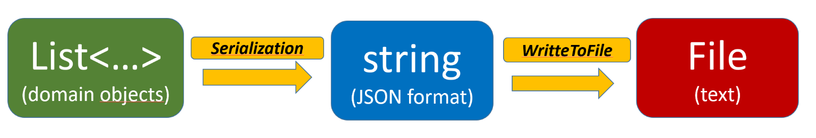

Likewise, the text (on JSON format) can be read from the file again, and transformed back into C# objects. This is illustrated in the figure below. The conversion from sequ­en­ce of cha­racters into in-memory objects is known **as reserializing**. A string is read from the file, and then converted (an operation also known as reserializing) into a List of objects.

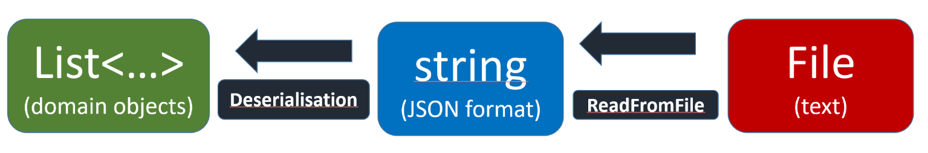

So when dealing with json files, our need can be limited into two main operations:

* Being able **to save a collection** of domain objects into a file ( using **serialization**)
* Being able **to load the collection back** into the application ( using d**eserialization**)

Saving and loading data from a json file may take time and performing these operations synchronously ( the way we did it in Part I ) may have some bad effects on the performance of the application. To tackle this issue, you may opt for running these operations **asynchronously**. This enables the application to continue doing useful work while the method call runs. We do not have space to talk about the advantages of asynchronous programming for the moment, but I suppose that at the time of reading this chapter, you are familiar with asynchronous programming. The other reason of running these methods asynchronously is that .Net framework offers many asynchronous methods for manipulating data in a text file, ***so why not to use them***?

Another aspect that is also important for any application is code reusability. Indeed, a real application will contain numerous object types and as you will notice in a moment, some code for manipulating different object types has many similarities, which requires to make it more generic.

## **The sample app**

The app built in this chapter is the same as the ***EventMaker*** application we covered in the first tutorial. A traveler /tourist can view events that are organized in most of the European countries. A travel organizer will be able to manage countries/events. The system is based on the following data model.

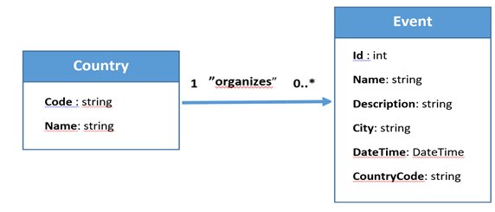

## **User stories**

In this Part II, we will implement the following user stories:

* As an organizer, I will be able to create / delete an event
* As an organizer, I will be able to create/delete a city
* As a traveler, I will be able to view all events
* As traveler, I will be able to view all events that take place in a city in Europe (able to filter events based on the city).
* As a traveler, I will be able to view all events that are taking place in a specific country

The following illustration shows the way we conceptualize the relationships between the Razor Pages and the Data access layer services that uses Json file as the data source.

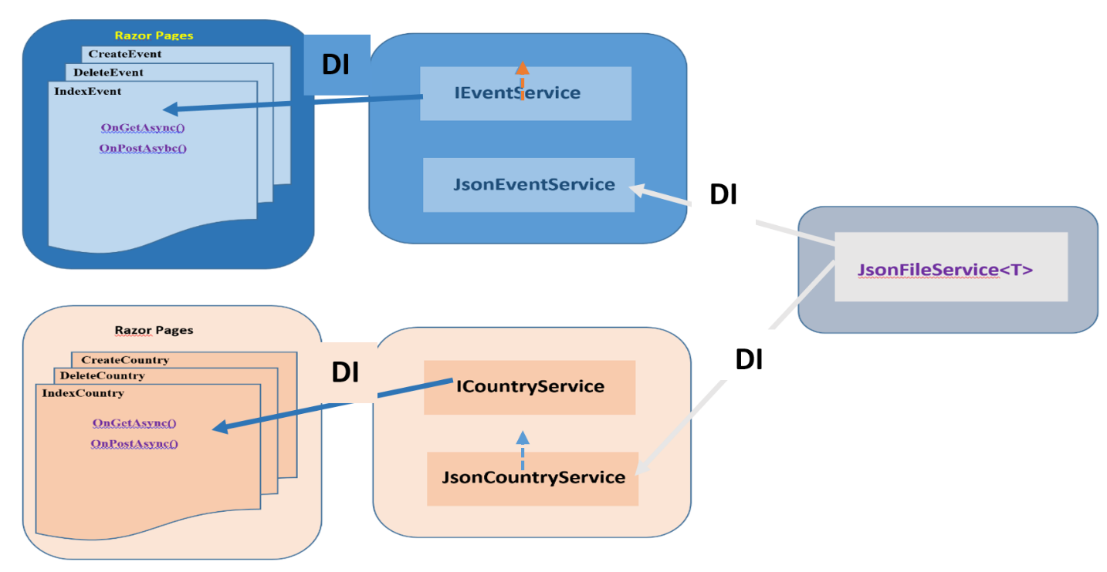

The only class that is generic is the **JsonFileService.cs** class. This class contains mainly the methods **SaveItemsAsync(…)** and **LoadItemsAsync().** I limit our generic code to only this method because I do not want to overburden you with many things at the same time. Later on, I will show how to implement the different services ( at the middle ) as generic classes.

**Implementation**

The code below shows the ***FilePersistency.cs*** .

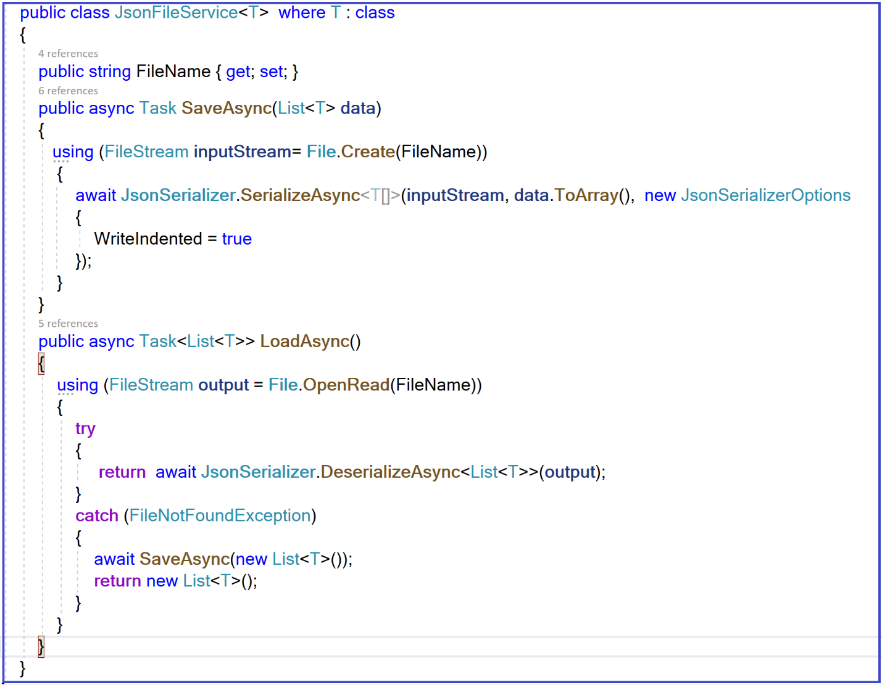

As you can see, we made the ***JsonFileService<T>*** generic where the type **T** is either Country or the Event. The class contains the 2 main methods: **SaveAsync** and the **LoadAsync** methods. The suffix **Asyn** indicates that these methods are implemented as asynchronous. The **await** keyword indicates that we are awaiting the operations that may take time. Remember that a **await** keyword can exist only in an asynchronous method. To make the method asynchronous, we need to add the keyword **async** to the method definition.

In the case of **SaveAsync,** We first create a ***FileStream*** object, then we use SerializeAsync method to asynchronously convert our List of objects of type T to UTF-8 encoded JSON Text and writes it to the stream. We used **JsonSerializerOption** object to write data in an indented way for pretty printing. The SerializeAsync method is asynchronous.

In the case of **LoadAsync**, we do the same thing in the reversed order. We create a ***FileStream*** for reading data from a file. Then we call the **DeserializeAsync()** method to asynchronously read the UTF-8 encoded Json text into a list of objects of type T. The **try-catch** block in the **LoadAsync** method is added to handle the case where the caller attempt­s to load data from a file that does not exist. In this case , the **LoadAsync** method simply calls the **SaveAsync** method with an empty list, to invoke the creation of the file.

Now that this class is in place, let us look at how we can use it in a Razor Pages application. We start by creating one json file for managing the **country** **objects** and another one for managing the **Event objects**. We could use a single json file but we adopted the two-files approach, similar to how a relational database works.

**Implementation**

The ***JsonEventService*** class implements the ***IEventService*** interface

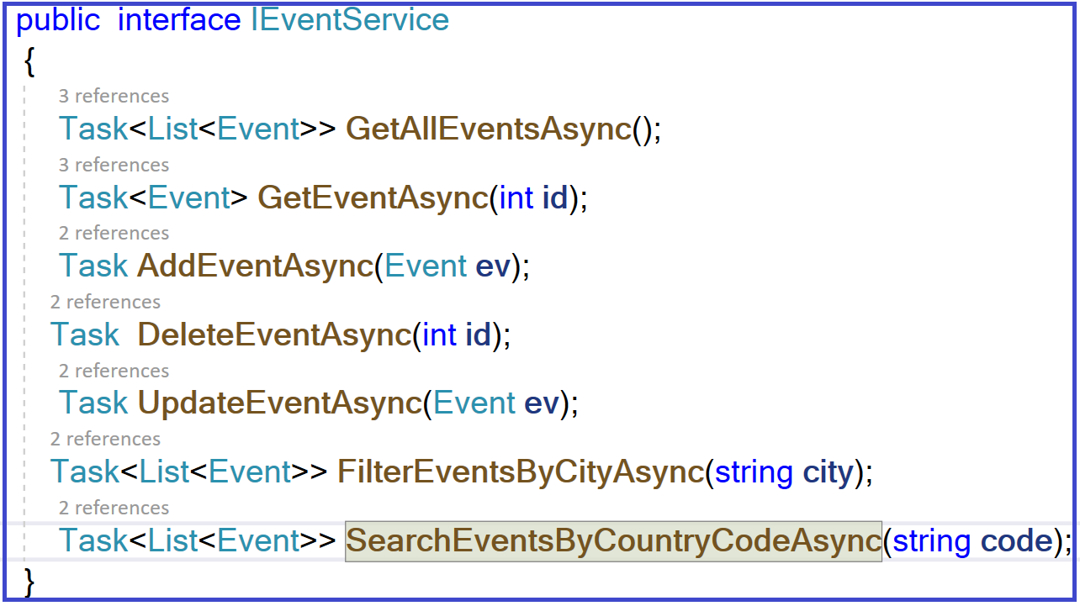

The **JsonCountryService** class implements the **ICountryService.**

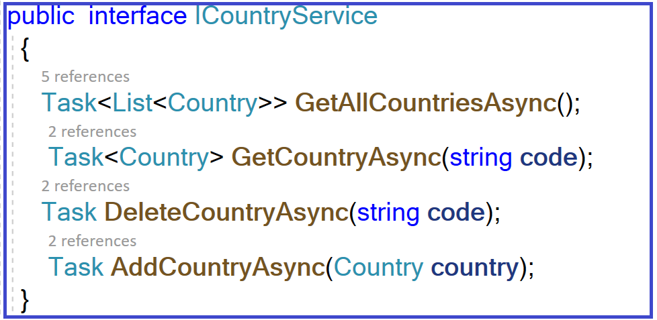

In this section, I am not going through the implementation of each service class. I am going to cover some user stories to explain how we use the generic class and how we implement our methods as asynchronous. The code is self-explanatory and very similar. That is why I am not explaining the code in details every time. The rest of the code can be found on GitHub at: <https://github.com/elallalimohammed/RazorPages_Spring2021>

1. **User story : As an organizer, I will be able to create a new Event**

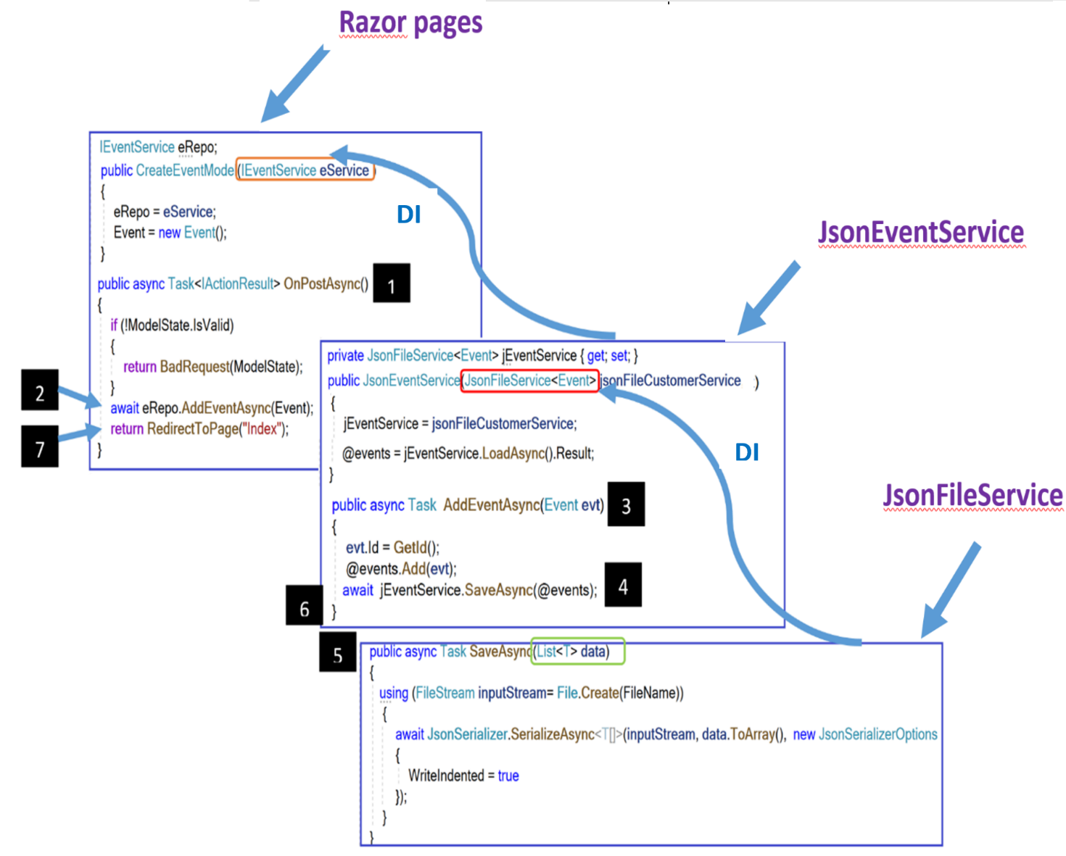

The code is very easy to understand.However there are things that you have to notice. Notice how I performed Dependency injection ( DI in the figure above) . I did inject the **JsonFileService**  service into the **JsonEventService** service. When injecting this service, I did specify the Event type because the JsonFileService class is a generic class. Every time a generic class is used, we need to specify the type of the generic parameter. Notice how in turn we did inject the IEventService interface into the **CreateEvent** razor page. Notice also, how the Razor Pages are using the back-end. Indeed, as our Razor Pages are calling asynchronous methods that requires the await keyword, it is wise to use the ***OnGetAsync*** and ***OnPostAsync***  action methods. Notice also that I added numbers on the line of codes to show the sequence is which asynchronous code is executed from the time we fill up the form and click on the submit button to create a new Event.

1. **User story : As an organizer, I will be able to delete an Event**

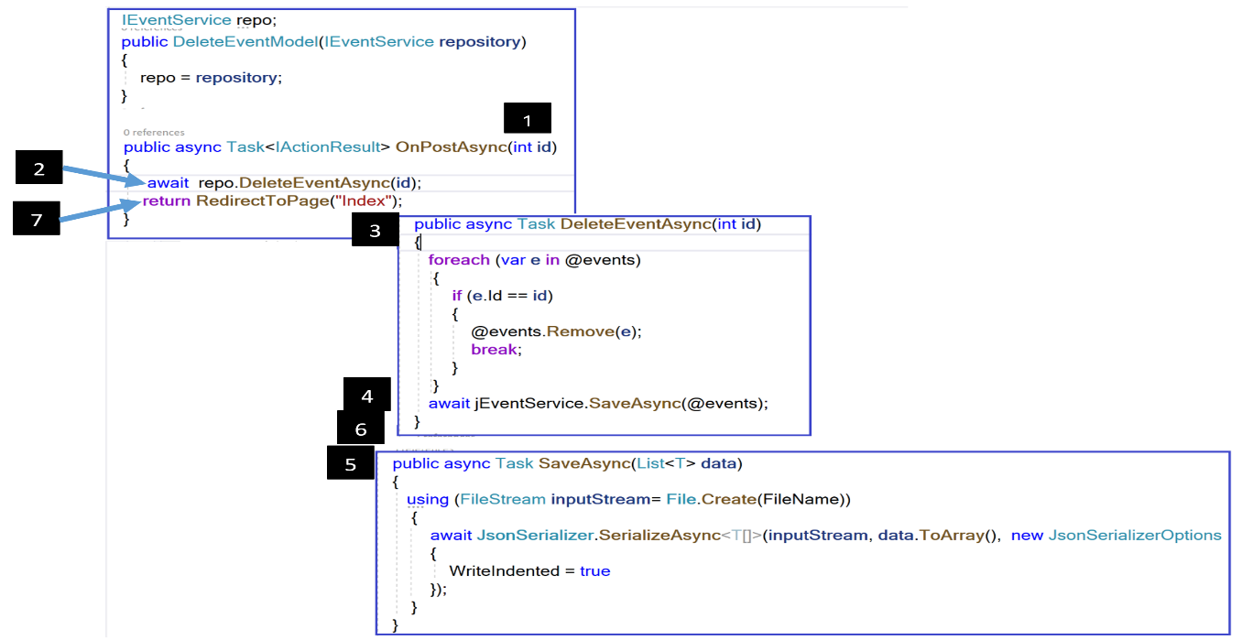

In this user story, the code is self-explanatory.

1. **User story : As an organizer, I will be able to view all events and be able to filter events based on the city that organizes these events**

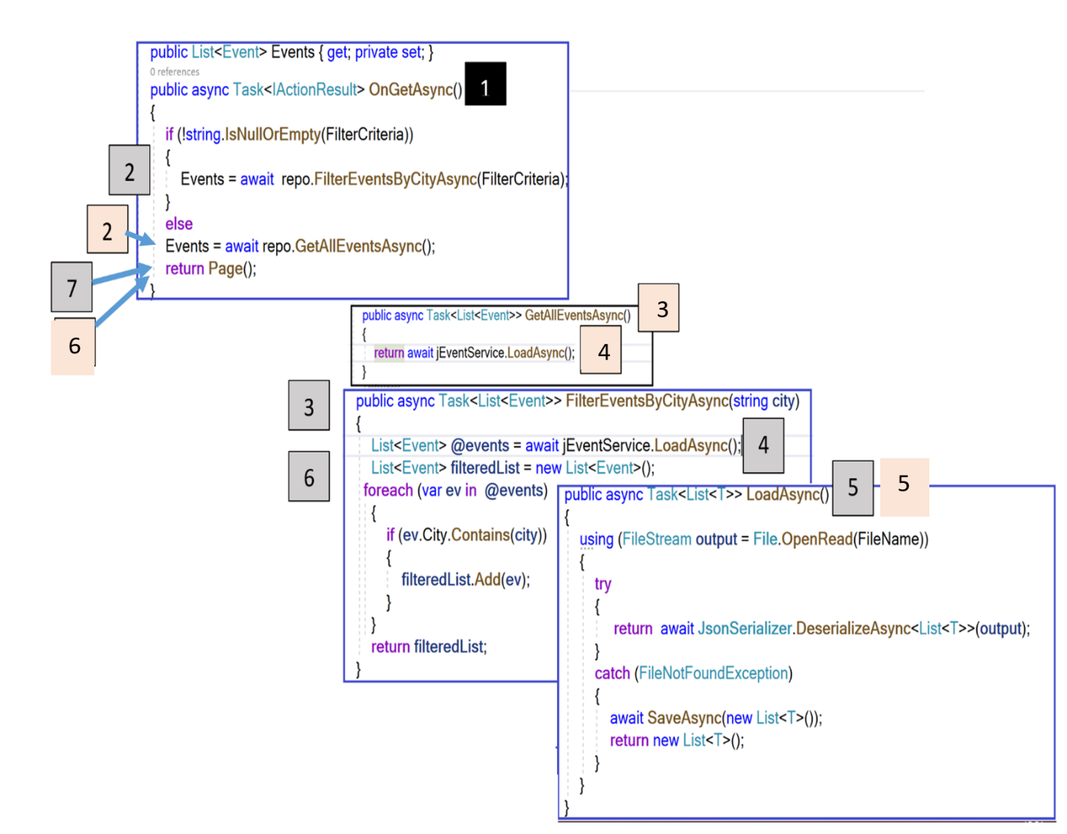

1. **User story :As an organizer, I will be able to view all the events that take place in a specific country**

What is interesting in the implementation of this user story is the fact that, in order to display events for a specific country, we use the same Razor Page for displaying all events (named IndexEvent). No need to create a new page. The problem is that, when we display all events, we are calling the **OnGetAsync()** method ( with no parameter). Then, which handler method is called when displaying events for a specific country? The **OnGetMyEventsAsync(string code)** handler method is called as shown in the illustration below.

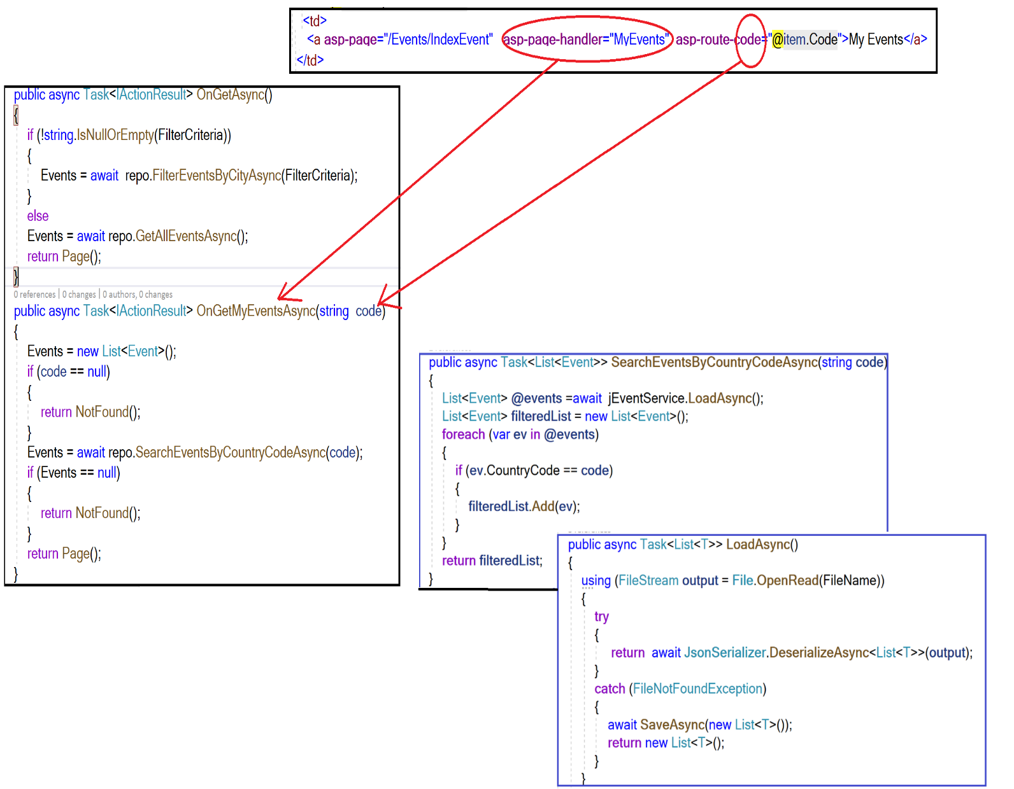

Now it is time to configure or register all these services .The figure below shows how we use the ConfigureServices method of the Startup.cs file to register these services in the Dependency injection container.

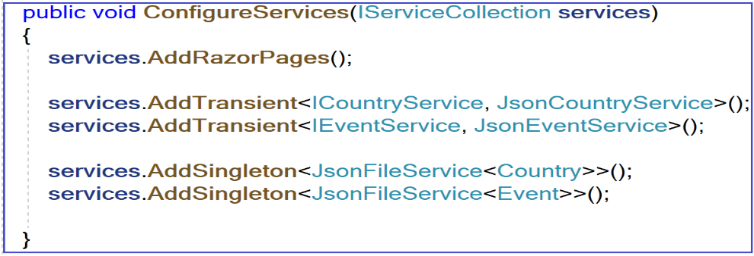

**Sprint Review**

Let us run the application.

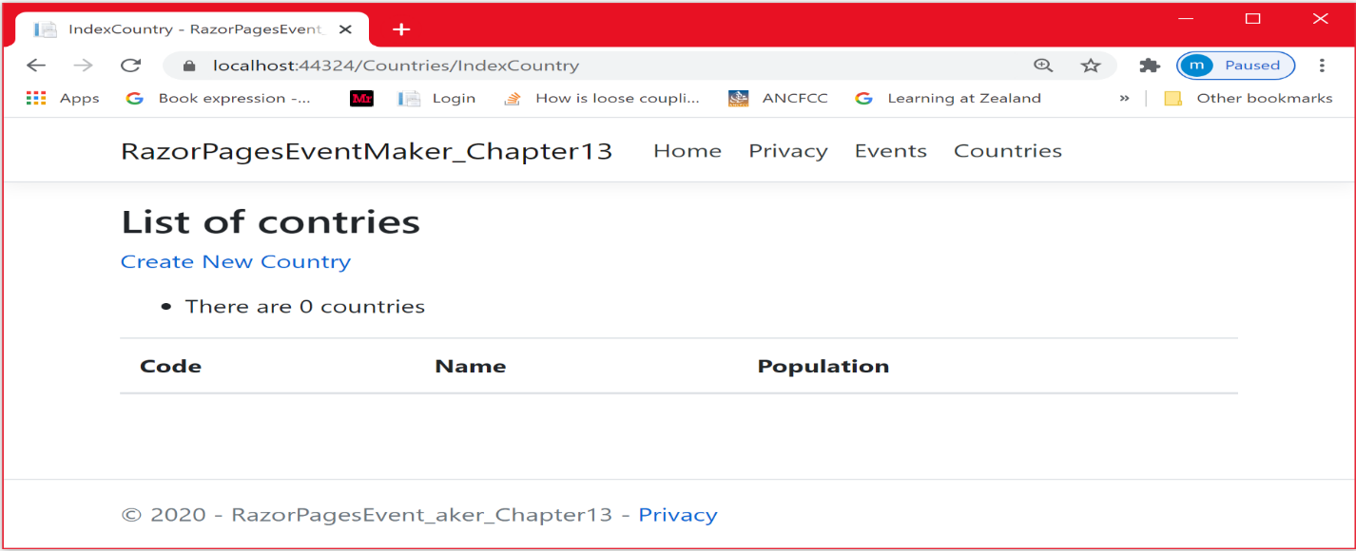

**User story**: Create a country

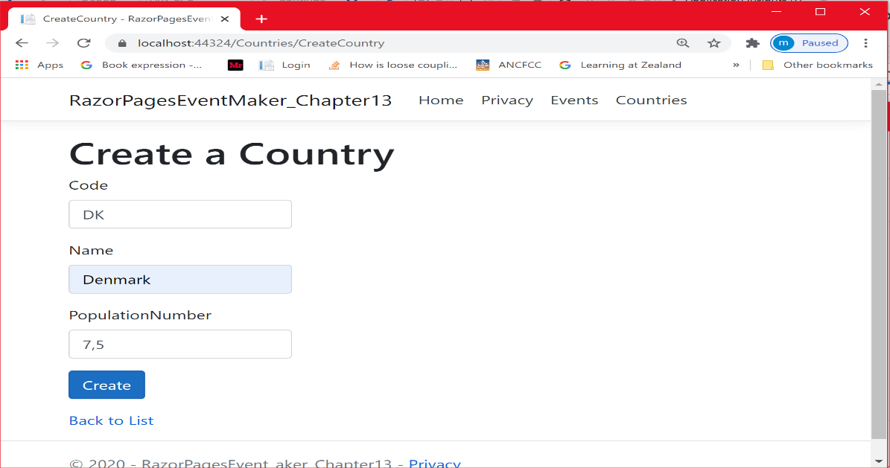

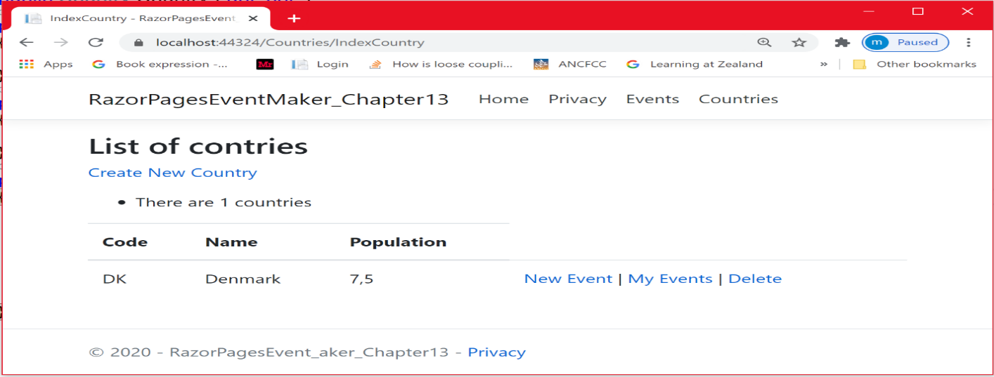

We created 3 countries. We want to add a new event in France.

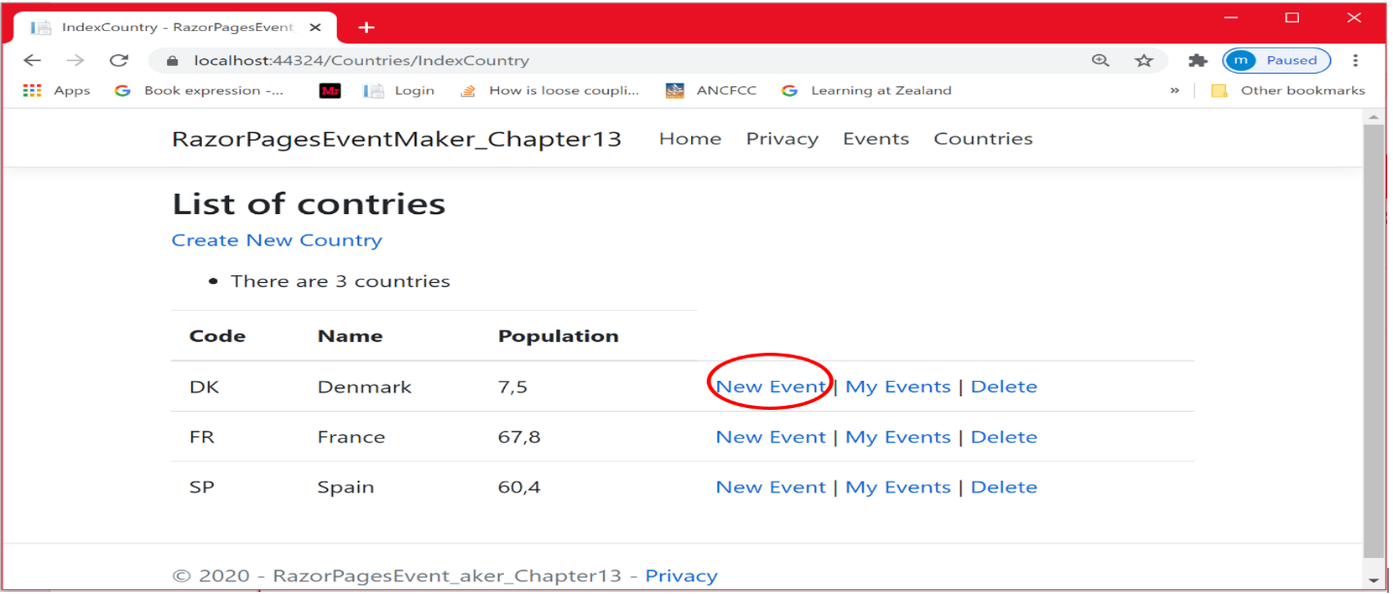

**User story** : Create 2 Event in Denmark and 1 in Spain and no one in France

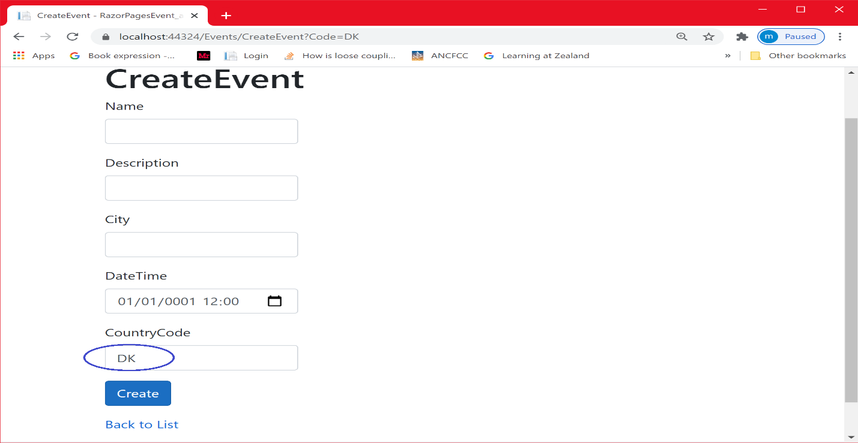

As shown above, by selecting the country, its Code is passed to the CreateEvent page

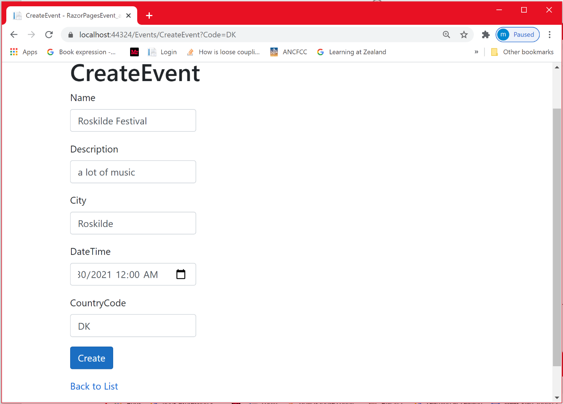

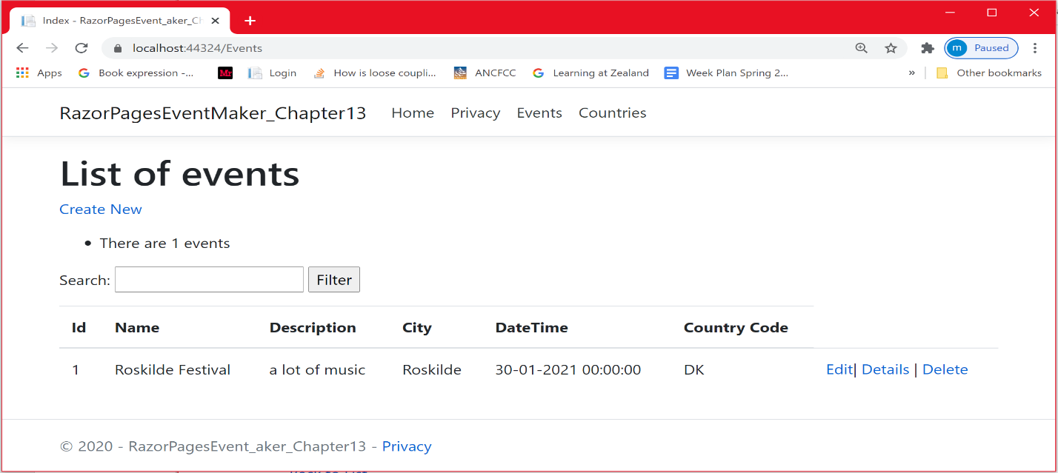

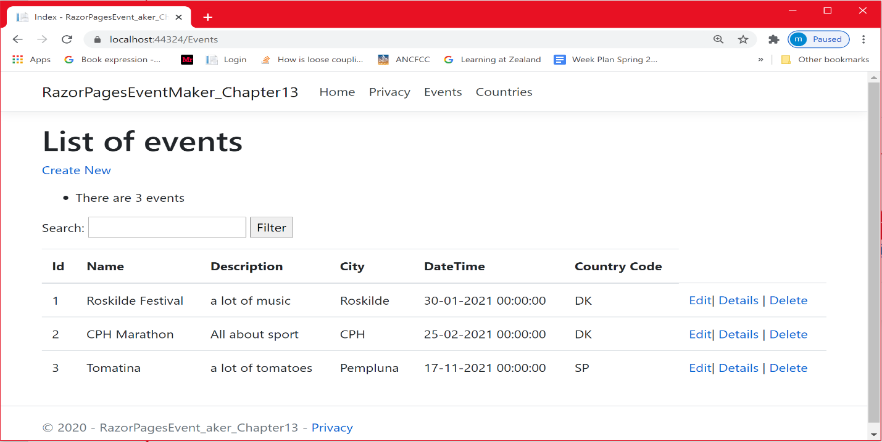

**User story**: I will be able to view all events that take place in a country

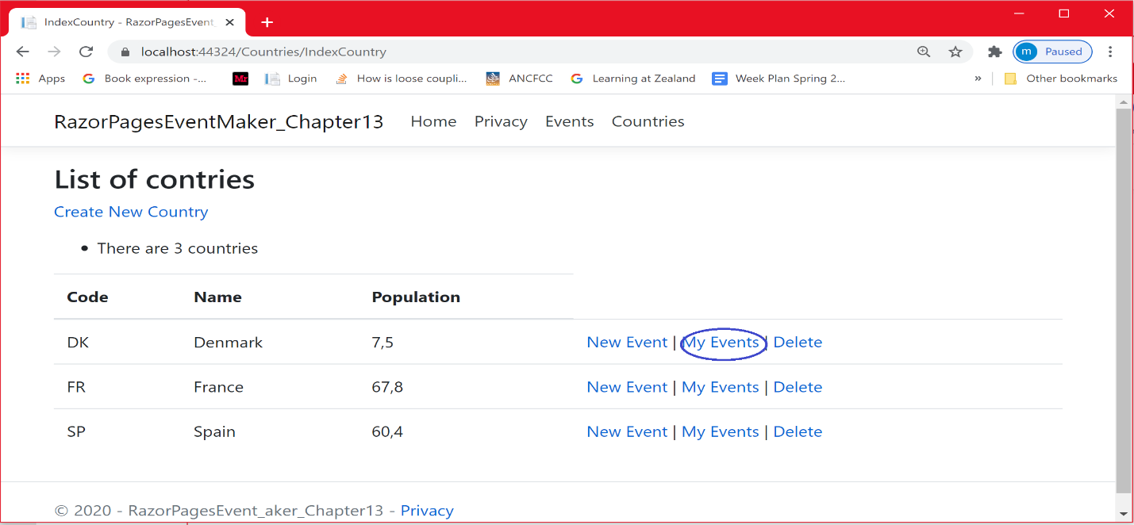

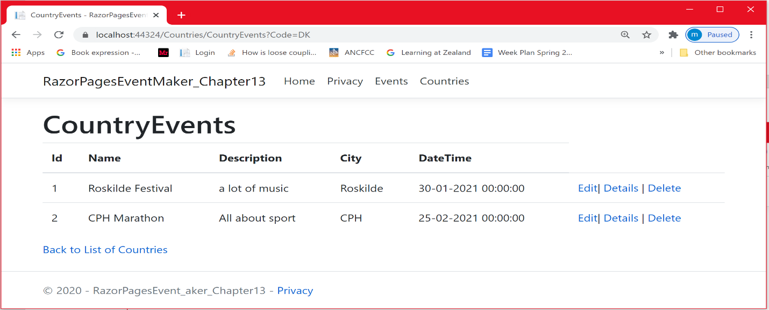

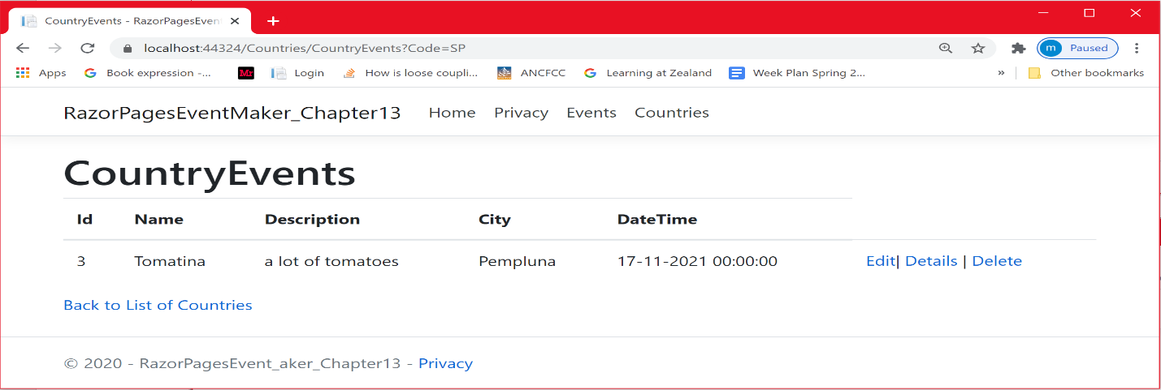

**User story**: I will be able to filter events by city

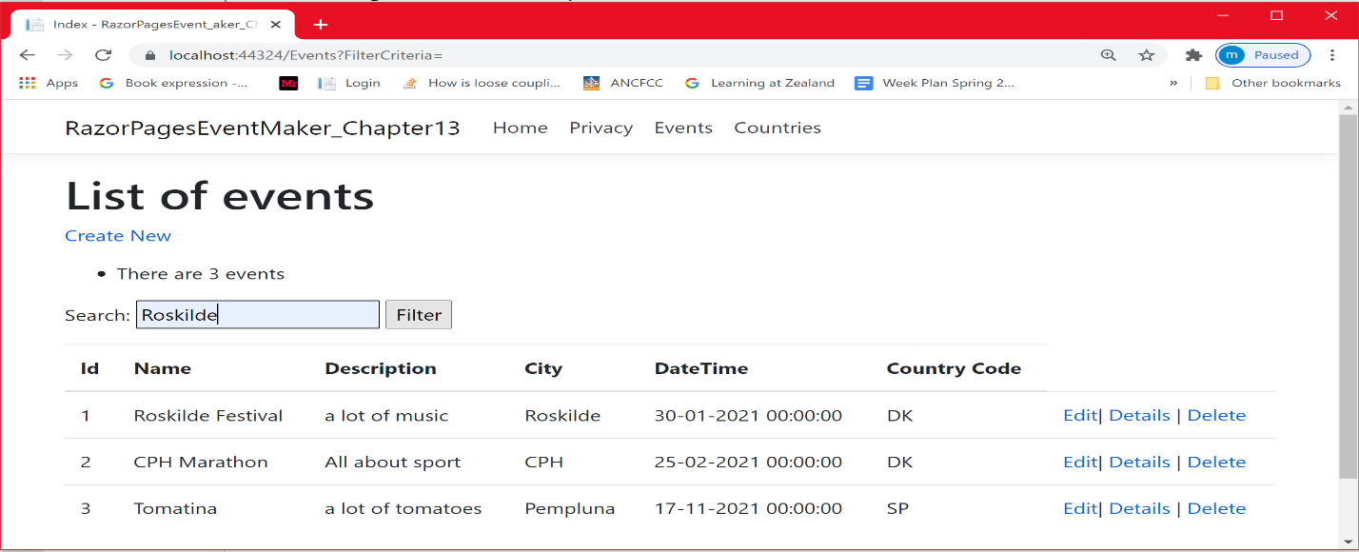

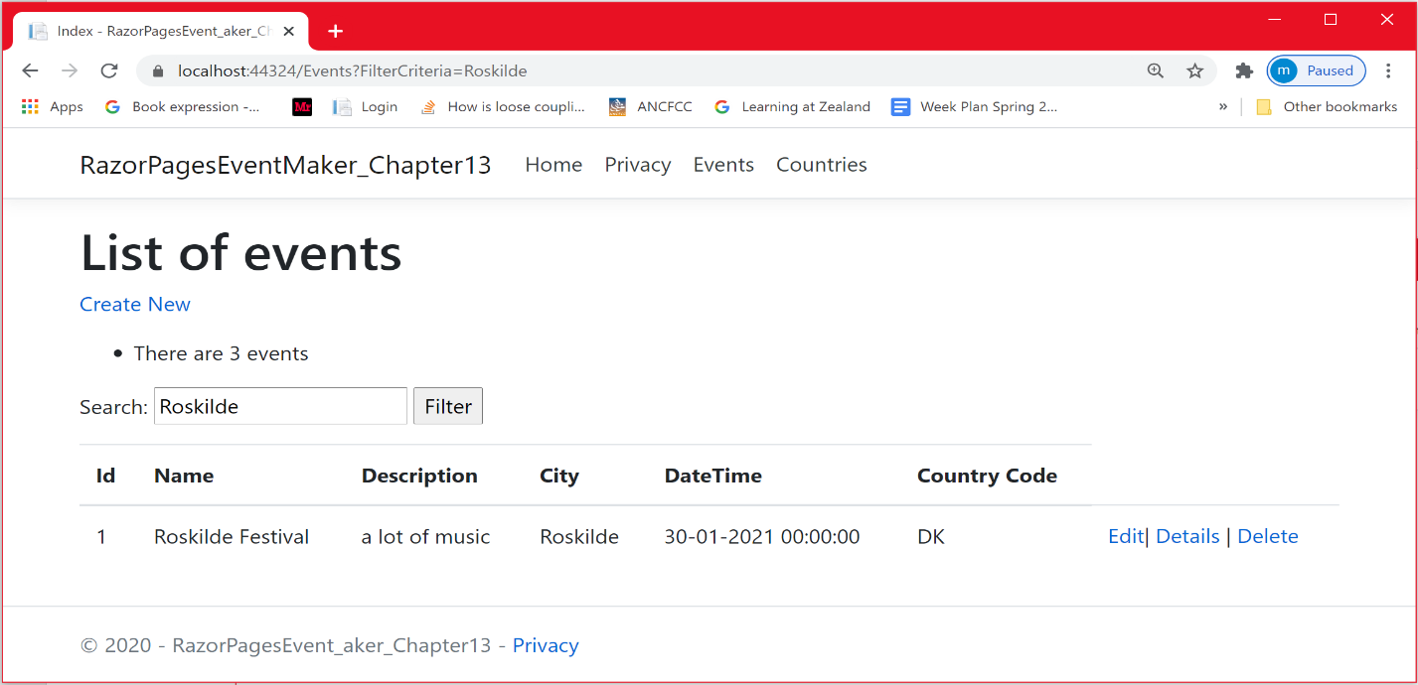

**User story**: I will be able to delete an event

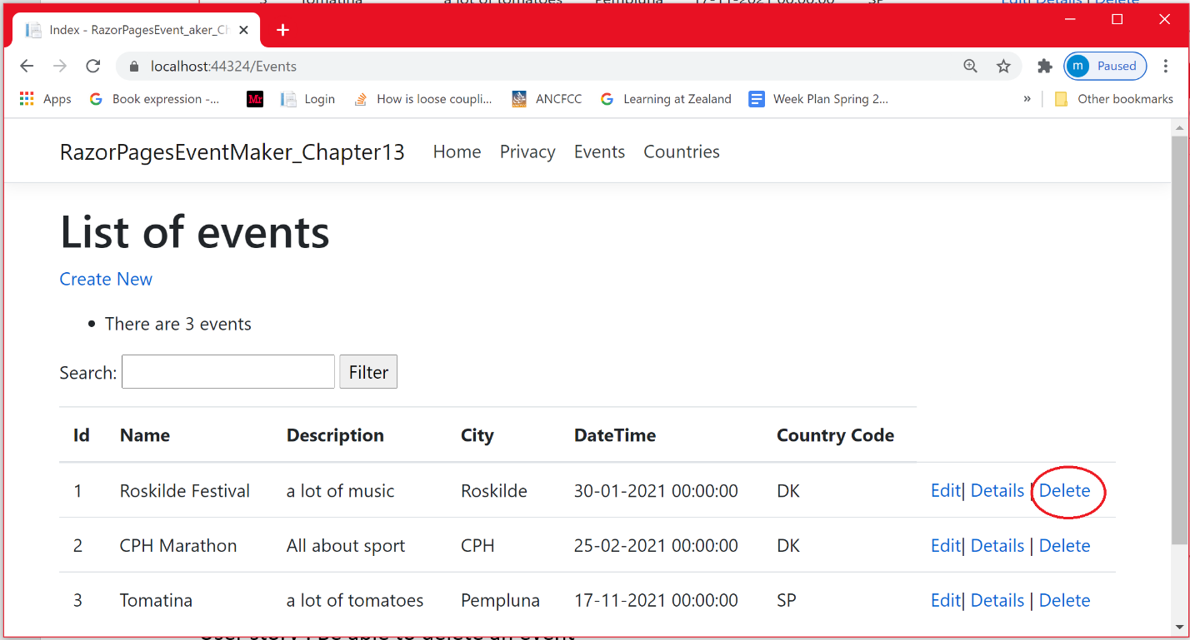

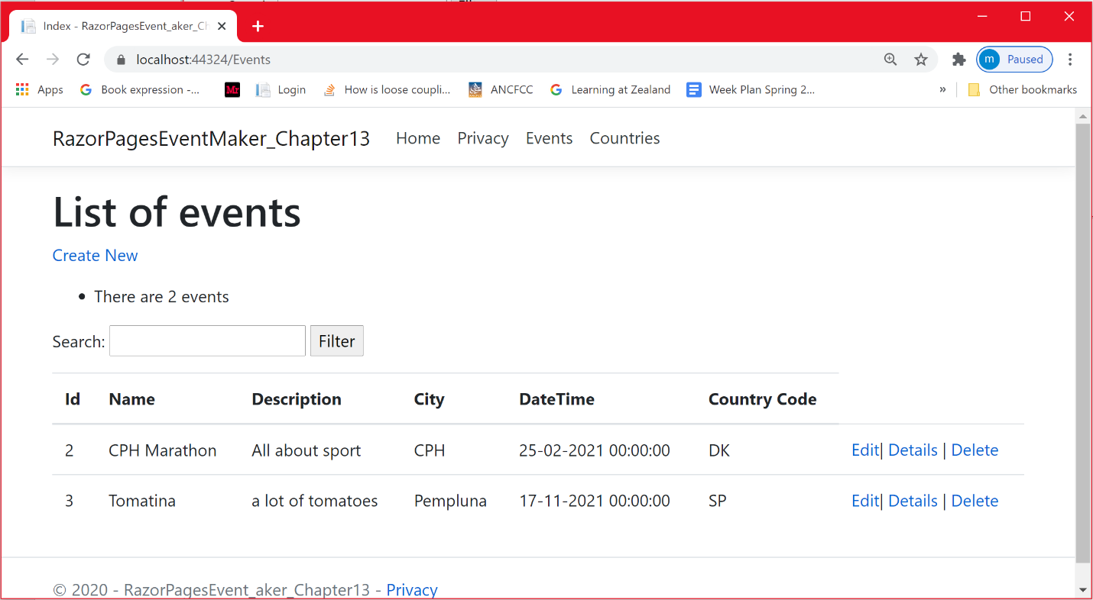

**Conclusion**

In this chapter, you did learn how use generics to make the code for storing and retrieving data from a json file more generic. The generic implementation made your code reusable. All your business entities will use the same code by specifying its class type. You also used asynchronous programming to perform these operations asynchronously, which may improve the performance of the application.

**Chapter 2: Entity Framework- Database First approach**

# *Database First approach?*

In this chapter, we are going to look at the Database-First approach. In this approach, we create our database first. Then we create the entity classes and the context class for the existing database using what we call Entity Framework Core. This approach is useful when we work with an existing database. This is also useful when we migrate from existing applications. The approach is illustrated in the figure below.

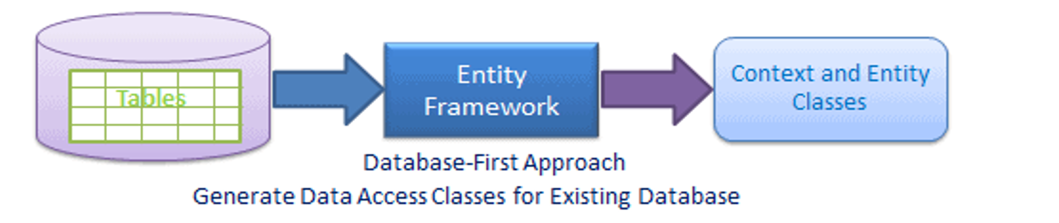

However, before digging into the implementation of such framework, let me introduce you to the relational model because we are going to use a relational database.

**Relational model**

In part I of this tutorial we have seen how to persist (storing and retrieving) data using a Json file as a data source. We used this option because it is relatively suitable for small applications. However, data management is very crucial when working with large client application like windows, web and other client applications. In this case, dedicated databases are best suited for storing, manipulating and retrieving the data. The most used model for data storage and retrieval is the relational model, the one that we adopt in this tutorial. We are using an SQL Server Relational Database. The Relational Model is a very large topic. I am not going to dig into it in details because you may probably get a deep understanding of it in your Database course. Here are some words about the relational model:

The relational model expresses the data and relationship among the data in the form of **tables** (relations), data semantic and constraints on the data. Such constraints may include domain constraints, key constraints, entity integrity constraints, referential integrity constraints and more. Each relation has **columns** and **rows** which are formally called **attributes** and **tuples** respectively. Each tuple in relation is a real-world **entity** or **relationship**.

The relational model is very popular due to its ease of use, the simple understanding of such model and possibility of hiding the physical storage details from the users. It is widely used to design the database systems and today the majority of database system are designed using the relational data model. To store and retrieve data from a relational database, we use standard database manipulation language, a language that the RDBMS can understand. The Structured Query Language (**SQL**) will be used in this tutorial.

### **Introduction to Entity Framework**

As mentioned above, we are going to use a relational database. A general problem when working with relational data in an object-oriented langu­age, is the mismatch between the object model and the relational model . The object oriented model use classes whereas the relational database use tables. This problem is known as the **Object-Relational Mapping** (**ORM**) problem and it is illustrated in the figure below.

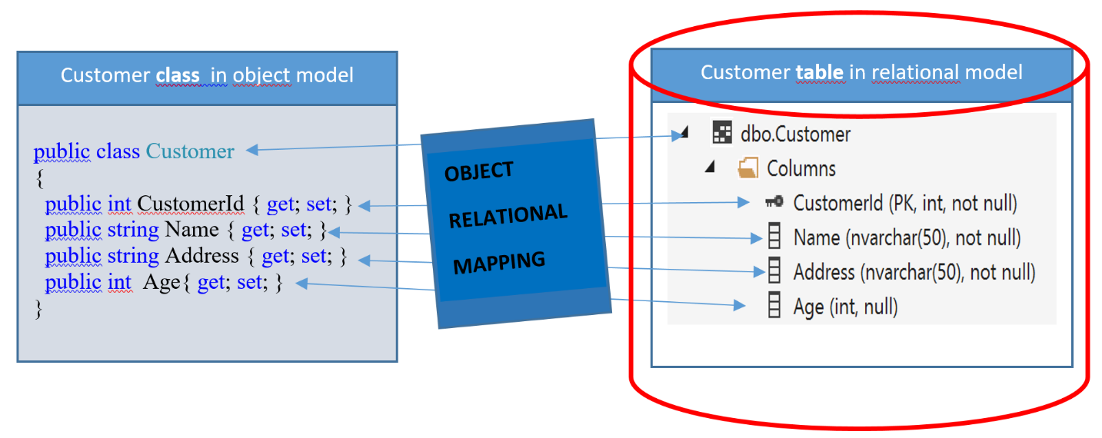

The question is how to properly “map” data between these two data representation para­digms: relatio­nal and object-oriented. If we can automatically map the business objects to the database, this allows us to focus more on the business problem and less on the data storage. Fortunately, several frameworks exist for performing this mapping. In a Microsoft context, a framework known as the **Entity Frame­work** (**EF**) has been the predominant framework for this in the recent years.

As part of Microsoft’s shift towards a cross-platform .**NET Core**, Microsoft also started the process of porting EF functionality to .NET Core, in the form of the **Entity Framework Core** (EF Core) library. Before 2018, the first version of EF Core ( version 1.0) did not support SQL Server databases . It was until early 2018, where EF Core version **2.1** was released. This version supported access to SQL Server databases, so it is now indeed possi­ble to interact directly with an SQL Server database.

Today, Entity Framework Core (EF Core) is Microsoft’s recommended data access technology when building new and modern .NET applications. It is a modern object-database mapper for .NET. It enables developers to work with relational data using domain-specific objects without having to write code to access data from a database. It supports ***LINQ*** queries, change tracking, updates, and schema migrations. EF Core works with SQL Server/SQL Azure and many other databases.

EF Core supports two main development approaches

### ***Database-First.***

### ***Code-First***

In the Database-First approach, we first create the database. Then the domain and context classes are created based on your existing database using either EF Core commands or the DbContext scaffolding.

In the Code-First approach, we create the database and the tables using **migration** based on the conventions and the configuration provided in your domain classes.

In this chapter, I am going to use the first approach (the Database-First). To be able to predict somehow how the relationships in the relational database design will be represented while creating the corresponding entity classes and the context class using EF Core, you need to know the different relationships between rows in the database tables. You have probably learned from your database design class that there are three types of relationships in relational database design:

* + - One-to-One : A row in **Table A** can have only one matching row in **Table B**, and vice versa
    - One-to-Many: A row in **Table A** can have many matching rows in table B, but a row in table B can have only one matching row in **Table A**
    - Many-to-Many: A row in **Table A** can have many matching rows in **Table B**, and vice versa.

Note that if you are able to manage the One-to-Many relationship, you will be able to easily manage the other relationships. In this chapter, I am dealing with One-to-Many relationship. I am still working with the EventMaker App. The model and the DB Design are shown below.

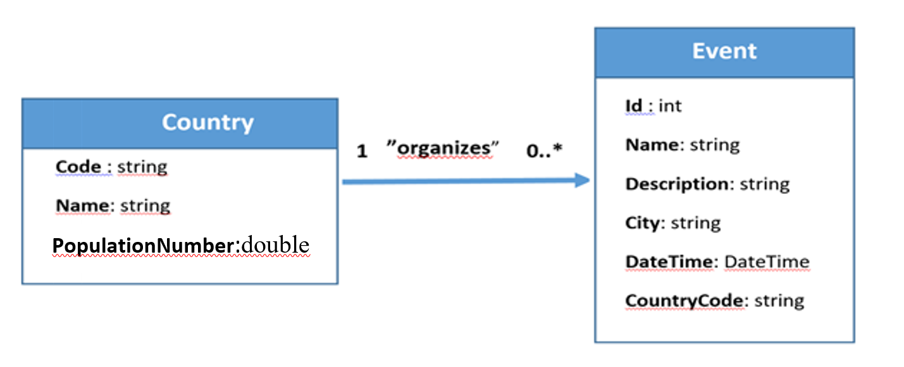

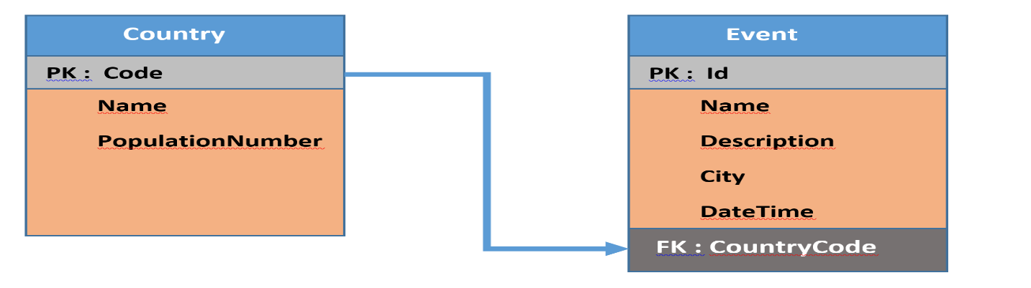

In terms of the database design, the **Code** column in the Country table is unique (a primary key) while the ***CountryCode*** column in the Event table is the foreign key that refers to the Code column in the Country table.

## **Creating a local database with Visual Studio**

Now that we have a database design in place, we are going to create our database. Since databases are an integral part of many applications, Visual Studio offers sub­stan­tial support for working with databases. Microsoft also offers various data­base products as part of its product suite, the primary product being **Microsoft SQL Server** (MSSQL), [SQL Server LocalDB](https://docs.microsoft.com/en-us/sql/database-engine/configure-windows/sql-server-2016-express-localdb), a version of SQL Server Express that runs only on Windows. It is quite easy to create a relational database from within Visual Studio. For use in this chapter, we will create a database called **EventMakerDB**. The database is a local database, i.e. it simply resides on your computer. Later, we may describe how a database can be deployed into a cloud hosting service.

There are many ways to connect to the Local SQL Server and create a database with tables. In this section, I am going to opt for a very simple option using Visual Studio. I will use SQL Server Object Explorer in Visual studio to connect to the Local SQL Server and create the new database. Later on, in chapter 5, I will show you how to create and execute a script to create database, tables and insert data. Anyway, in your database class, you have probably learned how to create scripts that creates database, tables and insert data.

* Another way to connect to the SQL Server is to use the SQL Server Management Studio(SSMS).

Let us create the **EventMakerDB** database using visual studio. This database will contain the Country and Event tables.

***In visual studio***, select View   SQL Server Object Explorer  as illustrated below

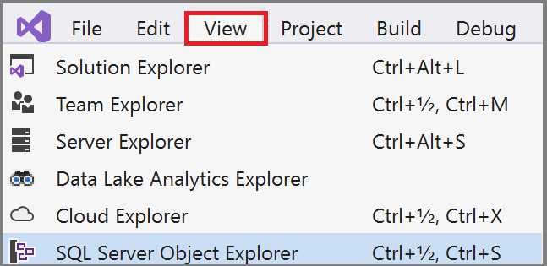

* Expand the SQL Server option

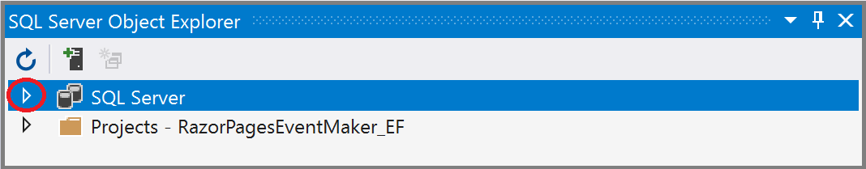

* Select your local SQL Server installed on your computer: (localdb)\MSSQLLocalDB
* To create the new database and the corresponding tables, right click on the **Database** node and select the **Add New Database** option.

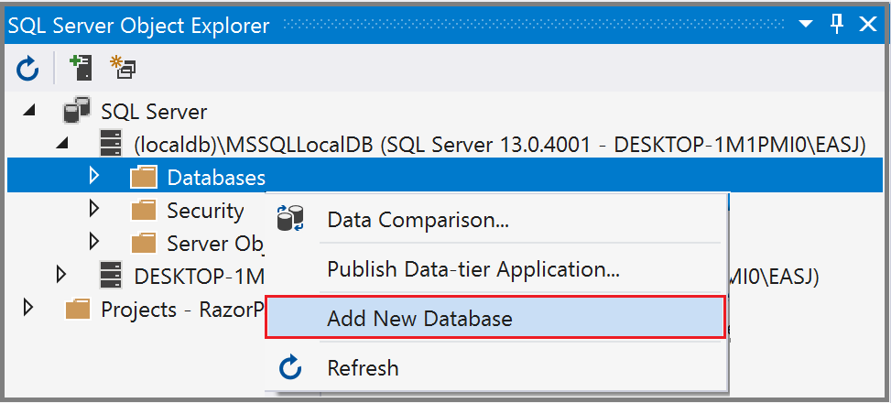

* In the resulting dialog, enter **EventMakerDB** as the name of the database and click OK to create the database. The database is created in your local SQL server.

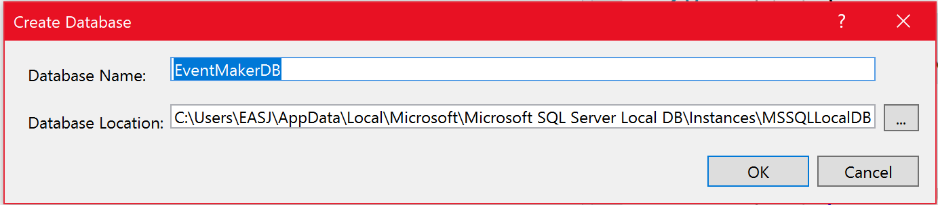

As shown below, the new database is created.

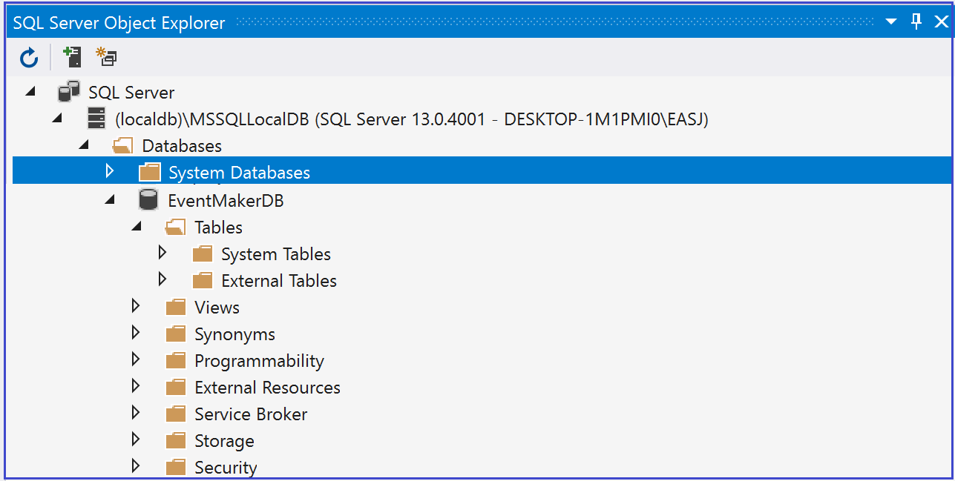

This database will contain two tables:

* The Country table that keeps track of the countries.
* The Event table that keeps track of the events that take place in a country
* Right click on the **Tables** node and select **Add New Table**. This is illustrated in the figure below

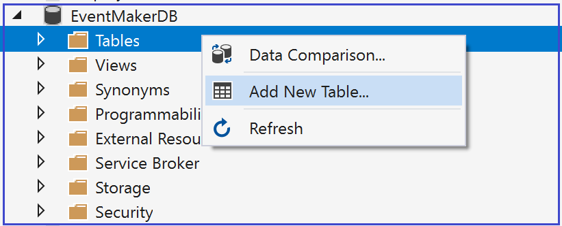

The figure below shows the ***Table Designer*** and ***The T-SQL*** windows.

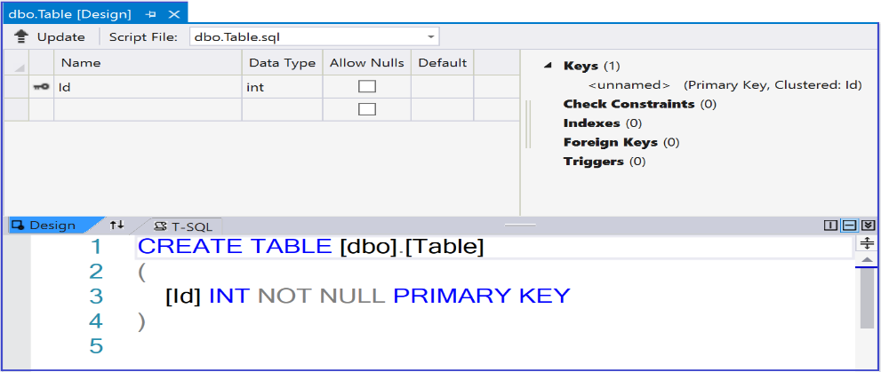

As shown in the figure below:

* Use the **T-SQL** window to enter the name of the table (i.e. **Country**) instead of [Table] as shown below.

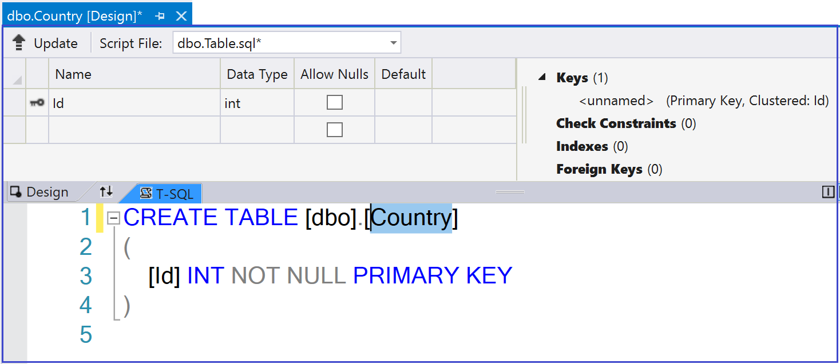

* Use the **Table Designer** window to add the different fields for the Country (*Code, Name , PopulationNumber*) along with their corresponding types. The Code and the Name are of type Varchar(50). Notice that the PopulationNumber could be null (not defined).

Notice that all the operations performed in the Designer are reflected in the T-SQL window as a script.

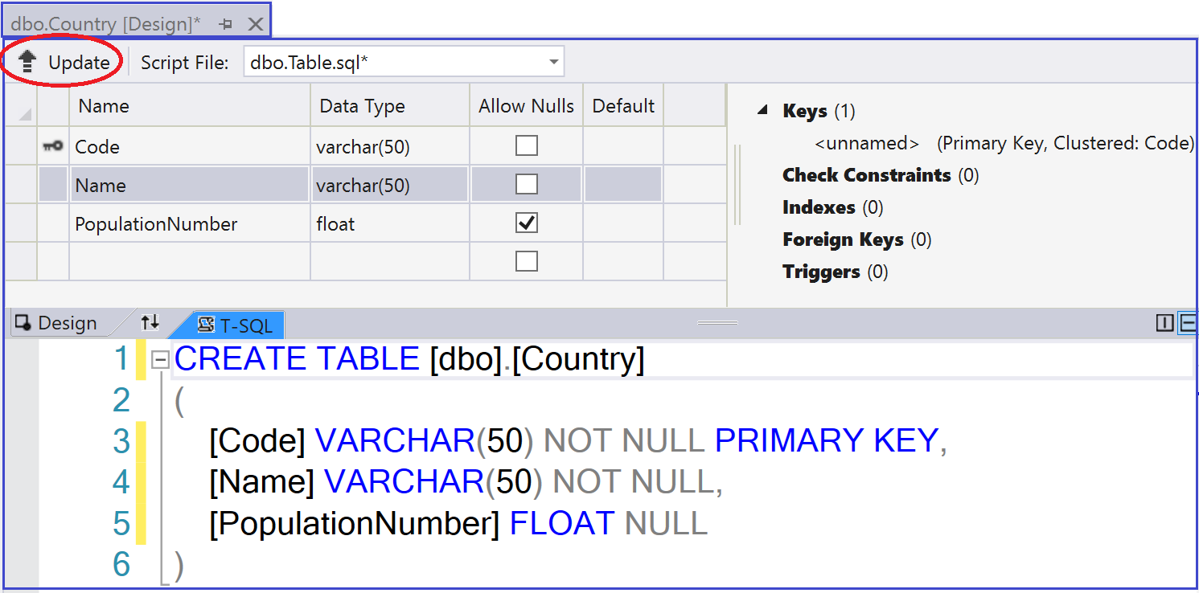

As you can see from the T-SQL window:

* The PRIMARY KEY keyword indicates that the Code is the primary key. That means it is unique.
* The **NOT NULL**  keyword indicates that columns should contain some value of the given type .
* The **NULL** keyword indicates that columns may have a null value(not defined ).
* Once you enter all the data, click on the **Update** button to save the changes made to the Country table. Confirm the update by clicking on the “***Update Database***” as shown below.

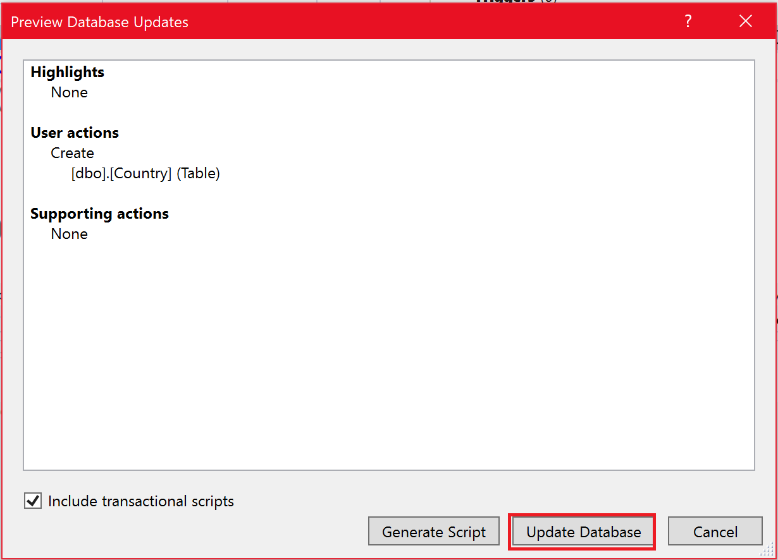

**Creating the event table**

To create the Event table, we followed the same process:

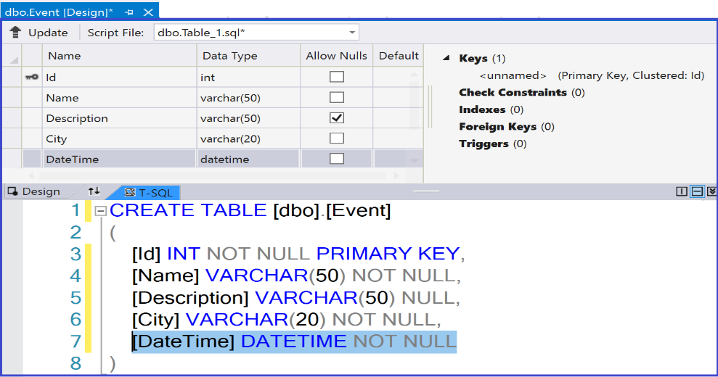

As the primary key is of type integer, let us make it increment automatically.

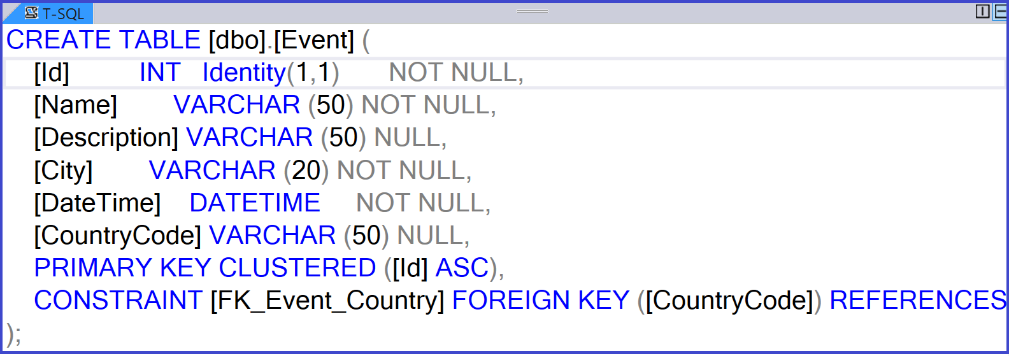

The only thing that deserves more attention in the Event table is how we refer to the Country Table. This is achieved using a foreign key. In this case, the CountryCode in the Event table is going to be the Foreign key. ***How to add the foreign key*** ?

* Use the Designer to add the CountryCode field ( should have the same type ). As you can see, the CoutryCode foreign can be null as sometimes the coutry where the event will take place is not defined yet ( ***because of Corona*** ).

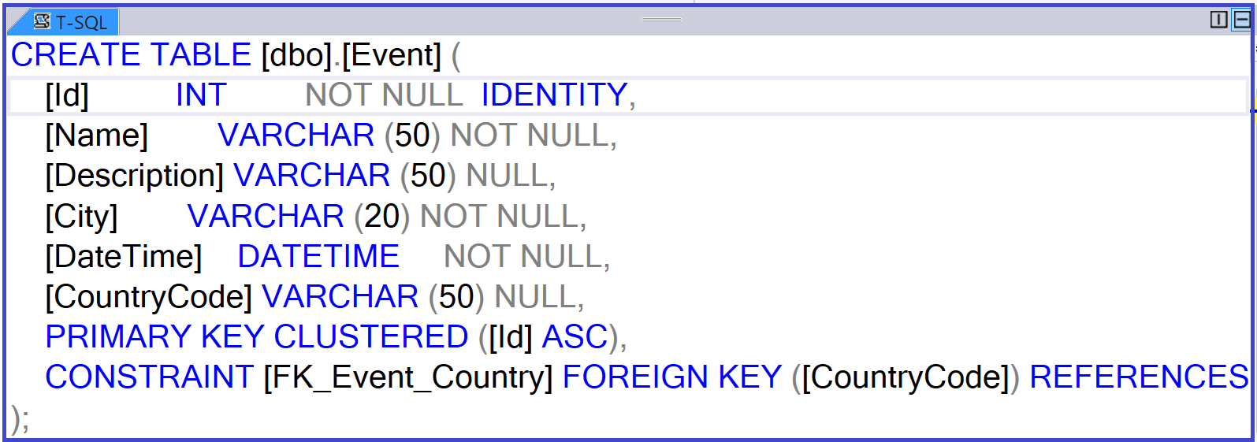

Now, let us configure the CountryCode as the foreign key, as shown below.

* Select the CountryCode .
* Right-Click **Foreign Keys** option on the right hand side
* Choose **Add New Foreign Key**

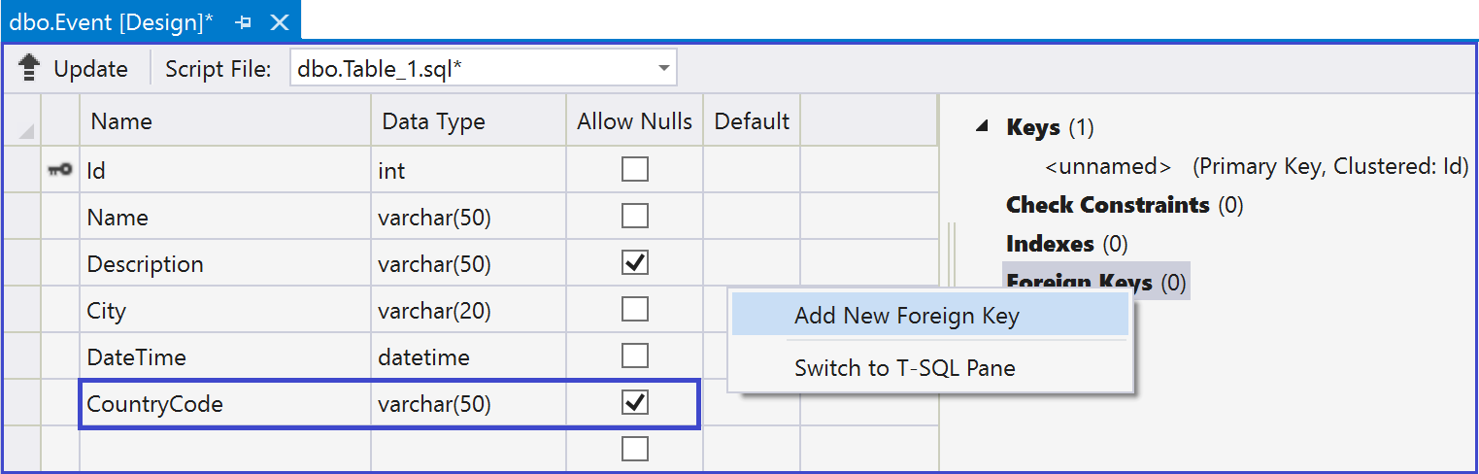

* As shown below, specify the destination table, which is the Customer table.

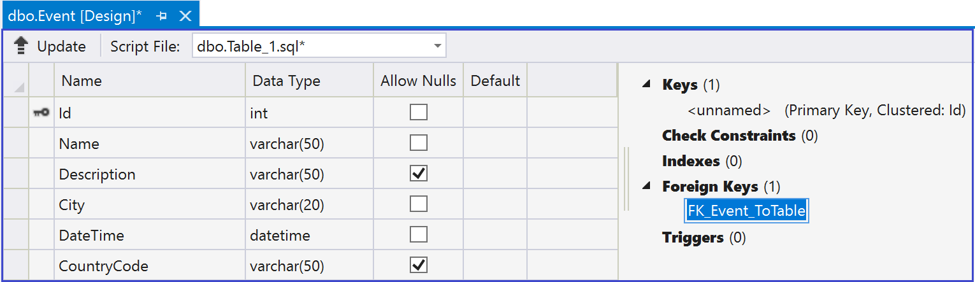

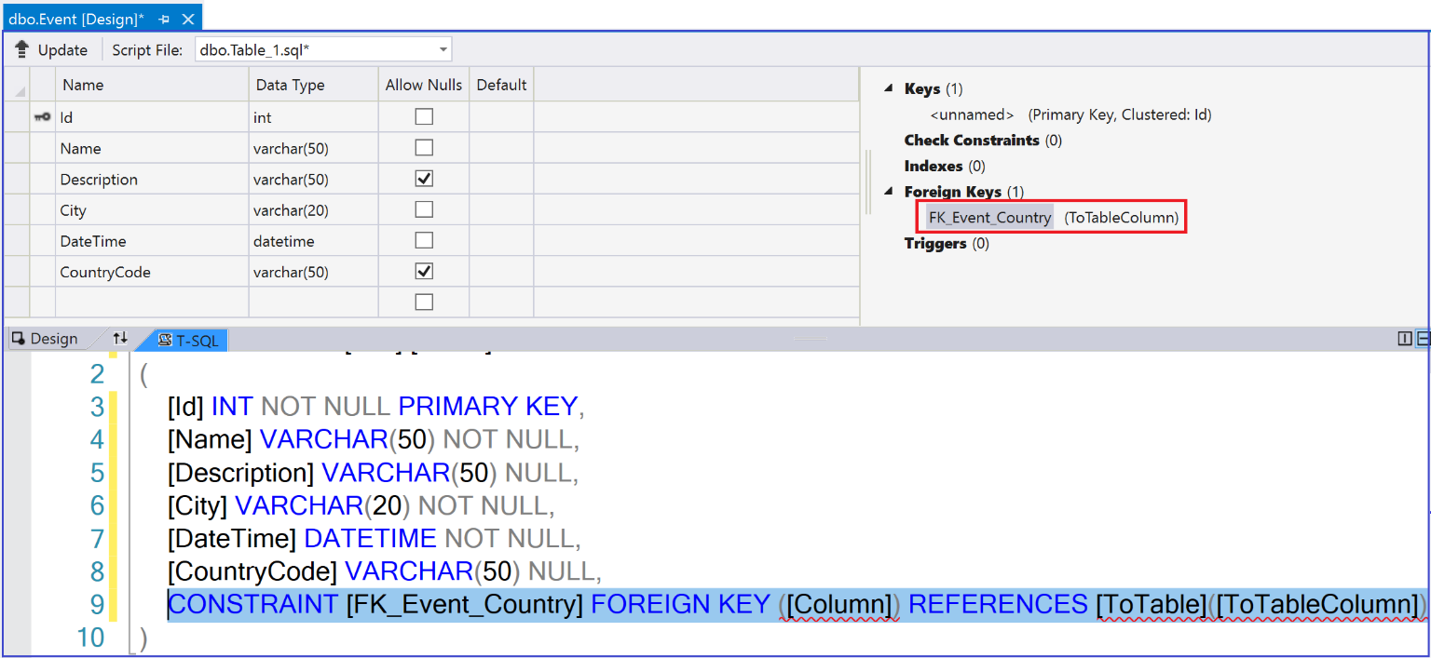

As you can see above, some errors pop up. To correct these errors, we need to specify respectively the foreign key, the table it refers to and the primary key in this table.

* Add the changes shown below.

.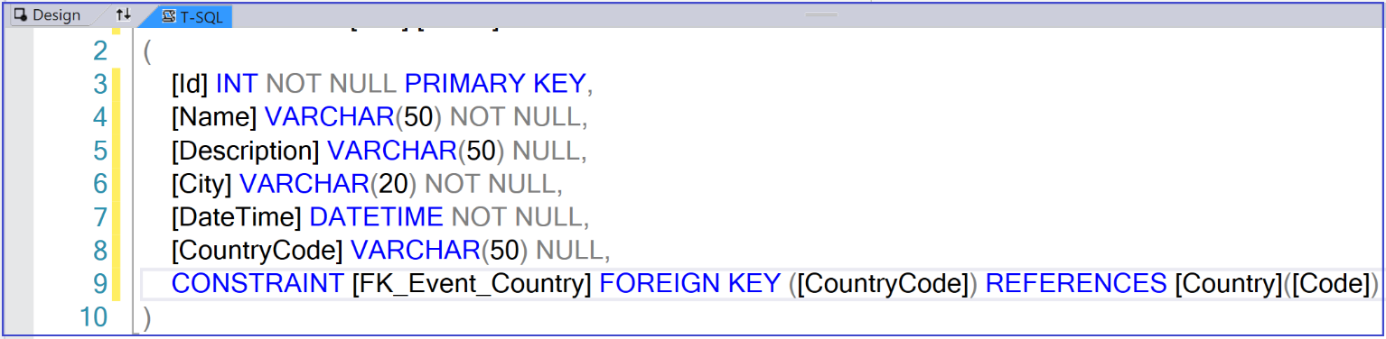

* Click on Update , then Update Database to update the changes

While we are adding the foreign key, let us add some rules on it. In our case, when we delete a row from the Country table, we also want to delete all rows in the Event  table that refer to the row in the Country table. It makes sense to delete all events if the country in which these events take place is no longer participating in these festivities.

To set up the rule mentioned above:

* Add the ***ON DELETE CASCADE*** statement as shown below
* Click the **Update** button to save the changes

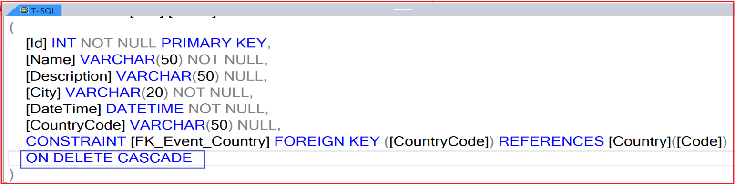

As you can see , the database, the Country and the Event tables are created

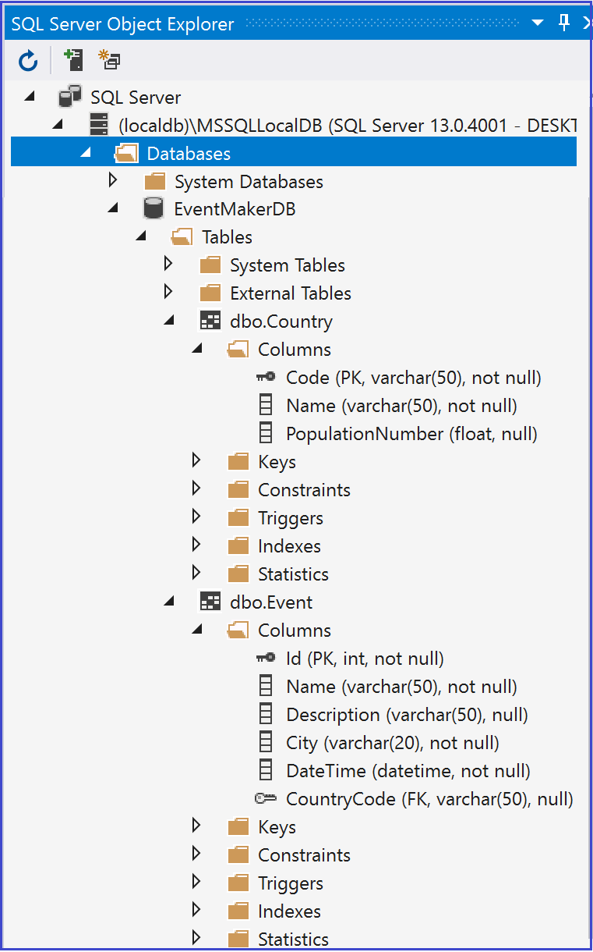

Now that the database is in place, we are ready to apply the database-First approach

***Creating Models and a Context***

The app structure is shown below

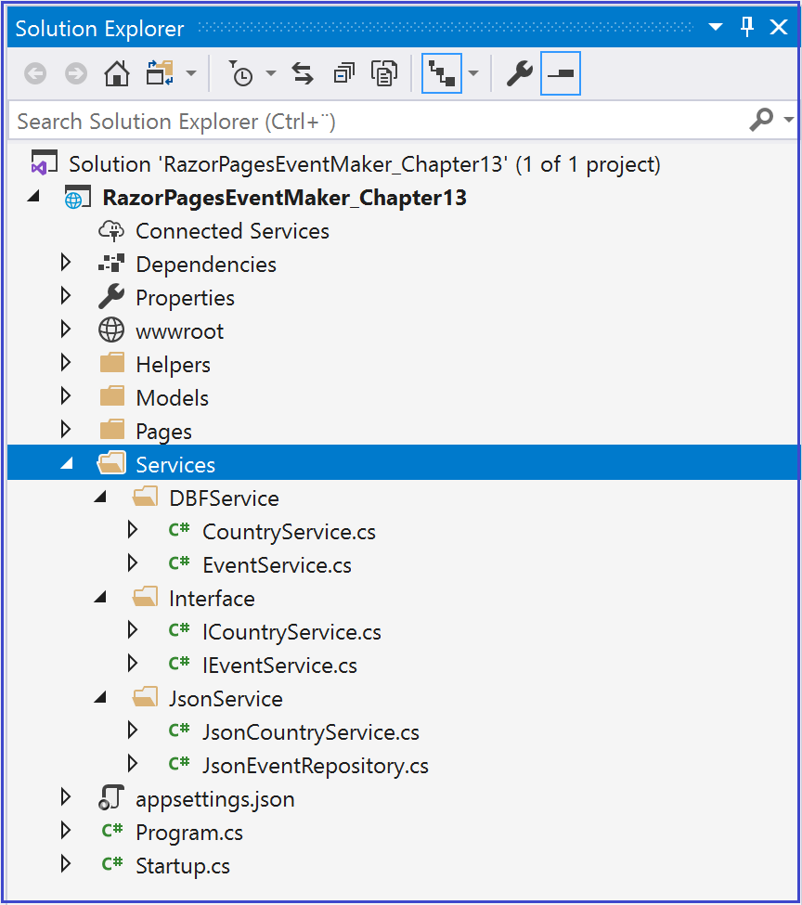

As you can see, we have two data access layer services that implement the same interfaces, the ***JsonService*** service that manipulates data in a json file (already implemented) and the ***DBFservice*** service that we are going to implement in a moment and that manipulates data in a relational database using EFCore . Once implemented, we can shift from one service to another without the Razor Pages App being aware of which one is used.

***Implementation of DBFirstService***

### ***Install the following NyGet packages* :**

* ***Microsoft.EntityFrameWorkCore.Tools***

*( usefull if you want to use the Package Manager Console)*

* ***Microsoft.EntityFrameWorkCore.SqlServer***

EF Core does not support visual designer for DB model and wizard to create the entity and context classes similar to EF 6. ***Fortunately***, there are other ways to do the job:

### ***Method 1***

### 

* ***Install EF Core Power Tool*** (<https://marketplace.visualstudio.com/items?itemName=ErikEJ.EFCorePowerTools>

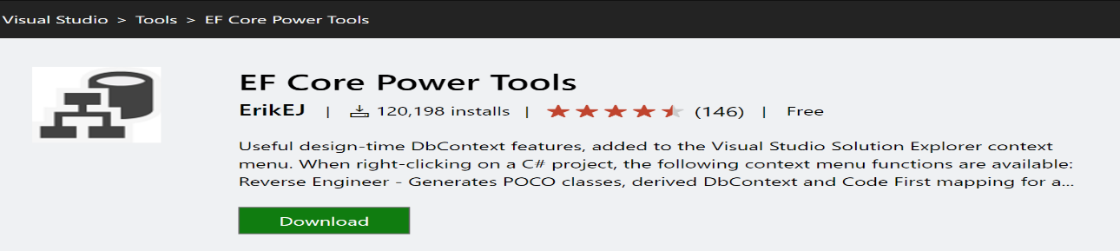

Now that that the EF Core Power tool is installed , we are going to create the model classes and the context class.

* ***Creation Model classes and DbContext***

Normally, you create the Razor Pages App from scratch where you do not have any model classes yet. Let us assume that we do not have model classes yet and let us use the EFCore to automatically create the model classes based on the existing database.

* Right-click on your project and select EF Core Power Tools Reverse Engineer as shown below.

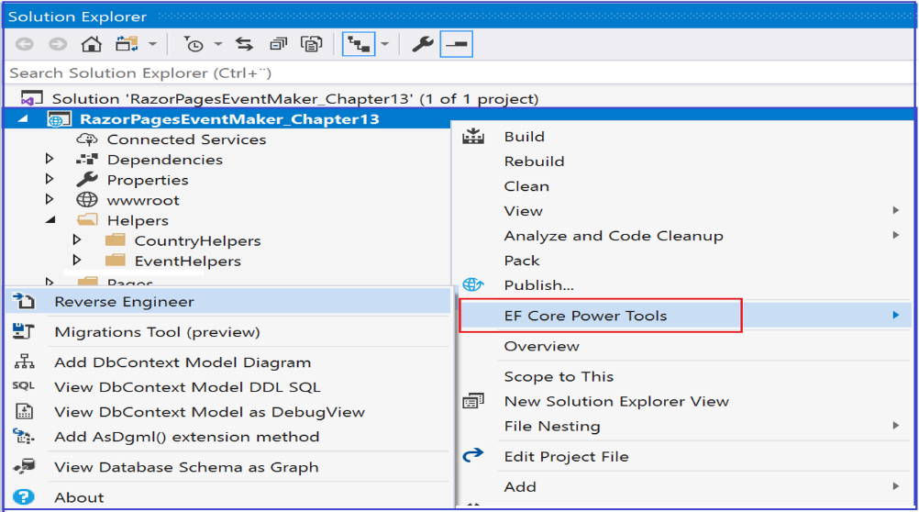

* Search for your SQL Server and the EventMakerDB database as shown below. Then ***Click OK***

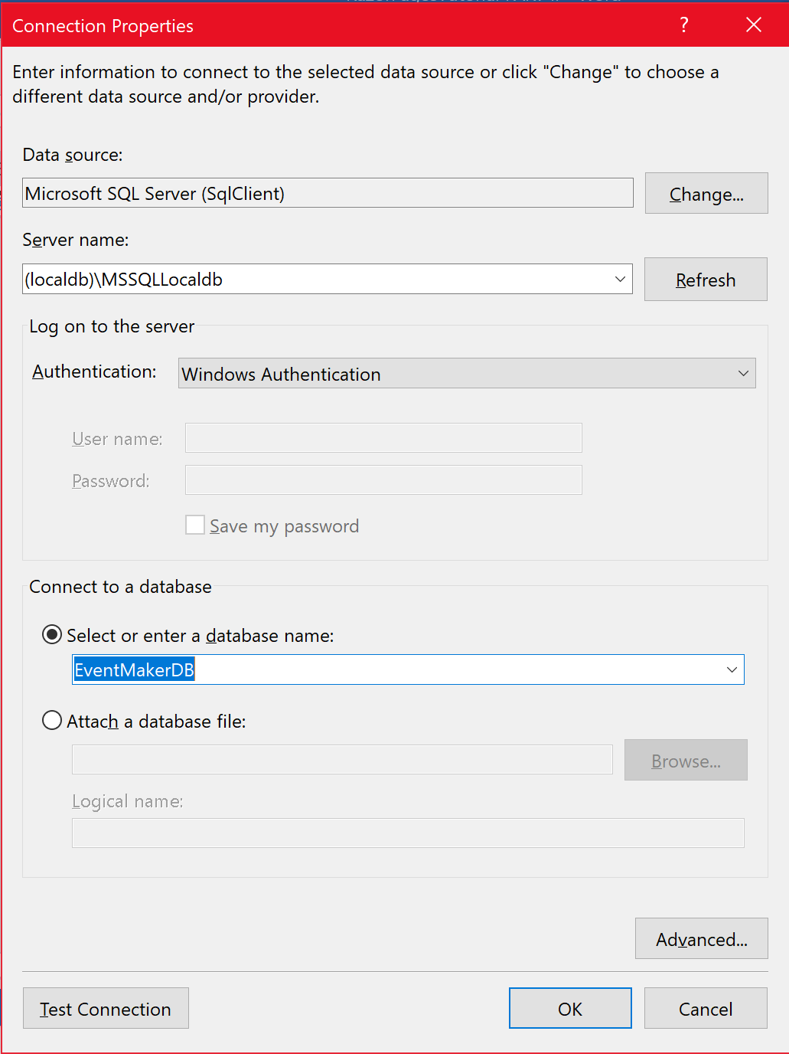

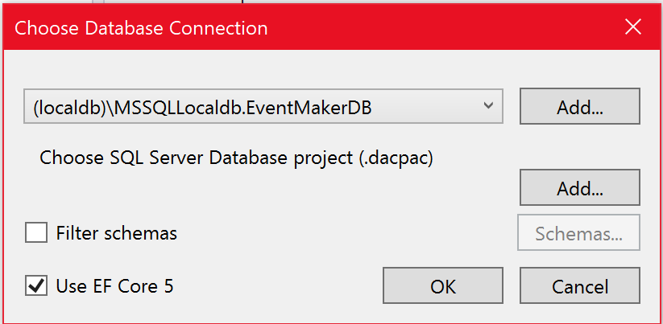

* Click on **OK**
* Select all the tables in the database as shown below and ***click OK***

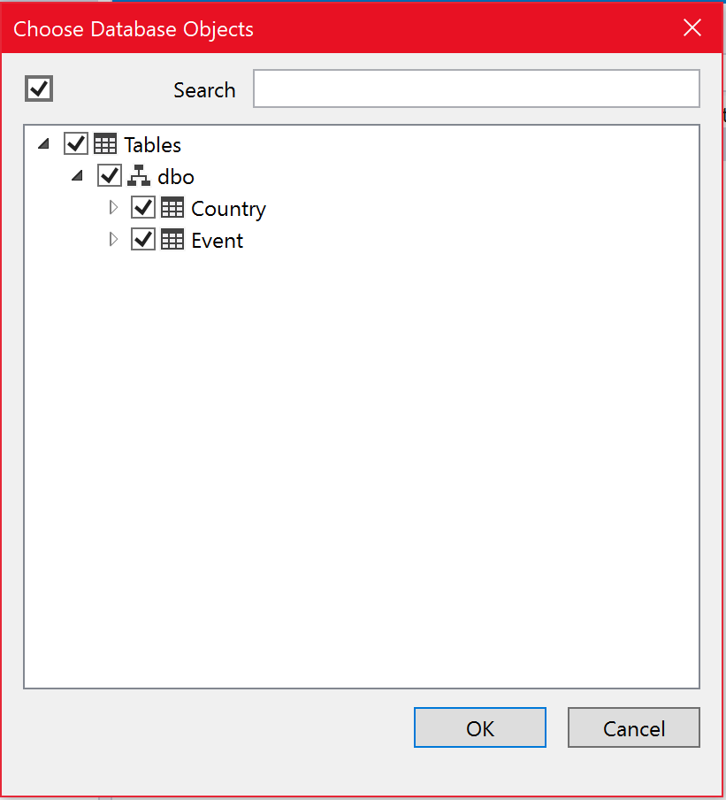

* In the Generate EF Core Model window, Select the options as shown below :
* ***Models****: is the folder where the DbContext class and the model classes will be created*
* *Pluralize or Singularize: to create the DbSet properties in plural form.*
* ***DataAnnotation****: it adds the validations imposed by the database on the generated model classes.*
* *Include* ***connection string*** *: will add the connection string to the DbContex class*.

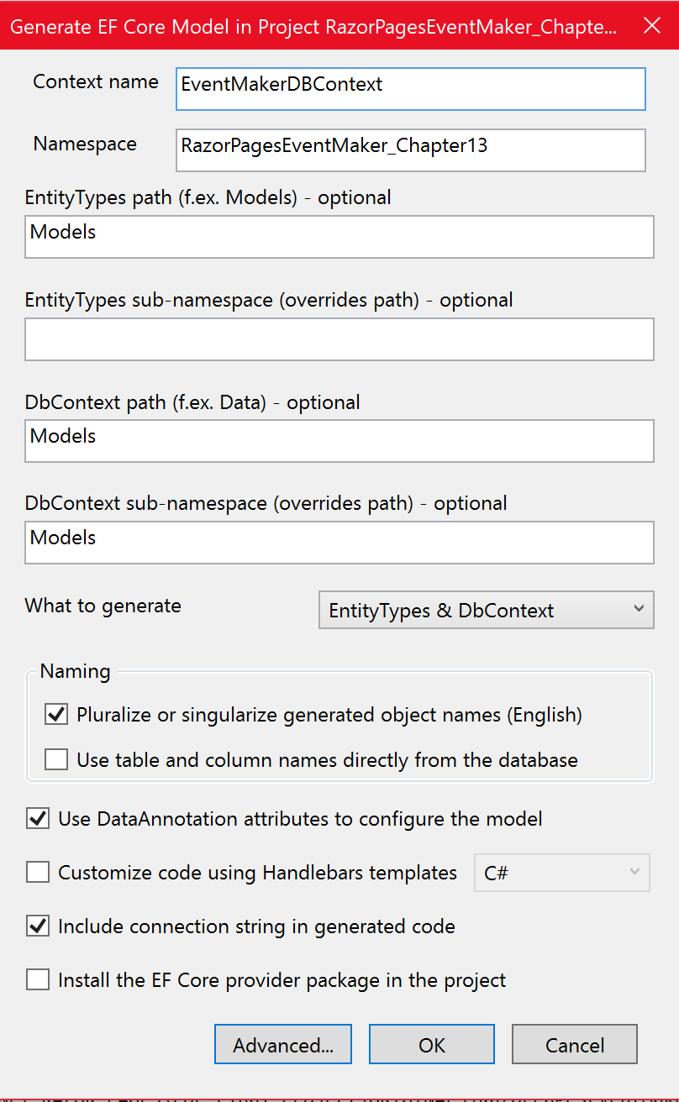

* Click on OK.

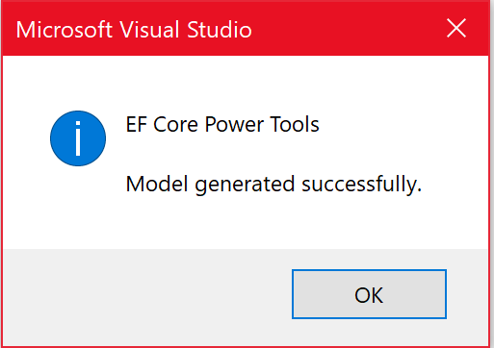

* Click on OK.

The model classes along with the DbContext class are generated. They are shown below.

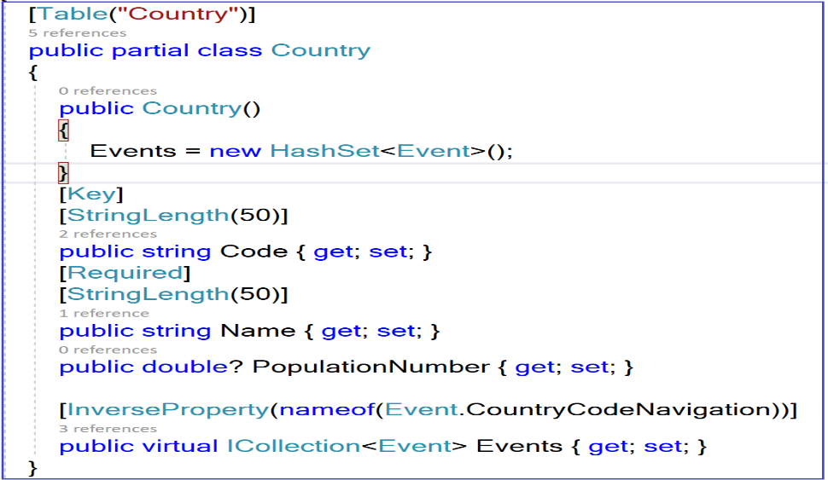

As you can see above, the country class that is generated by the EF engine is decorated by some attributes that reflect exactly the validations imposed by the database. For example:

* The [**Table(“Country”)]** indicates that this class is mapped to the table “Country”.
* [**KEY**] indicates that this property represents the primary key.
* [**StringLength(50**)] indicates that the length of the property is 50 characters max.

Notice also the presence of the ***question mark ?*** that indicates that the property is optional, that means it can be null (not defined).

Notice also the generation of what we call the navigation property: **ICollection<Event> Events{get;set;}**

The navigation property represents all the events associated with a country because of the One-to-many relationship between the Country and the Event objects.

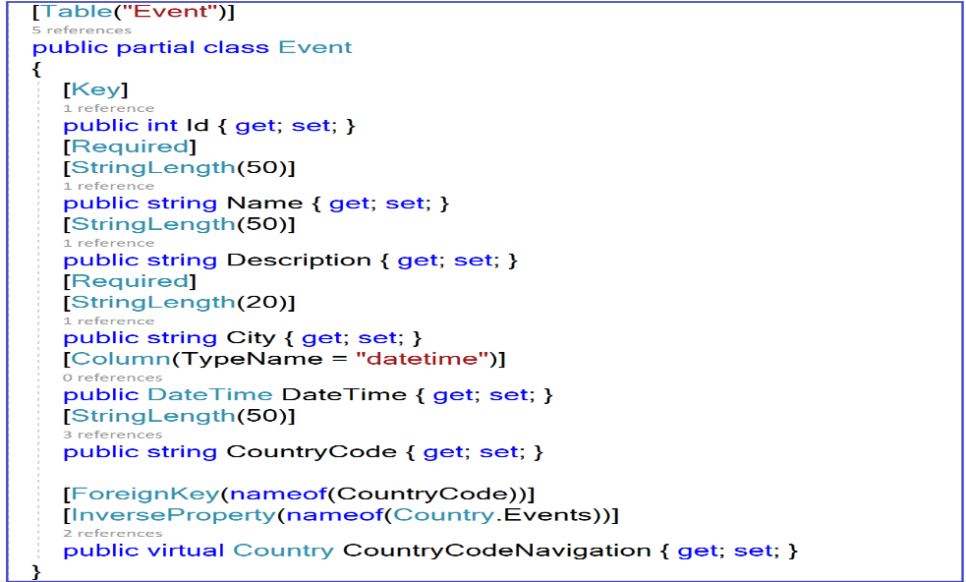

As you can see from the auto-generated Event entity, the attribute [**ForeignKey**(nameof(CountryCode))] indicates that the CountryCode property represents the foreign key. All the constraints imposed by the database are reflected on the model as validation rules using DataAnnotations.

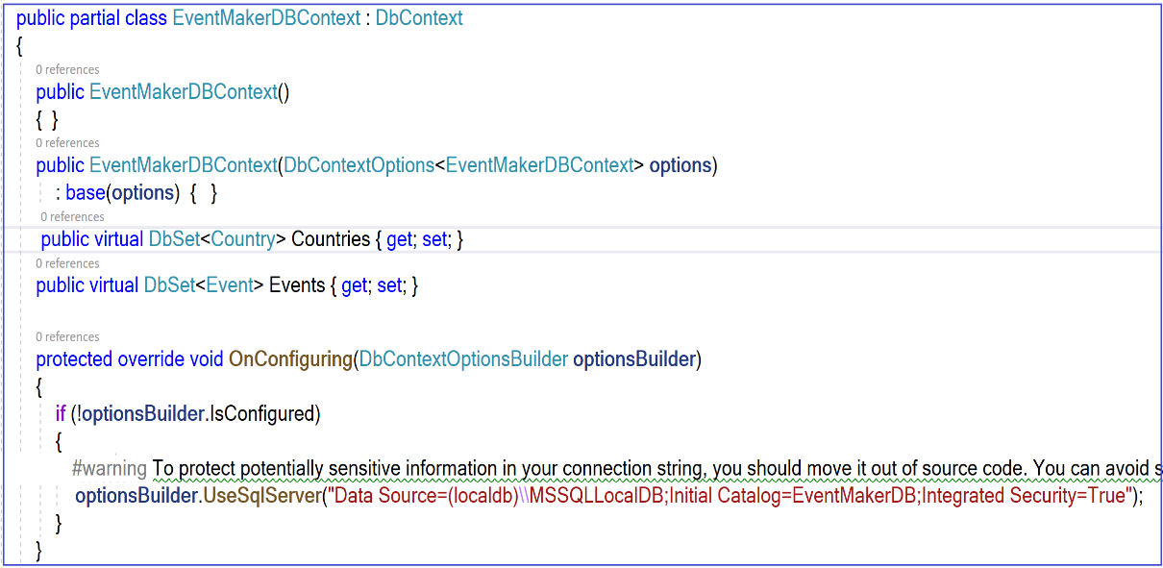

The Entity framework also generates the class above ***EventMakerDBContext*** that derives from [Microsoft.EntityFrameworkCore.DbContext](https://docs.microsoft.com/en-us/dotnet/api/microsoft.entityframeworkcore.dbcontext) class. We refer to the EventMakerDBContext as the context class. The context class is the main class that coordinates Entity Framework functionality for a given data model. In an EF-based application a context is responsible for tracking changes that are made to the entities after they have been loaded from the database. To persist the changes back to the database, we use the **SaveChanges**/**SaveChangesAsync** method on the context. As you can see, the EF Core creates the **Countries** and **Events** properties of type **DbSet<Country**> and **DbSet<Event**> respectively in a plural form. These properties represent the Country and the Event tables. **So how Razor Pages are going to interact with these representations of the database** ?. Fortunately, we have LINQ to Entities, a powerful query language that allows us query not only MS Sql server but many other data source such as collection, web services and many other databases. Let us dig into what is LINQ and introduce you to this query language by providing you with the necessary to understand the code we will go through. You may have gotten a deep understanding of LINQ in your software construction class.

***What is LINQ ?***

LINQ stands for Language-Integrated Query. LINQ is a powerful query language that we are going to use along with C# to query our SQL server database using Entity Framework Core.

***Why LINQ?***

Before C# 2.0, to traverse a collection to find a particular object, we had to use a 'foreach' or a 'for' loop. In the code of tutorial I, we had many examples where a foreach loop along with an if statement were used to find a specific item from the collection. As you will see, with LINQ, we reduce considerably the number of lines of code to do the same job. The figure below shows an example of code that finds a Customer object from a collection of Customers whose CustomerId is equal to id .

|  |  |
| --- | --- |
| ***Without LINQ*** | ***With LINQ*** |
| foreach (var country in Context.Countries)  {  if (country.Code == code)  return country;  } | return context.Countries.Find(code); |

As you can see, the use of for loop is cumbersome, not maintainable and not readable. With LINQ the code is more compact and readable. Another important feature of LINQ is that the same query can also be used to query different data sources.

In this tutorial we will work most with the ***Linq Method*** syntax.

**Inserting data**

The DbSet.Add and DbContext.Add methods add a new entity to a context (instance of DbContext) which will insert a new record in the database when you call the SaveChanges() method

**Deleting data**

Use the DbSet.Remove or DbContext.Remove methods to delete a record in the database table.

using (var context = new EventMakerDBContext())

{

var country= context.Coutries.First<Country>();

context.Countries.Remove(country);

**Updating data**

In the connected scenario, EF Core API keeps track of all the entities retrieved using a context. Therefore, when you edit entity data, EF automatically marks  EntityState to Modified , which results in an updated statement in the database when you call the SaveChanged() method.

using (var context = new EventMakerDBContext())

{

var country = context.Countries.First<Country>();

country.PopulationNumber= 24,5;

context.SaveChanges();

}

**Find()**

We use the Find() method of DbSet to search the entity based on the primary key value.

|  |
| --- |
| public Country GetCountry(string code)  {  return context.Countries.Find(code);  } |

**Where**

We use Where to filter a sequence of value based on a predicate

|  |
| --- |
| Public IEnumerable<Country> GetCountries(string name)  {  return context.Countries.Where(c => c.Name.StartsWith(name)).ToList();  } |

**Include**

The **include** method is really very powerful. Because the model class Country has the Events navigation property, you can return a country along with all its associated events in a single query.

|  |
| --- |
| Public Country GetEventsByCountryCode(string code)  {  Country Country = context.Countries  .**Include**(e => e.Events)  .**AsNoTracking**()  .FirstOrDefault(m => m.Code == code);  } |

In the above example, ***.Include(e=>e.Events)*** specifies the navigation property Events to be retrieved with the Country entity from the database in a single query.

The figure below illustrates the use of the Include method in the context of a Sale system where a customer can place many sales.

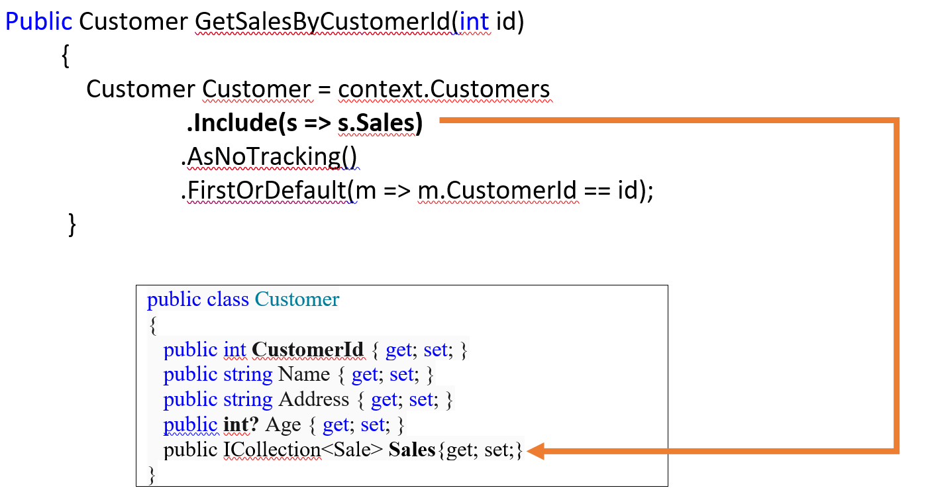

So having the Customer entity, it will be easy to get all the Sales made by this customer

**Important :** We can use the *Include()* method multiple times to load multiple navigation properties of the same entity. The code related to this chapter ( on GitHub ) shows clearly how to use the Include method.

**FromSql**

For those who want to use SQL, here is an example of using the ***Include*** method that shows how we can display a student along with all the grades associated with that student.

*Public Student GetStudent(string name)*

*{*

*var context = new SchoolContext();*

*var studentWithGrade = context.Students*

***.FromSql****("Select * from Students where Name ='name'")*

***.Include****(s => s.Grade)*

***.****FirstOrDefault();*

return *studentWithGrade;*

*}*

**Implementation**

## **User stories**

In this chapter, we will implement the same user stories as in chapter 1. This way, we keep the same interfaces for both the Json based data access layer and the EF data access layer:

* As an organizer, I will be able to create/delete a country
* As an organizer, I will be able to create an event for a specific country.
* As a traveler, I will be able to view all events /countries
* As traveler, I will be able to filter events based on the city.
* As a traveler, I will be able to view all events that take place in a specific country

## **Code**

In this part, I will show some parts of the code that deserve attention in the EventService.cs file and the CountryService.cs file.

**User story**: I will be able to add a new Event for a specific country.

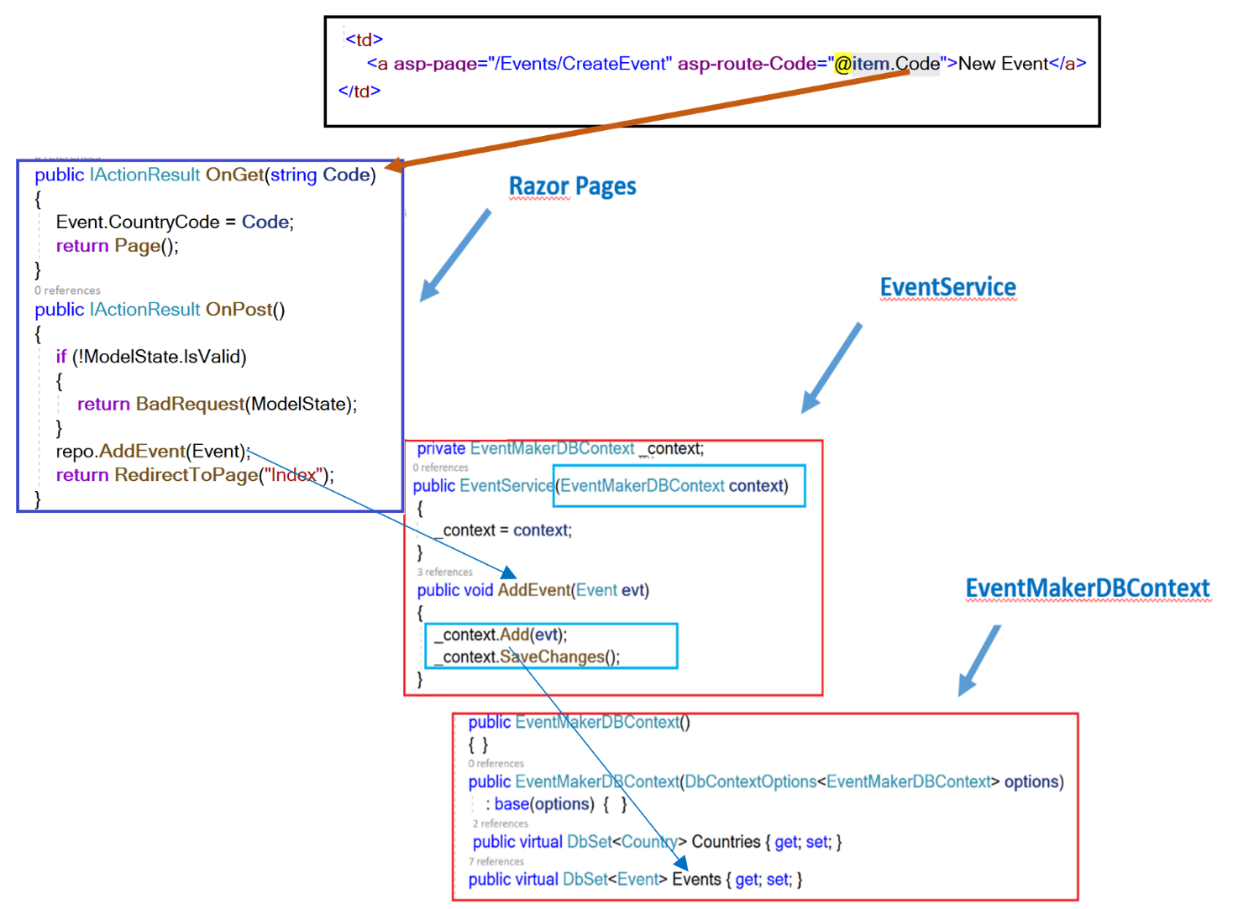

The most important part of the code that deserves attention in this code is how we pass the code of the selected country to the Create Event page. When displaying all countries, we select one. As shown above, its code is passed to the /Events/CreateEvent page through its URL( in the implemented code) when navigating to the page. The passed country code is collected as the OnGet parameter because it is the OnGet method is called when navigating to the page.

Notice also in the code above how we did inject the ***IEventService*** (implemented as EventService class) into our Razor Pages. The Razor Pages will be unware of which concrete implementation is used. In turn, the context service is injected into the EventService class and has been used to call the Add() method of the ***DbContext*** class ( Note that we can also use the Add method from the ***DBSet*** class ). Notice also the use of SaveChanges() method to persist the changes back to the database.

***User story***: Filter events based on the city

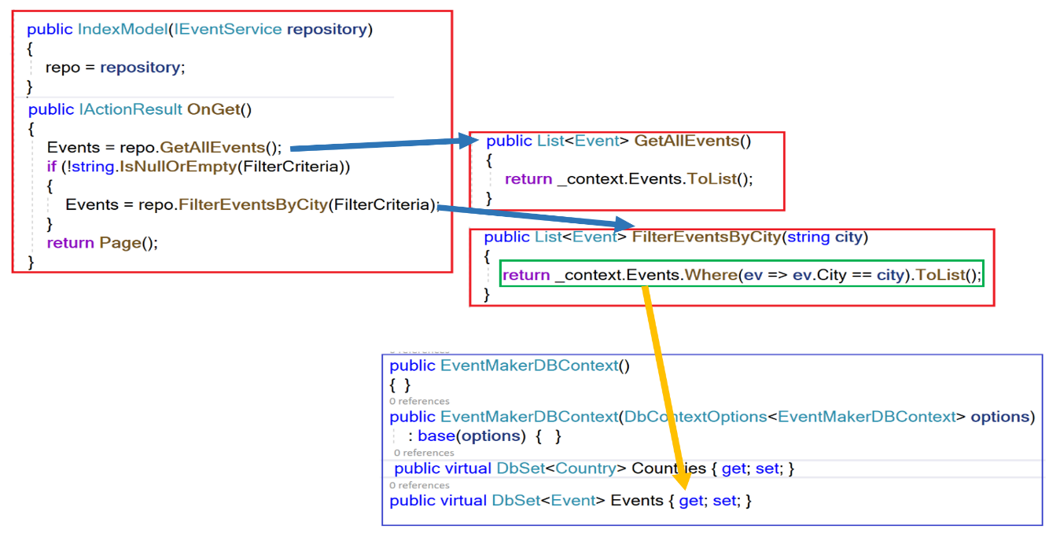

The most important of this code is how the number of code for filtering is considerably reduced using LINQ and Lambda expression.

**User story**: View all the events that take place in a specific country

As explained in the previous user story about creating a new event for a specific country , the selected country code is passed to the page that will display the events for this specific country.

The question is: should we create a new Razor Page that is dedicated for Events for a specific country (and name it ***Country_Events*** for example)? We can do that, but is it not the same for displaying All Events Page? Yes it is, so why to reinvent the wheel? The only problem is that we already have an OnGet method (with no parameter) for displaying all Events. So how to pass the code ? The answer is that we should have another OnGet method with the Code as a parameter. This is shown in the figure below.

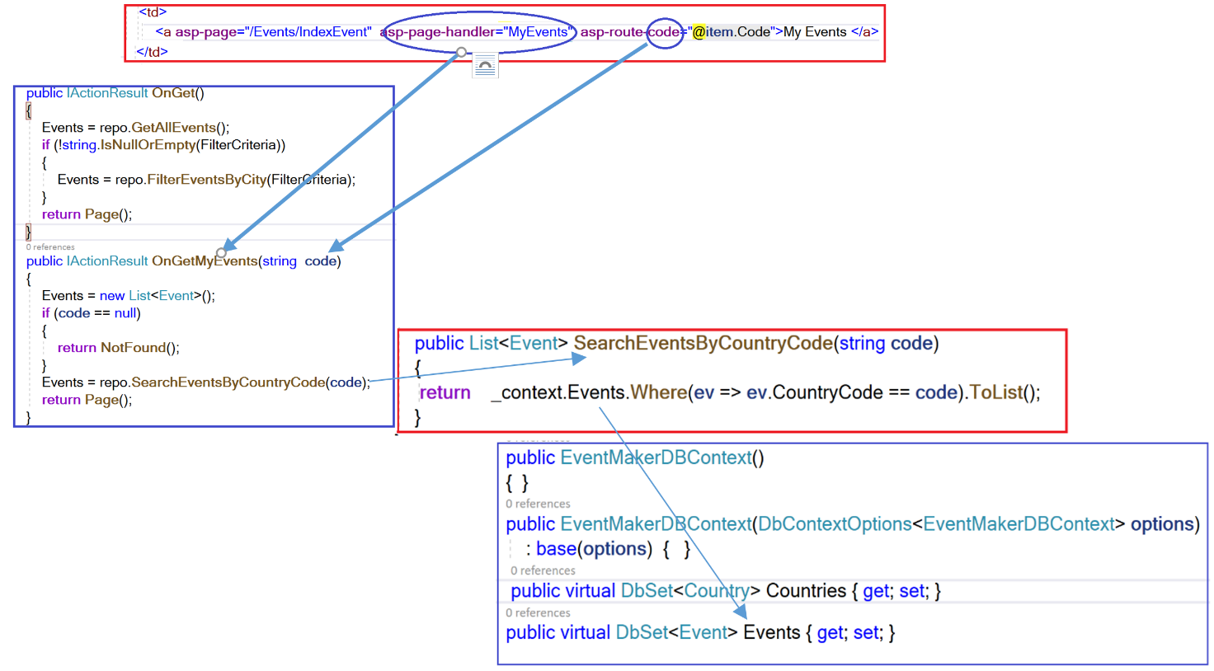

The other parts of the code is very similar to we have seen before.

But before performing the sprint review and show a demo, let me show you how the Razor Pages will be unware of which data access layer is used when for example we create a new country.

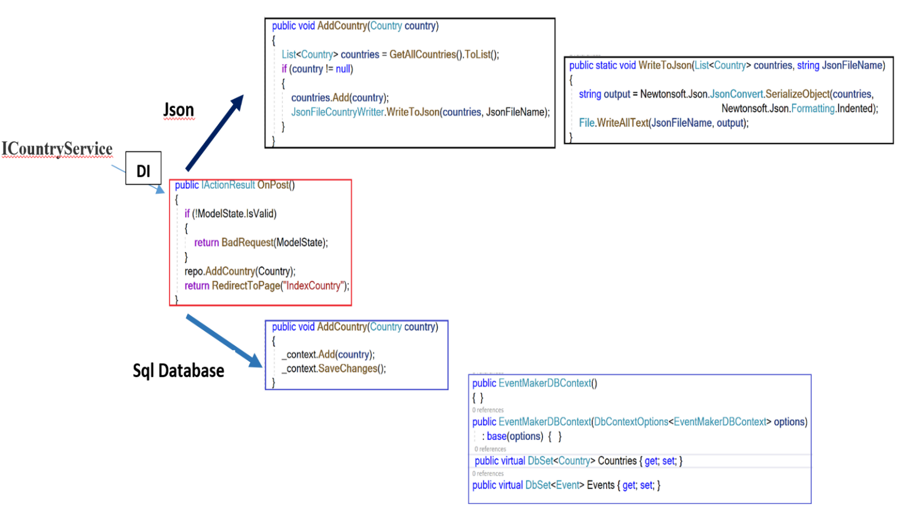

As we are injecting the **ICountryService** into the Razor pages using dependency injection, we are completely abstracting the data access layer. We can switch from one to another without the Razor pages being aware of that. Doing so, we achieve loose coupling between the Frond-end and the back-end of the application.

Before performing the sprint review , we first need to configure the different services in the Startup.cs file. The figure below shows these configurations.

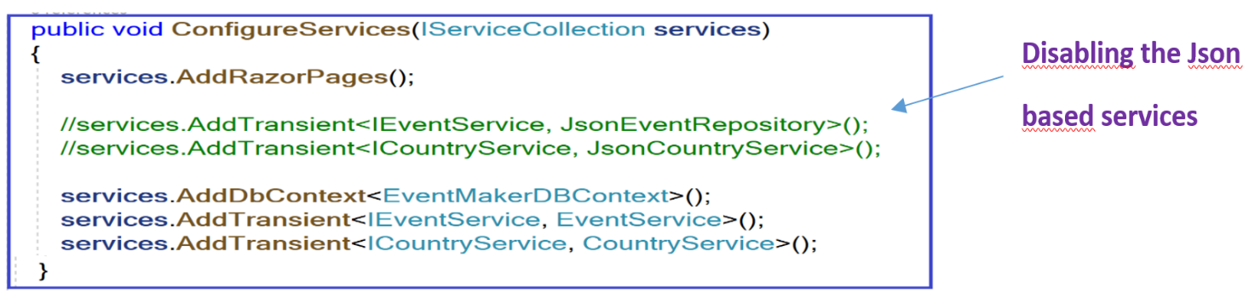

As you can see, I disabled the services that handle data from a json file and I am showing a demo using the service that handle data from the Sql database. Notice how I register the context class using the AddDbContext() method.

**Sprint Review**

Let us run the application.

**User story**: I will be able to create a country

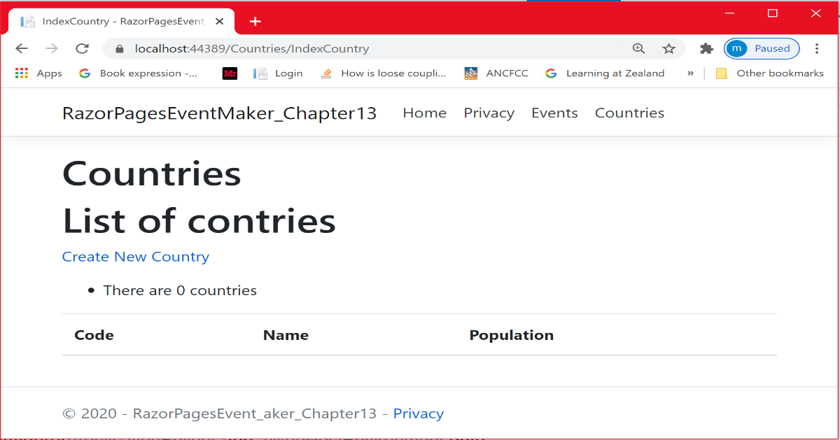

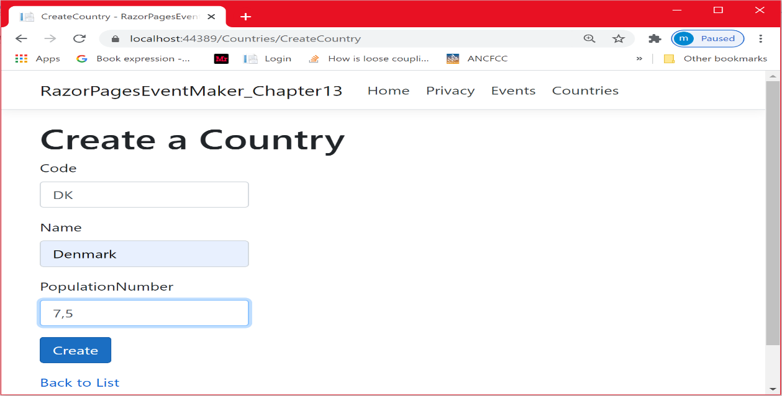

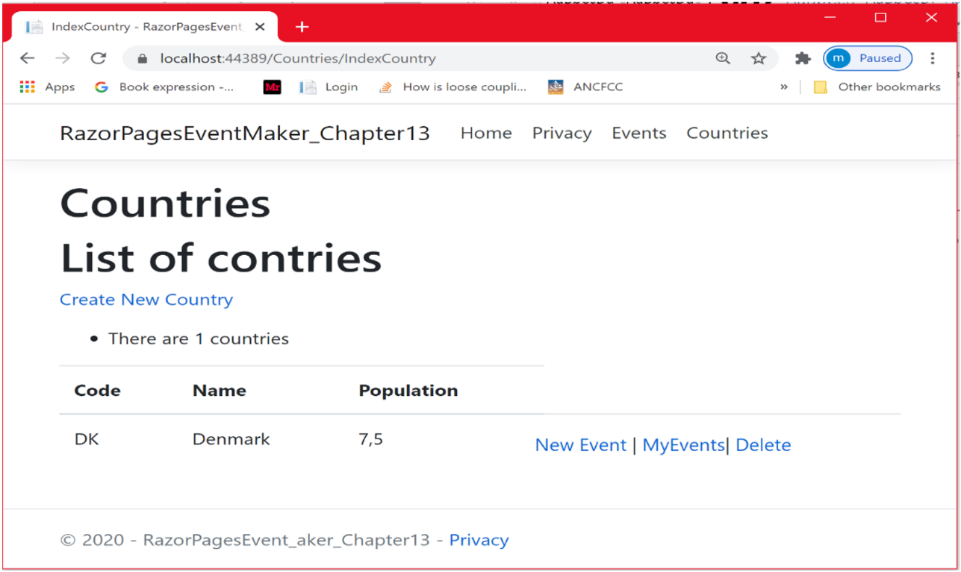

Let us have a look at the database. As you can see, the new created one is stored in the database

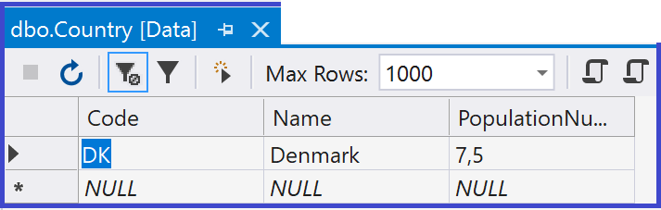

I created two more countries

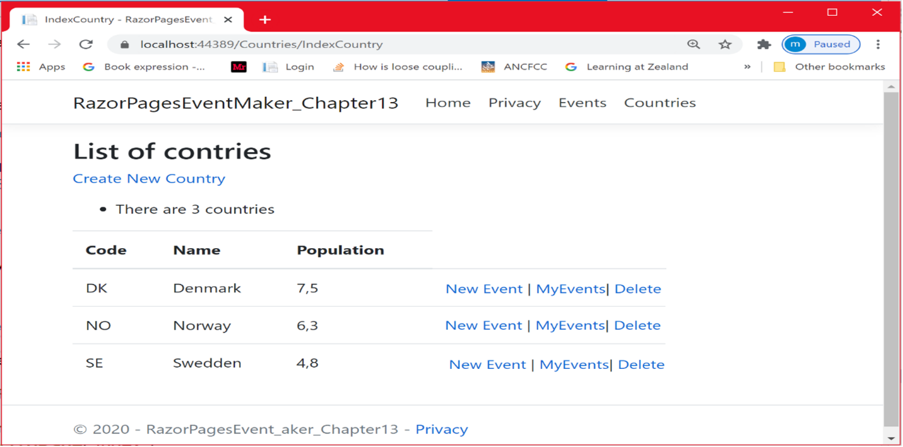

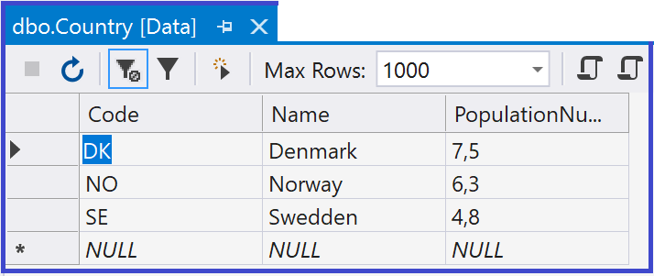

Let us create some new events in Denmark.

Having the list of all countries, click on the “***New Event***” link as shown below

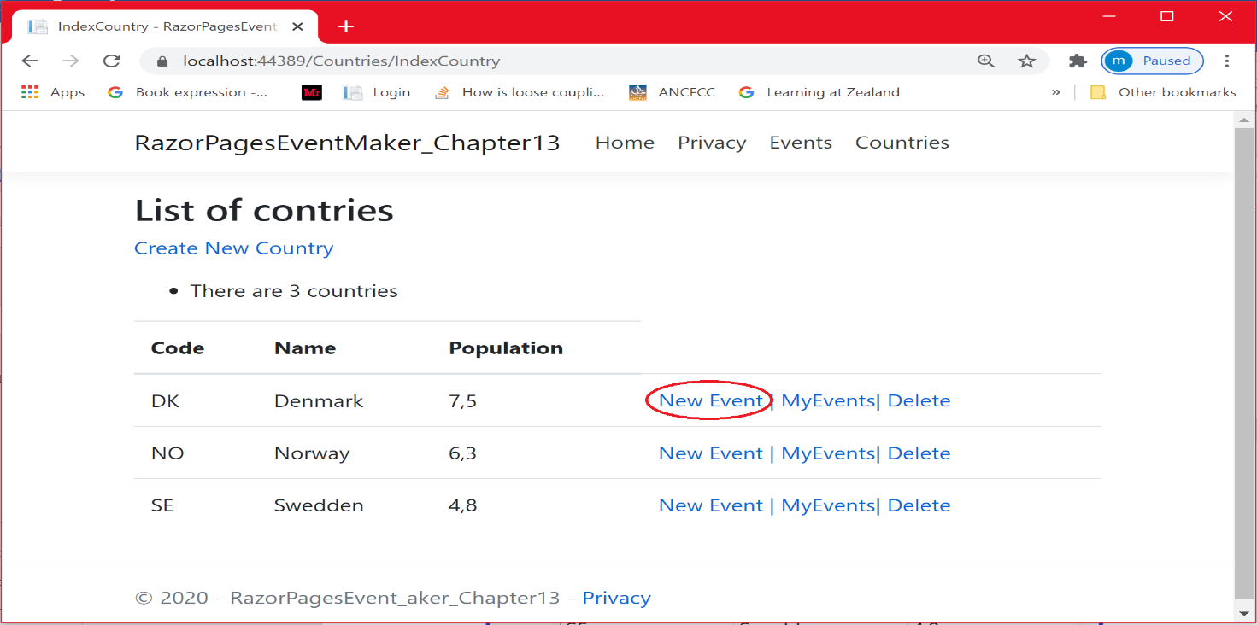

As you can see in the figure below, the country code of the selected country is passed to the ***CreateEvent*** page through the URL ( not recommended to pass sensitive data) .

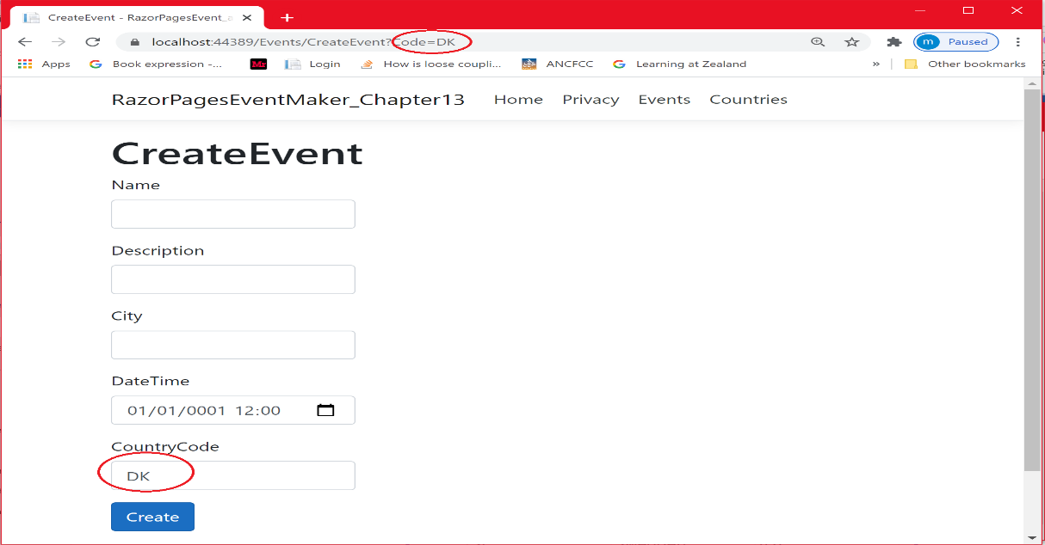

.

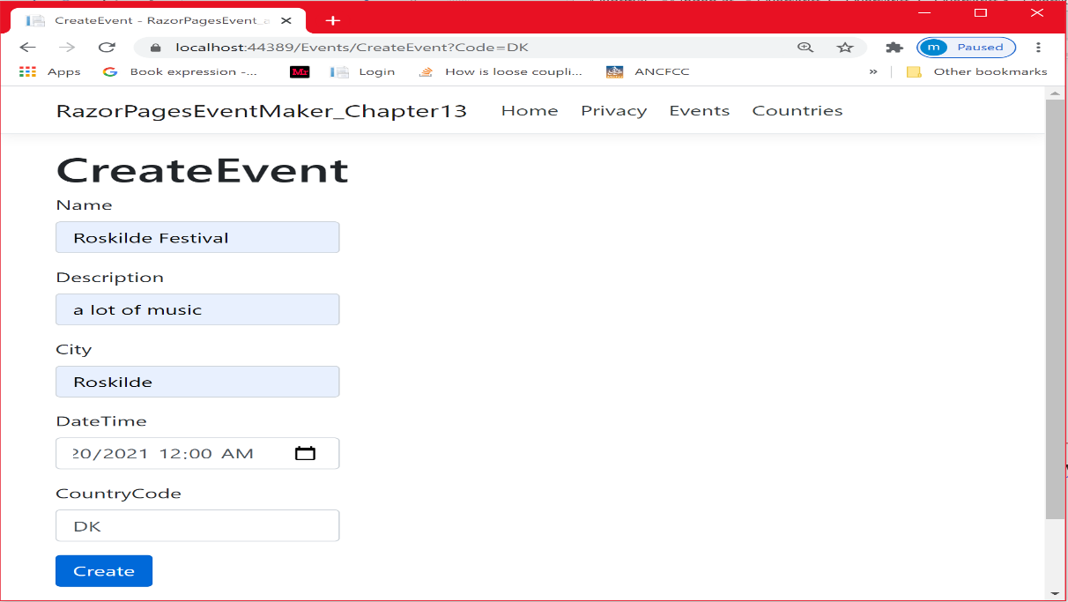

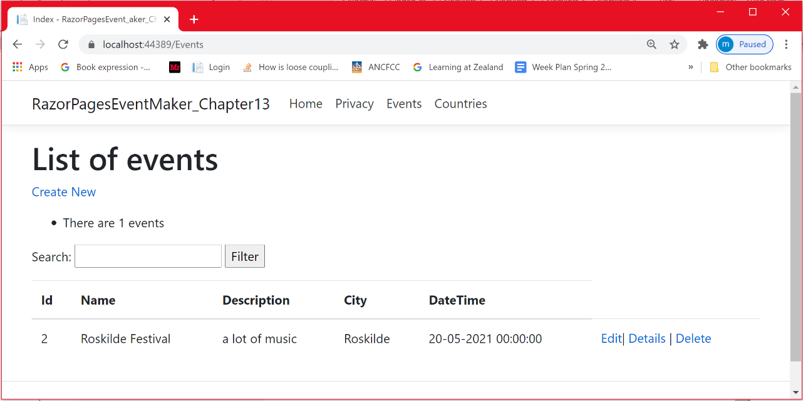

The new event is created.

Let us have a look at the database

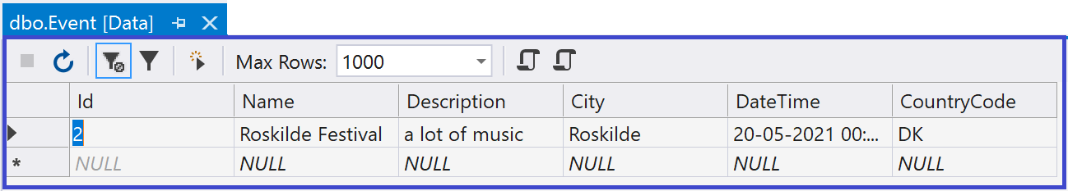

Let us add one more events in Denmark (Copenhagen) and one in Sweden(Malmø) and no one in Norway.

**User story**: View all events

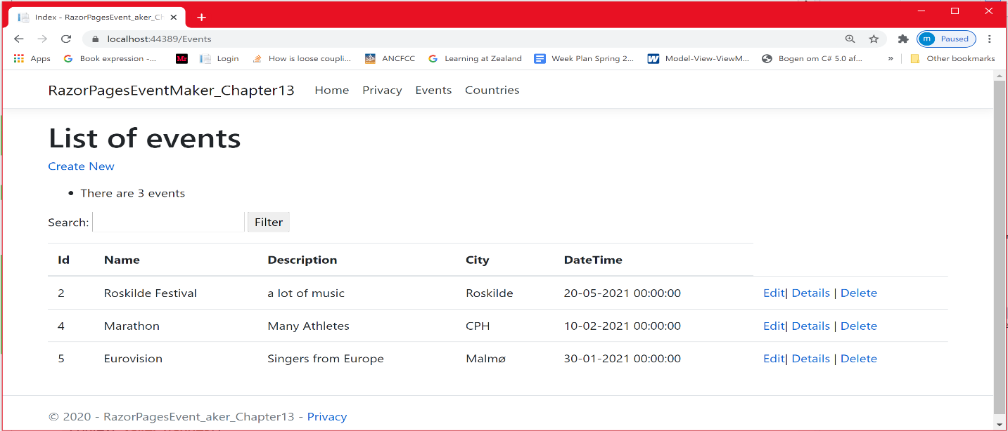

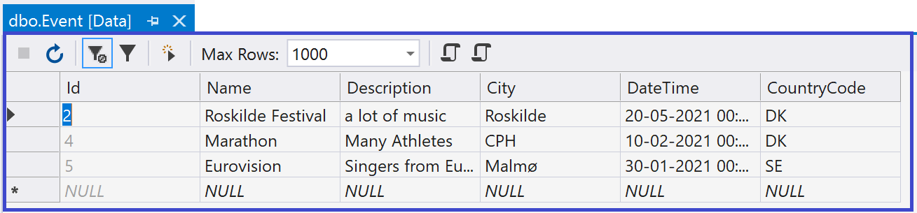

User story: Filter events based on the city

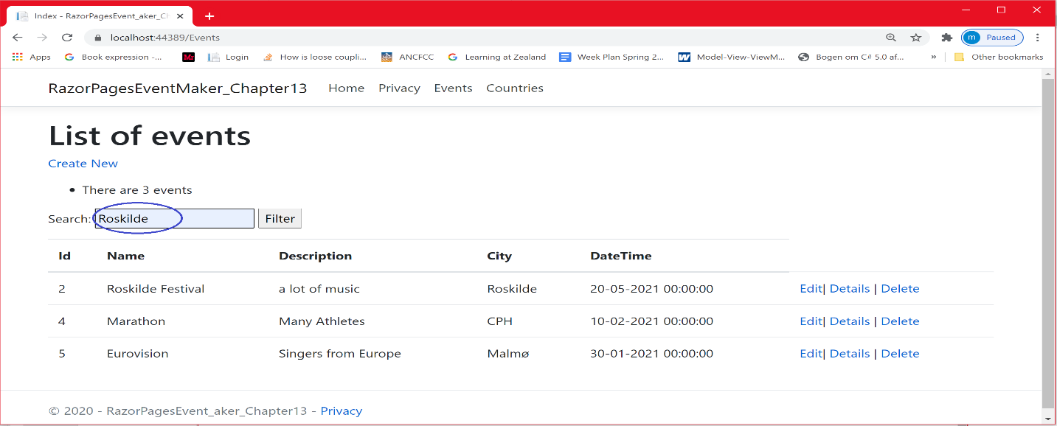

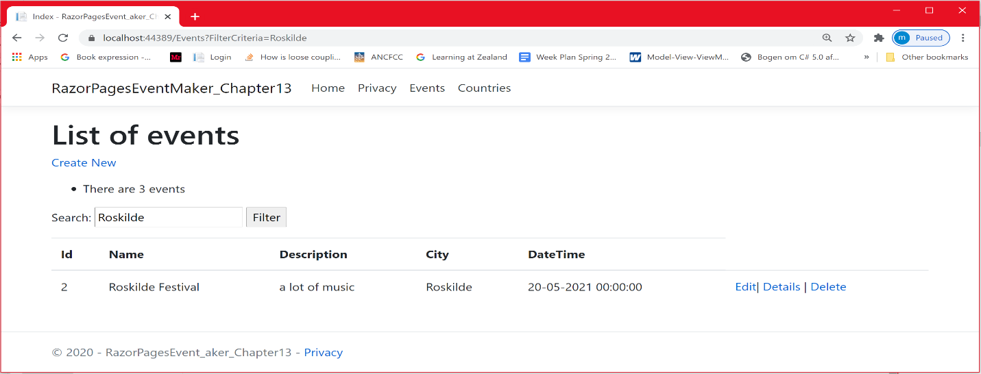

**User story**: View events in a specific country (Denmark)

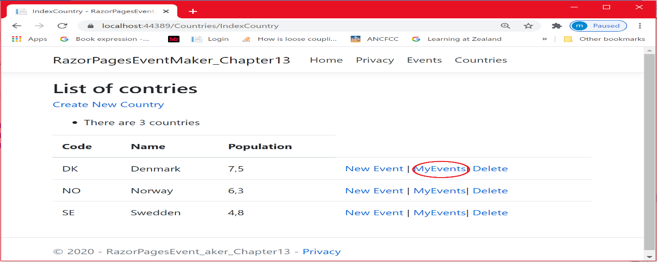

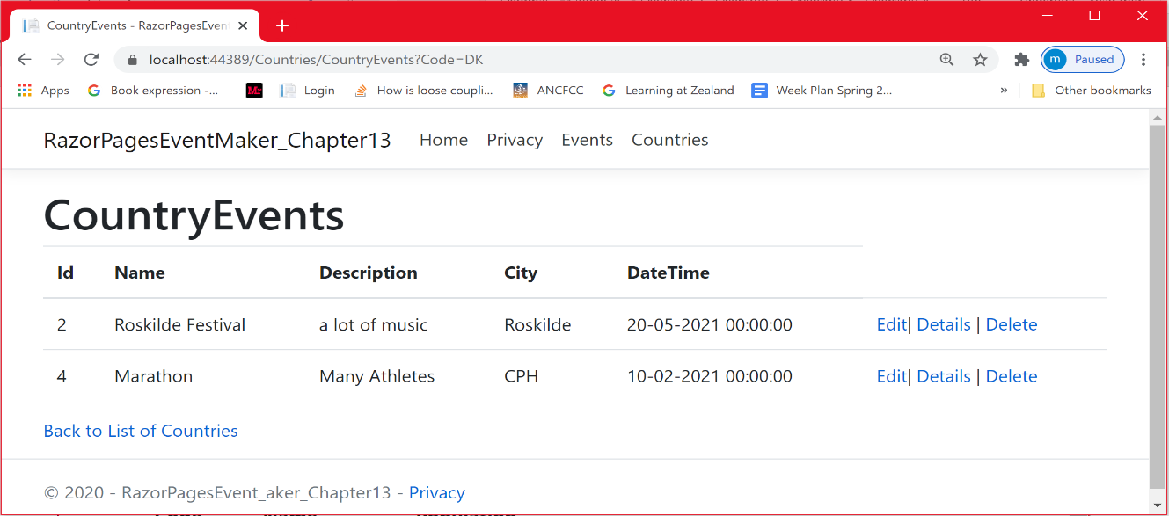

Let us try to switch to the Json data access layer. This can be done in the Startup.cs file as shown below. We did disable the EF services and we enabled the Json based services. As you can see, this time the data is from the json file.

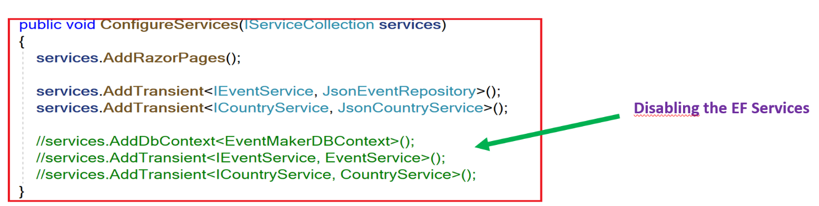

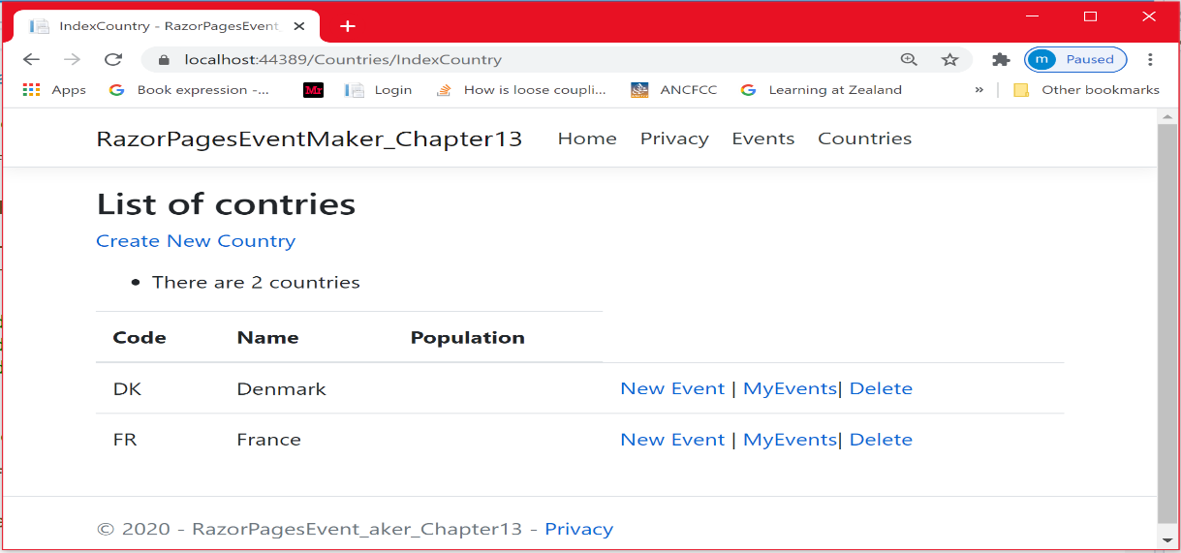

Let us have a look at the json file

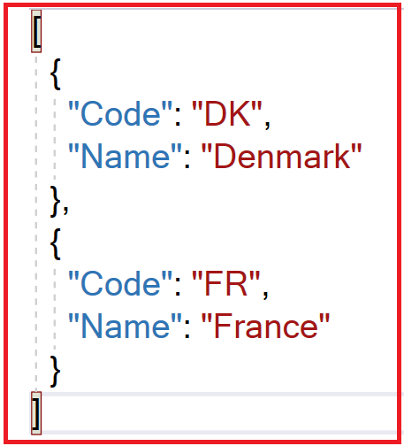

Now I am going to show you another alternative to using the ***EF Core Power Tool*** . I am going to show you how to perform the DbContext scaffolding using the ***Scaffold-DbContext*** command of the EF Core Package Manager Console (PMC) tools. This reverse engineering command creates entity and context classes exactly the same way we did with the EF Core power tool.

You need to install the following package:

**Microsoft.EntityFrameworkCore.Tools**

***Microsoft.EntityFrameworkCore.SqlServer*** (if you do not have it)

Using this package, you will be able to **create** migrations**, apply** migrations, and **generate code** for a model based on an existing database. Let us look at how we can use the tool. For a simple demo of the use of the DbContext scaffolding, I created an empty Razor Pages App. In this project, I will use the **Package Manager Console to apply the following command that will generate the code for the model entities and the context class. Do not forget to install the required packages.**

Scaffold-DbContext "Data Source=(localdb)\MSSQLLocalDB;Initial

Catalog=EventMakerDB;Integrated Security=True;

Connect Timeout=30;Encrypt=False;"

Microsoft.EntityFrameworkCore.SqlServer

**-OutputDir** Models

**-ContextDir** Models

-**Context** EventMakerDBContext

**-DataAnnotations**

Before applying the scaffolding, let us compare this command to what we did using the *EF Core Power Tool.*

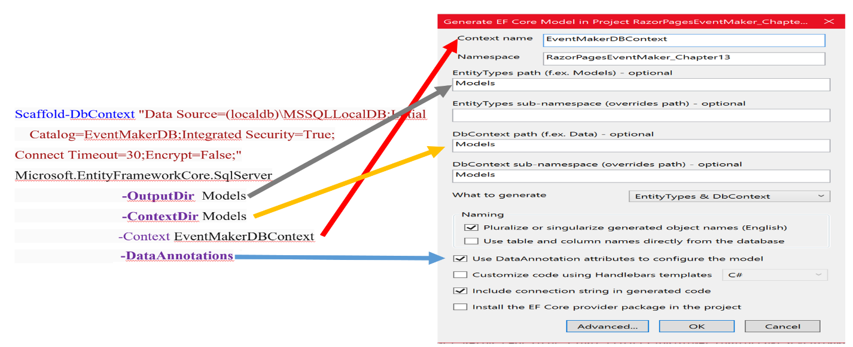

As you can see, the process of generating model classes and the context class is the same.

Now, let us apply the scaffolding-DbContext command:

* Go to **Tools –> NuGet Package Manager –> Package Manager Console**
* ***Use the Scaffold-DbContext command as follows:***

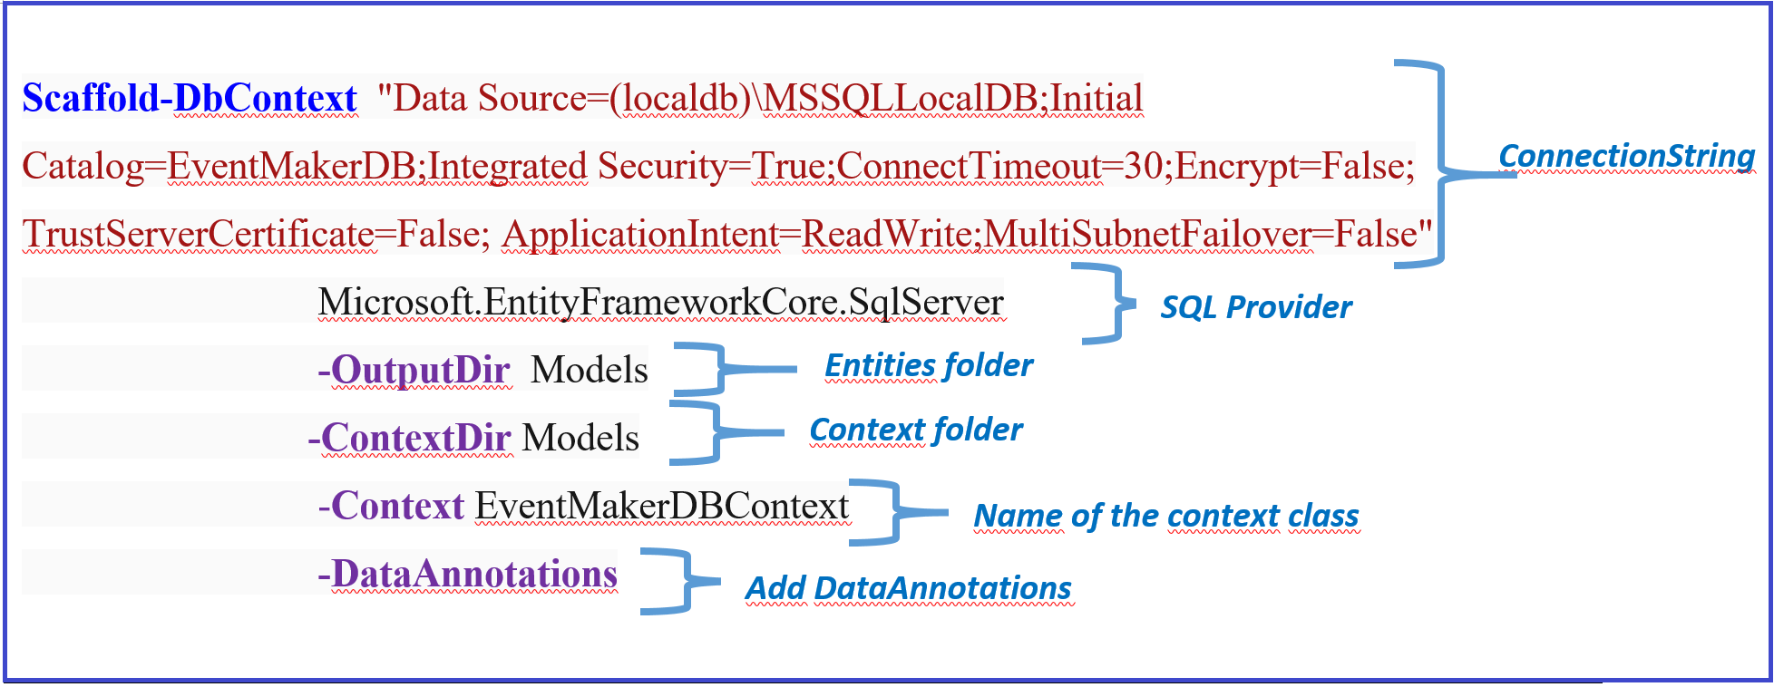

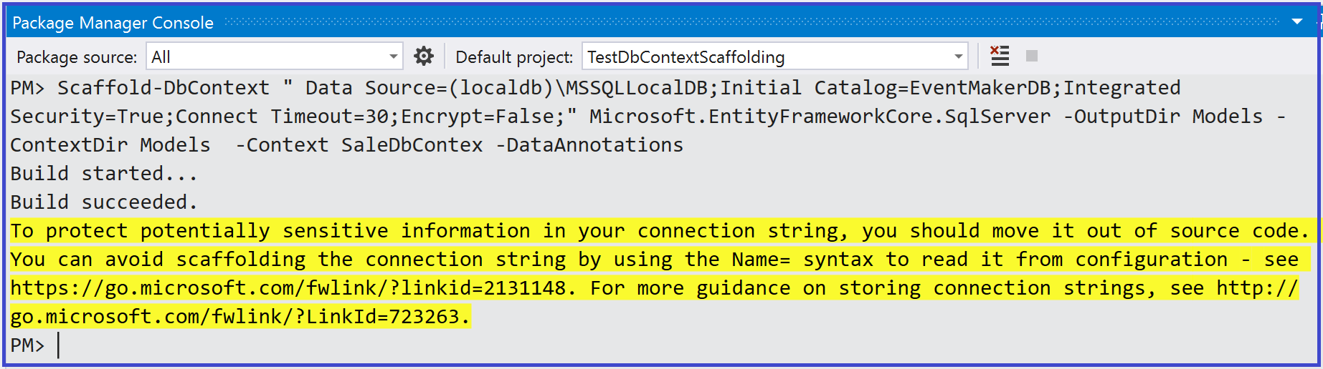

The figures below show the auto-generated entity classes and the context class. The auto generated classes are exactly the same. However, I recommend you to use the first option because the second one is prone of errors when typing the command.

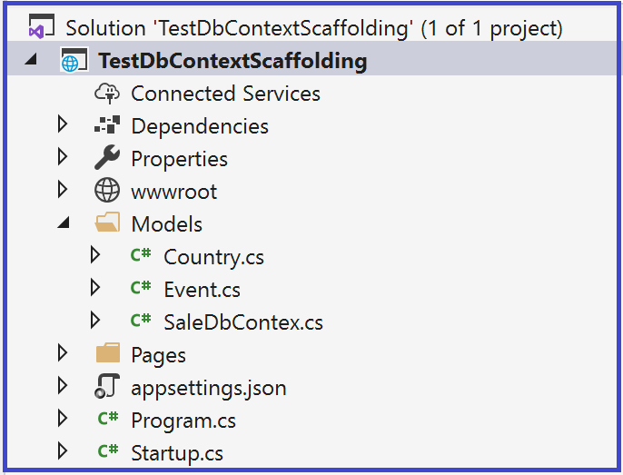

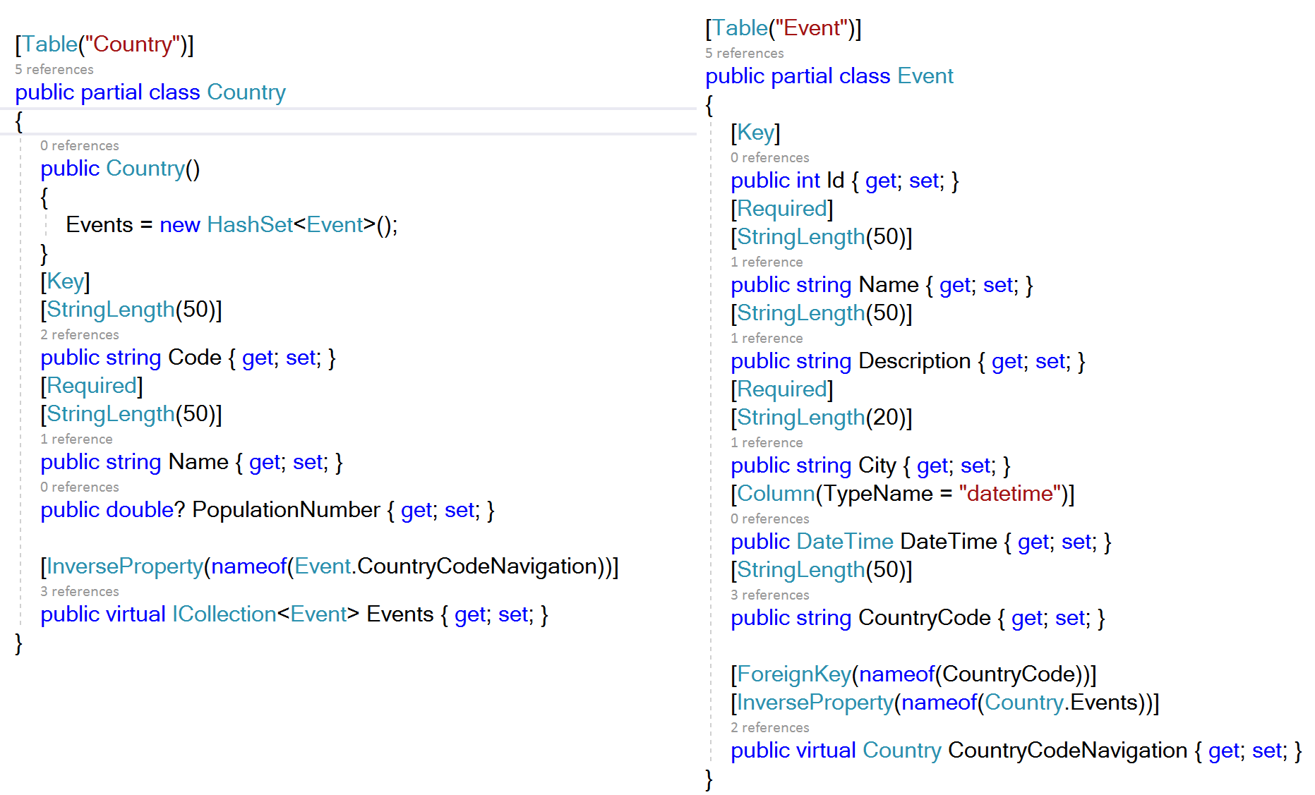

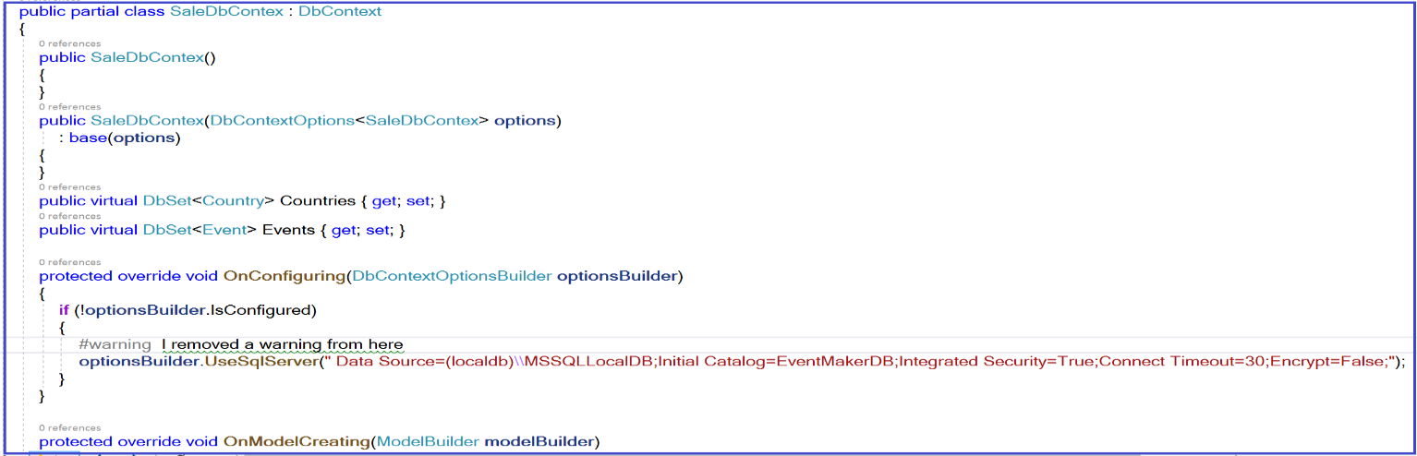

***Conclusion***

In this chapter, you did learn how to apply the EF Database-First approach to implement a data access layer using both the EF Core power tool and the scaffolding approaches. You could generate the entity classes and the context class based on the existing database. Once these classes are in place, the Front-end application used LINQ to query the data source. Using Dependency Injection, we did inject the **IEventService** and the **ICountryService** into the pages, which made these pages loose coupled to the back-end.

Notice that we did not make our methods asynchronous neither generics. In the next chapter, we are going to look at the EF Model-First approach and then we are going to make our code as much generic as we can and implement the asynchronous behavior.

**Chapter 3: Entity Framework- Code First**

In this chapter, we are going to cover the use of the Code-first approach.

### **What is Code-First?**

In the Code-First approach, you focus on the domain of your application and start creating classes for your domain entity rather than design your database. As you can see from the illustration below, EF API will create the database based on your domain classes and configuration.

[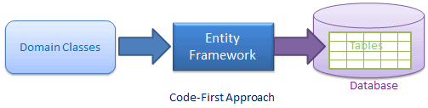](https://www.entityframeworktutorial.net/images/EF5/code-first.png)

In other words, you do not have an existing database when you start developing the application and a database schema is created based on the model. In this chapter, we are going to implement a simple sale management system where a shop-keeper can manage customers while a customer can place/view her/his sales. The model is shown below.

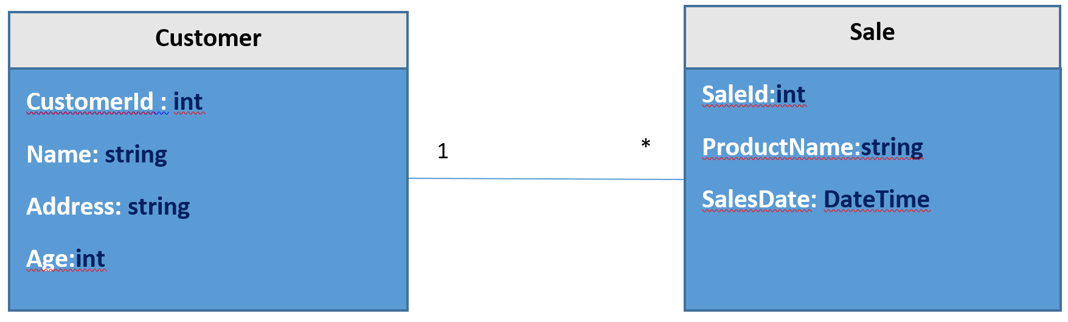

Before digging into implementing the Entity Framework Core based data access layer, it is very important to understand, that the database schema that will be created, is based on how you define your domain entities and the context classes. So, there may be some rules or conventions on how to represent your model entities that can help EF Core engine to map these entities to the database tables.

To make things clearer, let us consider the model shown above. It is about a one to many relationships. One customer can place one or more sales, while a sale should be placed by a single customer. There are many approaches to represent this one-to-many relationship. In this chapter, we will adopt the so called the **convention** approach.

***Convention Approach***

***What we mean by conventions?*** Conventions are default rules that **Entity Framework core API** rely on to create a database schema based on domain and context classes without any additional configurations. This is because the domain classes were following some predefined conventions. In this section, I am going to show you one way to define **One to Many** relationship. It is illustrated in the model classes shown below.

|  |  |
| --- | --- |
| public class Customer  {  public int CustomerId { get; set; }  [**Required]**  **[StringLength(20)]**  public string Name { get; set; }    **[Required]**  **[StringLength(50)]**  public string Address { get; set; }    public int? Age { get; set; }  **public ICollection<Sale> Sales { get; set; }**  } | public class Sale  {  public int SaleId { get; set; }  **[Required]**  **[StringLength(20)]**  public string ProductName { get; set; }    [**Required]**  public DateTime SalesDate { get; set; }  **[Required]**  public int CustomerId { get; set; }  **public Customer Customer { get; set; }**  } |

Notice the validations that are applied to the properties using DataAnnotations. These validations are going to be reflected in the created database.

**How will EF Core treat this model?**

***Customer Class: The principal entity***

The CustomerId property becomes the primary key column of the database table that corresponds to this class. By default, EF Core will interpret a property that's named  **ID** or **classnameID** as the primary key. So the Customer class primary key is CustomerId. The Sales property in the Customer class is a [navigation property](https://docs.microsoft.com/en-us/ef/core/modeling/relationships). Navigation properties hold other entities that are related to this entity. In this case, the Sales property of a Customer entity holds all of the Sale entities that are placed by that Customer. This navigation property is not required, but it makes the query very easy using the LINQ Include extension method. Indeed, once we have the customer, it will be easy to find all his/her sales. Notice also the question mark after the Age type declaration. It indicates that the Age property is [nullable](https://docs.microsoft.com/en-us/dotnet/csharp/programming-guide/nullable-types/). An Age that's null is different from a zero age—null means that the age is not known or has not been assigned yet.

**The Sale class: The dependent entity**

CustomerId property in the Sale entity is going to be a foreign key in the table that corresponds to the Sale entity, and the corresponding navigation property is the **Customer** property. As a Sale is associated with one single Customer, the Customer property in the Sale entity is of type Customer (corresponds to a single Customer entity).

**DbContext**

Another part that is vital when using EF Core Code-First is the DbContext class also called the context class. As mentioned in the chapter 2, the context is the main class that coordinates Entity Framework functionality for a given data model. In an EF-based application a context is responsible for tracking changes that are made to the entities after they have been loaded from the database. To persist the changes back to the database, you can use the **SaveChanges** method on the context. You may be familiar with the structure of the context class from chapter 2. This class derives from the DbContext class.

***Let us create the DbContext class***

## **EF: Add NuGet Packages**

Entity Framework Core is no longer included with .NET Core by default so to get started, you have to install the following NuGet packages.

**Microsoft.EntityFrameworkCore**

**Microsoft.EntityFramewrokCore.sqlServer (**to specify our data provider )

**Microsoft.EntityFramewrokCore.Tools (** to be able to use migration)

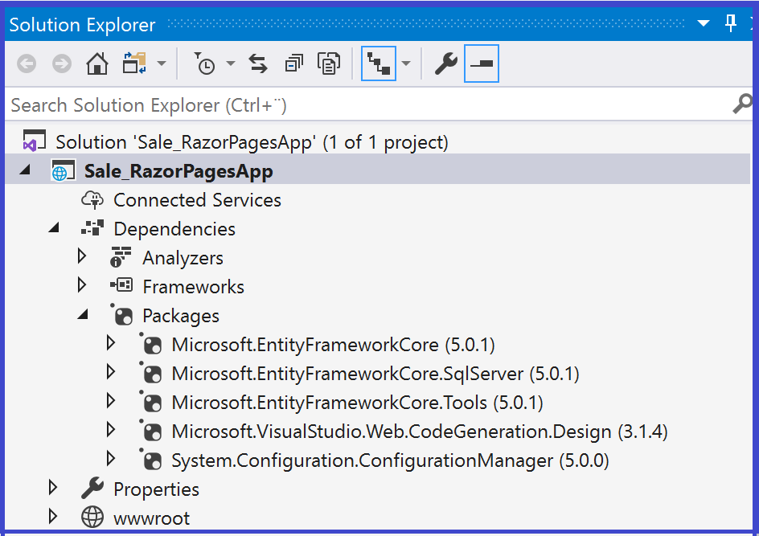

## **Domain classes and DbContext class**

Add a new folder called Models and inside this folder create the following classes:

* 1. The domain class **Customer** shown above
  2. The domain class **Sale** shown above
  3. **The SaleDbContext** class shown below

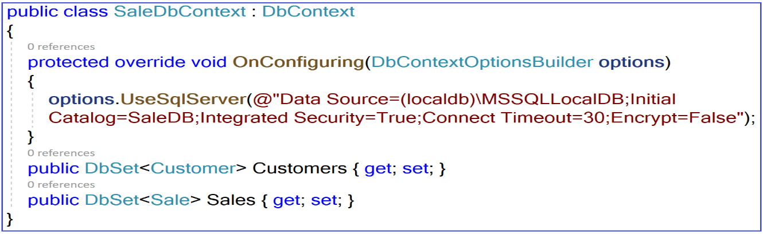

EF Core will create database tables for the ***DbSet<Customer>*** **Customers** and ***DbSet<Sale>*** **Events**   properties of type DbSet (a kind of collection). The tables will have the same name as the property names. It will also create tables for entities which are not included as DbSet properties but are reachable *through reference properties* in other DbSet entities. What I mean by this is:

***Important***: As the **Customer** entity has **Sales** as a navigation property, a table for Sales is created even though the SaleDbContext class does not include the **DbSet**<**Sale**> Sales property ( you could try it).

**Note** how I include the connectionString by overriding the OnConfiguring () method. In this case , there is no need to specify the connection string when configuring the Context service in the Startup.cs file. The registration of the context class service is very simple:

|  |
| --- |
| services.AddDbContext<**SaleDbContext**>(); |

**Another alternative.**

An alternative way to do things is to not override the OnConfiguring ()method. The DbContext class is simpler as shown below.

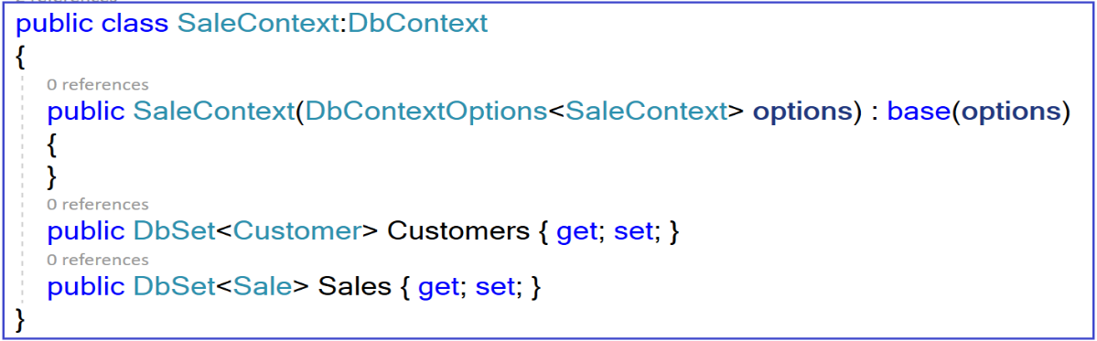

Then we setup the Connection string in the appSettings.json file as shown below:

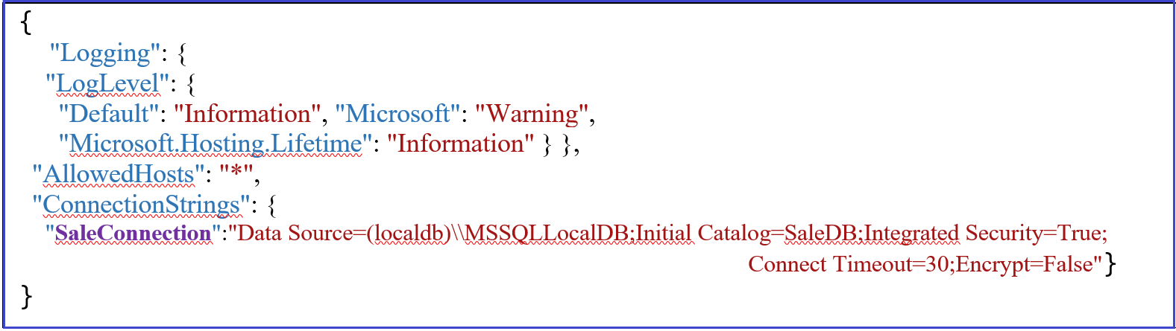

Then the registration of the context class in the Startup.cs requires specifying the ConnectionString as shown below:

|  |
| --- |
| services.AddDbContext<**SaleDbContext**>(options => options.UseSqlServer(Configuration.GetConnectionString("**SaleConnection**"))); |

***What is Migration* in Entity Framework Core?**

Migration is a way to keep the database schema in sync with the EF Core model by preserving data.

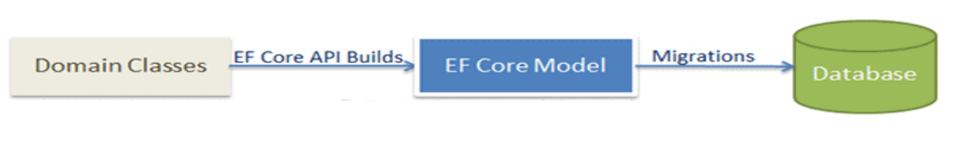

***Why Migration* ?**

In real world projects, especially when working with Agile methodologies, requirements may change as more features get implemented. This results in data models changes: new entities or properties are added and removed, and database schemas needs to be changed accordingly to be kept in sync with the application requirements. Migration is an **EF**/**EF Core** feature that do the job. It provides a way to incrementally update the database schema based on the model. I am not going to dig deep into the migration process, but at least let us look at what happened at high level:

* When a data model change is introduced, the developer uses EF Core tools to add a corresponding migration describing the updates necessary to keep the database schema in sync. EF Core compares the current model against a snapshot of the old model to determine the differences, and generates migration source files; the files can be tracked in your project's source control like any other source file.
* Once a new migration has been generated, it can be applied to a database in various ways. EF Core records all applied migrations in a special history table, allowing it to know which migrations have been applied and which haven't.

***How to apply migration to create the database ?***

There exist many tools that can be used to apply migration. However, since you are familiar and more comfortable working with Visual Studio , we are going to use the [**Package Manager Console tools**](https://docs.microsoft.com/en-us/ef/core/cli/powershell)**.**

You need to install the package ***Microsoft.EntityFrameworkCore.Tools ( you may already have it)***

Now that the entities (Customer and Sale) comply to the conventional approach, the Context class (saleDbContext) is in place and the different configurations are in place, let us use Migration to build the database (we suppose that we do not have any database yet).

* In Visual Studio, open NuGet Package Manager Console from

**Tool**s -> ***NuGet Package Manager*** -> ***Package Manager Console.***

* In the NuGet Package manager Console, enter the command: ***Add-Migration*** **name**. An example is shown below. In this case, MySale is the name parameter.

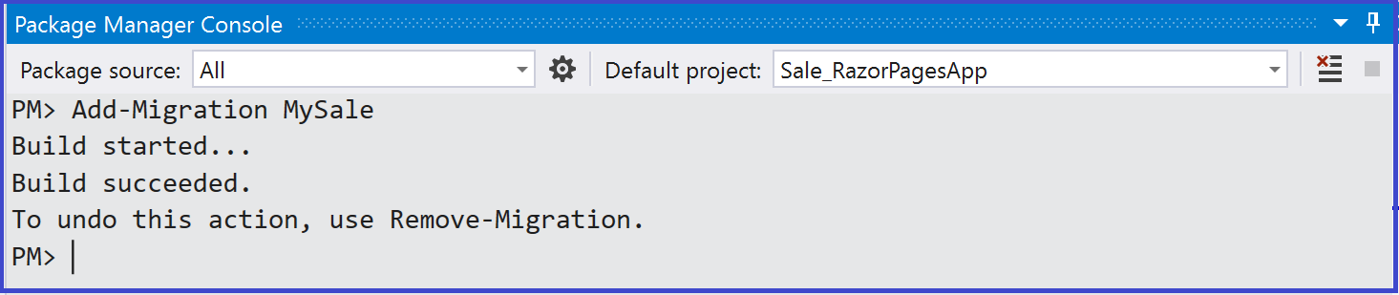

This will create a new folder named **Migrations** in the project and create the ModelSnapshot files, as shown below

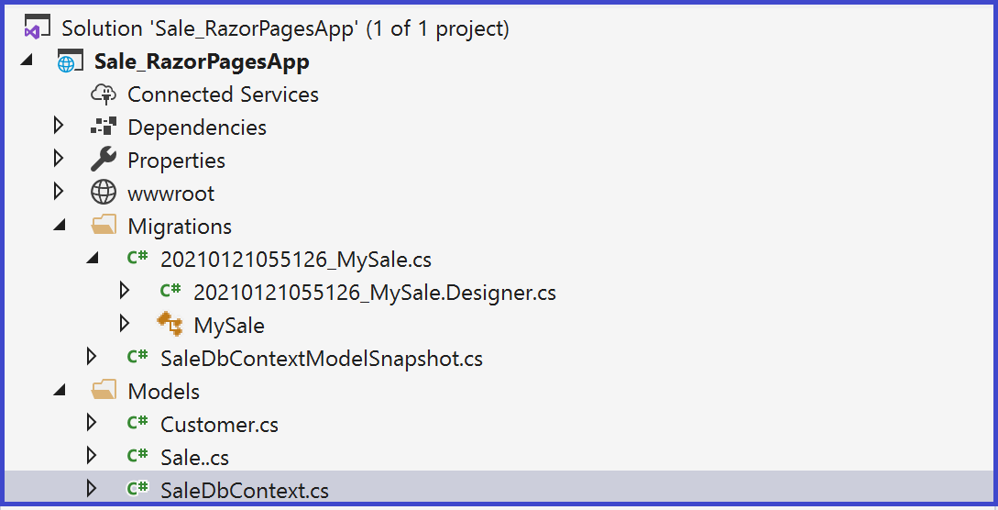

After creating a migration, we still need to create the database using the **Update-database** command as shown below.

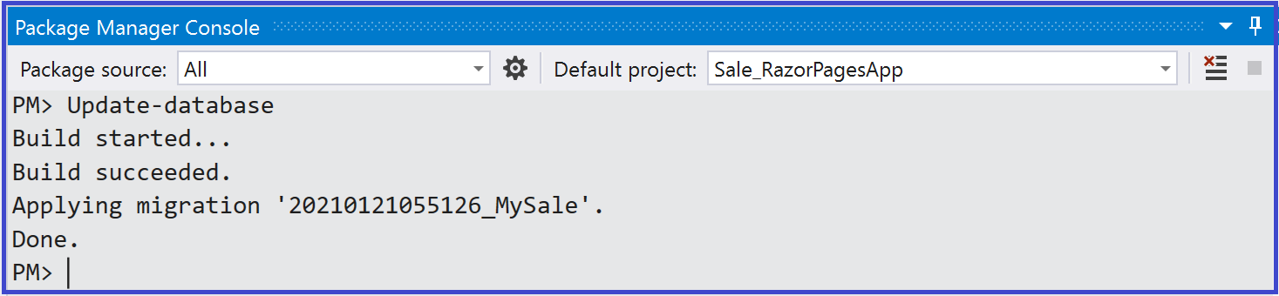

The database is created. One way to access the Sql server is to

* Select **View** 🡪***Sql Server Object explorer***
* ***Expand your Sql Server*** and click on ***Refresh button*** as shown below

As can be seen in the figure below, a database is created. The database schema is built based on the model shown on the left .

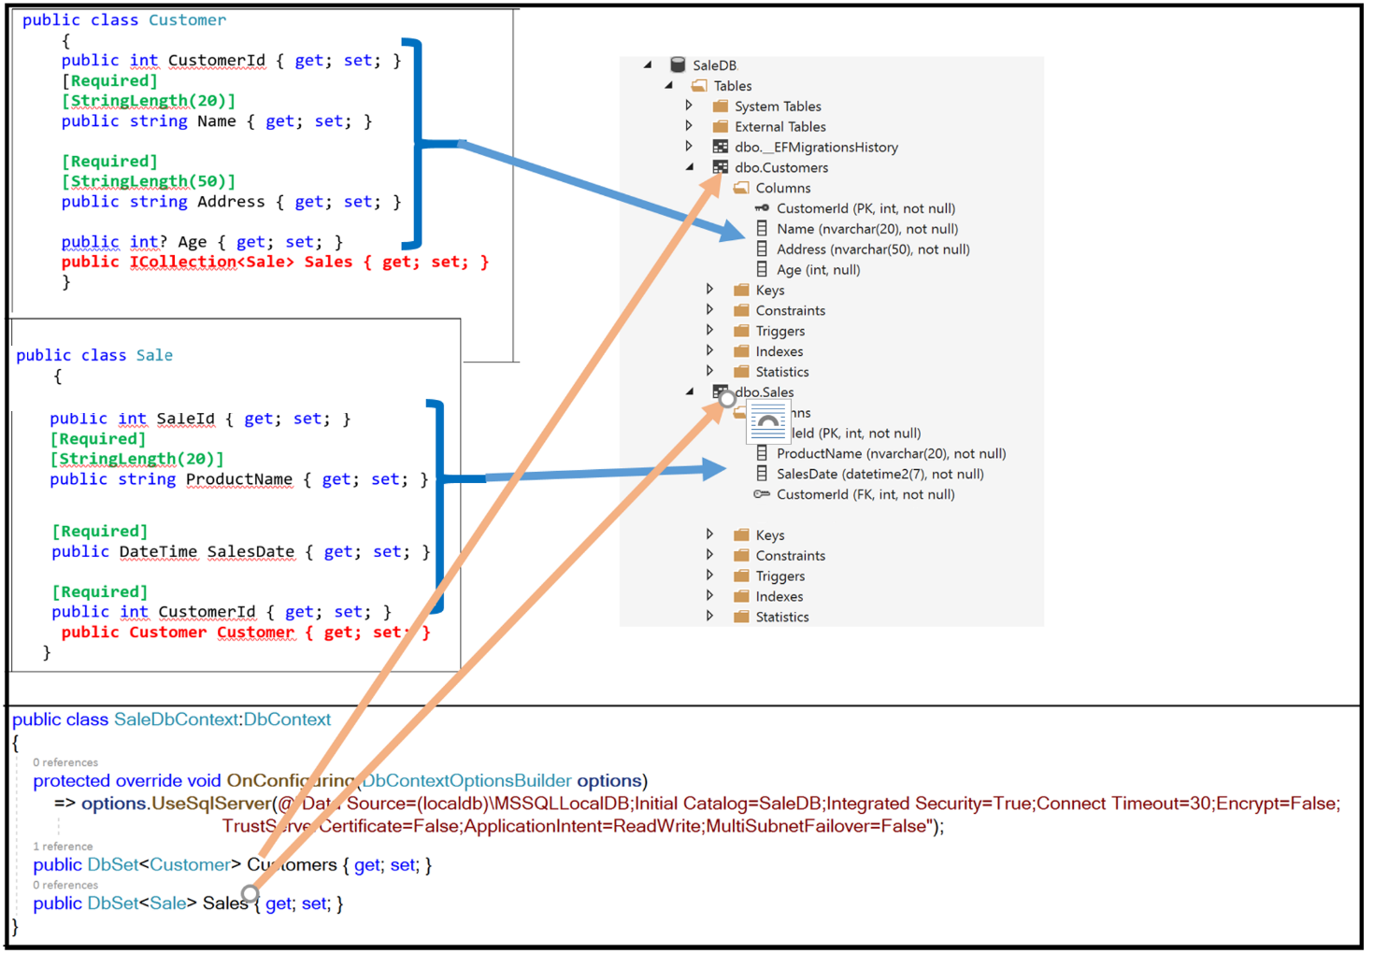

As you can see, EF Core create database tables for the   DbSet<**Customer**> and DbSet<**Sale**> properties. Tables have the same name as the corresponding properties. As you can see, the only column that may be null is the Age in the Customer table. The validations have been reflected in the database design.

As we are adopting the Agile approach, requirements are changing all the time. Let us suppose that the product owner came with the following requirement:

***“As a shop keeper. I want to be able to filter sales based on its amount”*** .

We do not have a property called “Amount”. So we need to make change to our model. We need to add the Amount property to the Sale entity. But what about the database? Should we go and add the corresponding column in the Sale table? The appropriate solution is to apply Migration, especially when we have data in our database. Indeed, in real scenario, we make change at a late stage of the development and our database is full of data.

Let us add the Amount property and apply Migration. Our model looks like the following:

|  |  |
| --- | --- |
| public class Customer  {  public int CustomerId { get; set; }  [**Required]**  **[StringLength(20)]**  public string Name { get; set; }    **[Required]**  **[StringLength(50)]**  public string Address { get; set; }    public int? Age { get; set; }  **public ICollection<Sale> Sales { get; set; }**  } | public class Sale  {  public int SaleId { get; set; }  **[Required]**  **[StringLength(20)]**  public string ProductName { get; set; }    **[Required]**  public double Amount { get; set; }  **[Required]**  public DateTime SalesDate { get; set; }  **[Required]**  public int CustomerId { get; set; }  **public Customer Customer { get; set; }**  } |

Let us apply another migration, called MySale2 and Update the database.

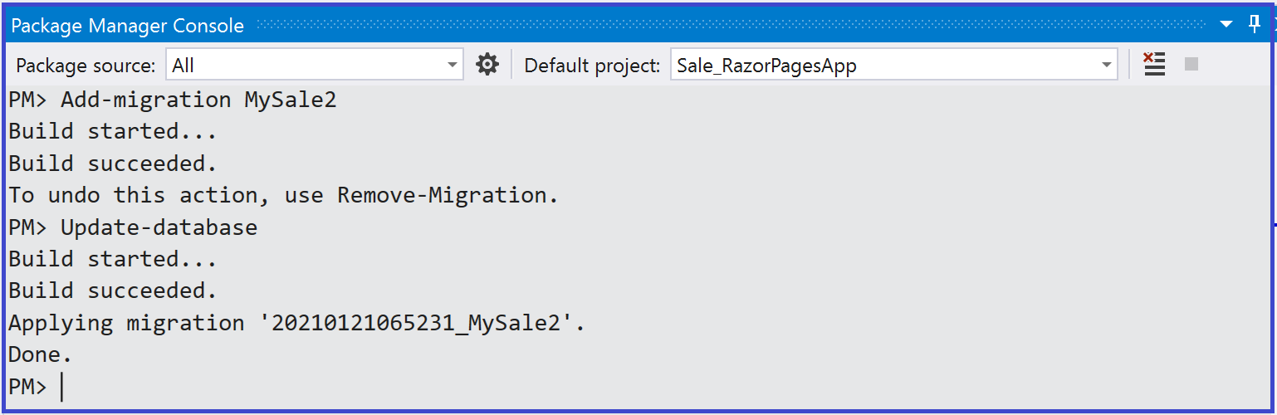

As you can see, the database has changed

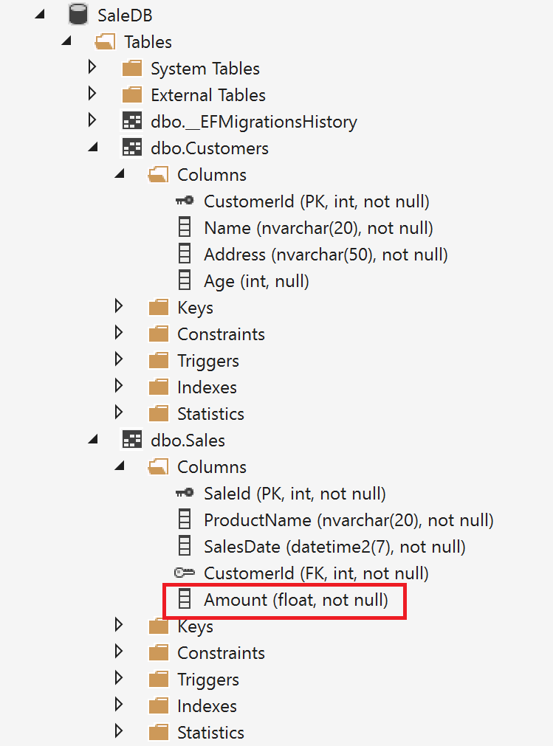

Let us explore the Customer and the Sale tables. We are interested in their definitions.

* Double-click on the Customer table

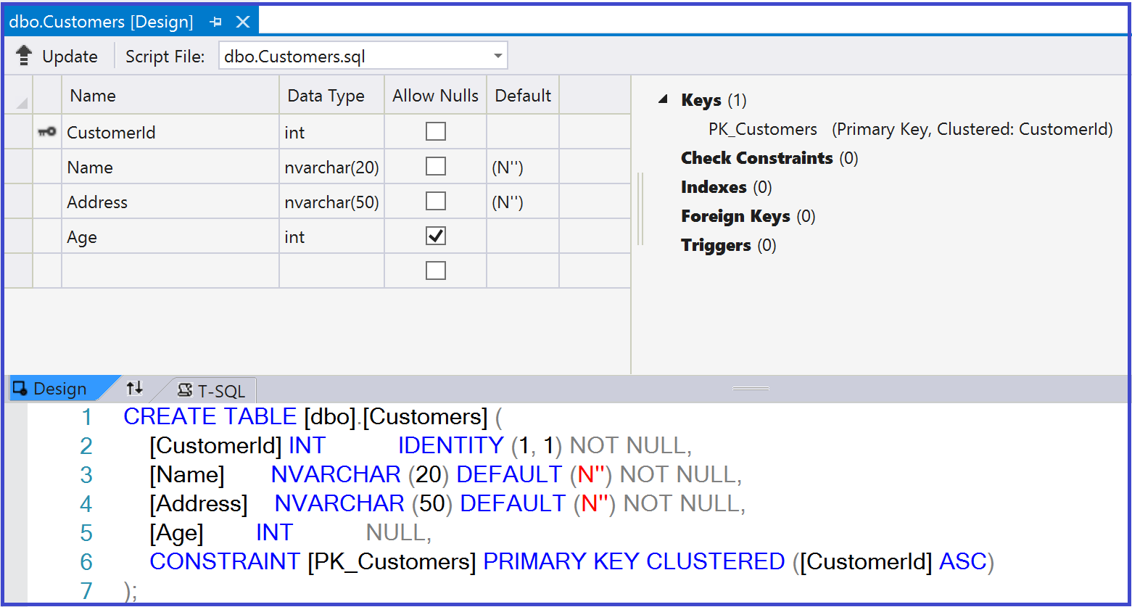

You are probably familiar with the figure from the previous chapter when we build the EventMaker database. As you can see from the Design view or the T-SQL view, the ***CustomerId*** is the primary key and cannot be null (it should be defined ). **IDENTITY(1,1)** means that this primary key is auto-incremented.

* Double click on the Sale table

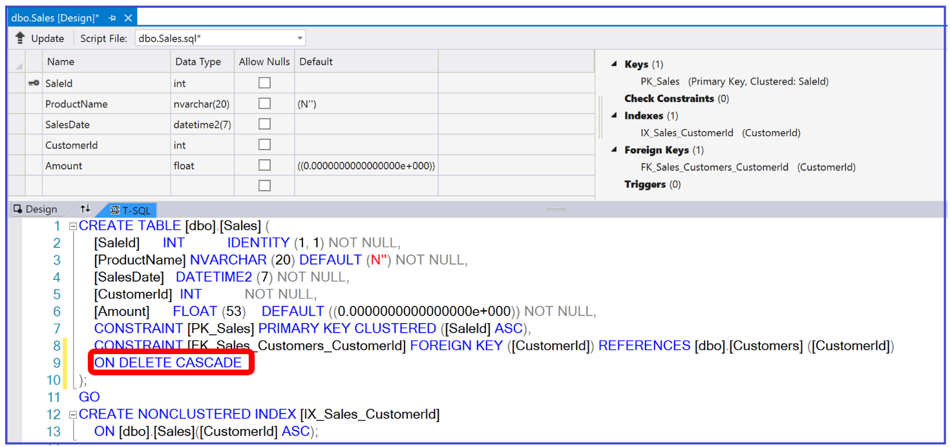

The most important part of the Sale table definition is what we have in line 8 in the T-SQL window.

You may remember the ***ON DELETE CASCADE*** rule from chapter 2. It seems that this rule is set by default when using the code-First approach. Itspecifies what to do in case we delete the parent (a Customer). In this case, we should delete all its children (all its sales).

Now that the database is in place, it is time to implement the different user stories.

|  |
| --- |
| As a shopkeeper, I will be able to create a Customer. |
| As a customer, I will be able to place a Sale |
| As a shop-keeper , I will be able to filter Sales based on the Amount |
| As a shop-keeper , I will be able to filter Customer based on the name |
| As a customer, I will be able to view all my sales |

The implementation is based on the following design.

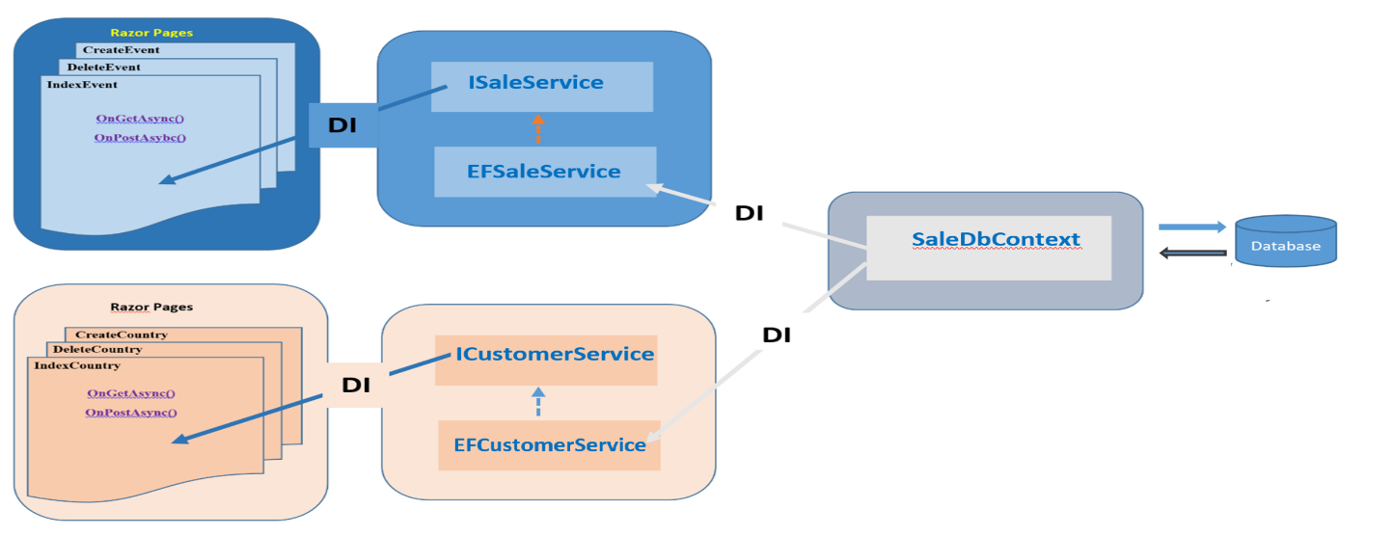

As we did in the chapter about Database-First approach, the SaleDbContext service will be injected into the the CustomerService and the EventService classes using dependency injection (DI). In turn the ICustomerService(implemented by CustomerService class) and the IEventService(implemented by EventService class) are injected into the Razor Pages using DI. Dependency injection using interfaces allows to abstract the data access layer from the front end.

The figure below shows the methods defined in the ***ICustomerService*** and **ISaleService** interfaces.

|  |  |
| --- | --- |
|  |  |

The code is similar to the one implemented in the chapter about the Database-First approach. However, the difference is that this time, the methods are implemented in an asynchronous way.

For the moment, I am going to show the code for only user stories mentioned above. For the rest of the user stories, the complete application is available on GitHub.

**User story 1***:* ***As a shop-keeper, I will be able to create a Customer***

The code below shows the implementation of the user story at different levels of the application design starting from the Front-End (on the left) and moving to the back-end ( on the right ).

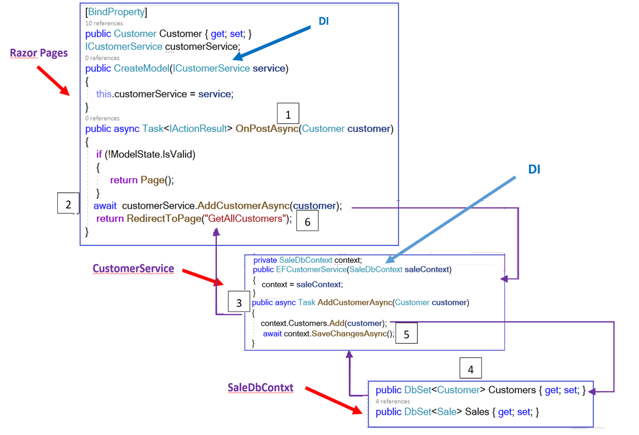

**DI**

Let us talk about the asynchronous behavior. How much benefit can we get by using Asynchronous programming is another debate. Anyway, as you can see, we used the **OnPostAsync** action method. As you know, this method is called when submitting the form using the Post method. In the figure above, I attached some number to different parts of the code. These numbers illustrate the order in which this part of code is executed. Notice the use of the keyword ***async, Task and await*** to implement the asynchronous behavior. I am ending each of my methods by the suffix ***Async*** (a good practice) to indicate that it is an asynchronous method.

In the OnPostAsync method, we are awaiting the call to the ***AddCustomerAsync(customer)*** method. That means the line of code ***[return RedirectToPage(“GetAllCustomers”)]***  will not be executed yet. The call to the RedirectToPage() method is suspended and the control is yielded back to the caller (the page in this case) until the awaited task (*AddCustomerAsync(customer)*)is complete.

In the ***AddCustomerAsync*** method, we used the Add method of the DbSet class to add the customer to the Customers Set. We call the SaveChangesAsync method to persist the changes on the database

Once the new Customer is saved, the ***[return RedirectToPage(“GetAllCustomers”)]***  is executed and the new created customer is shown.

***Sprint Review***

Let us run the application.

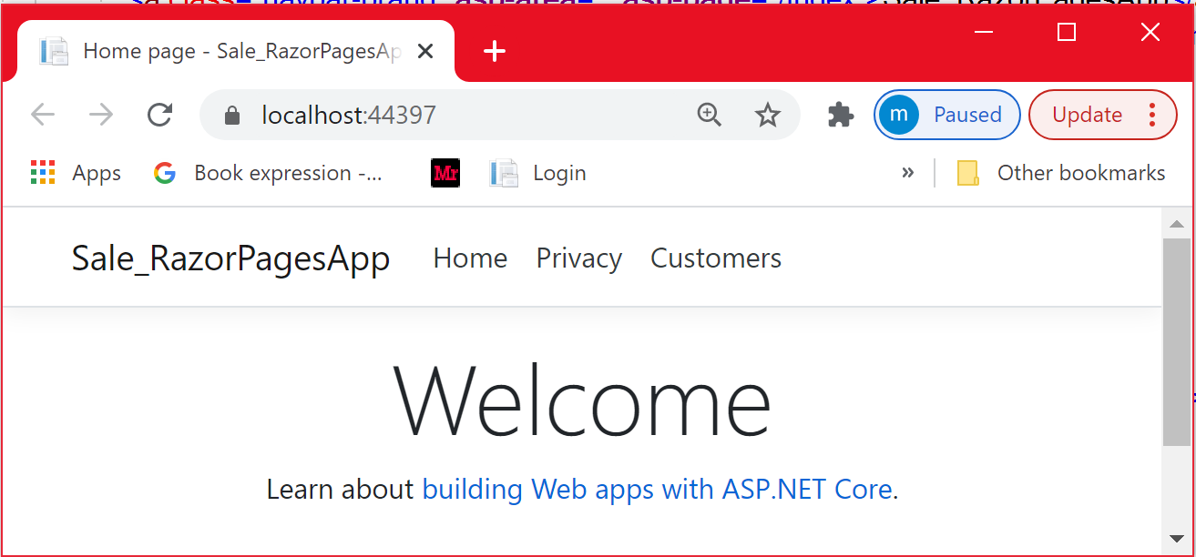

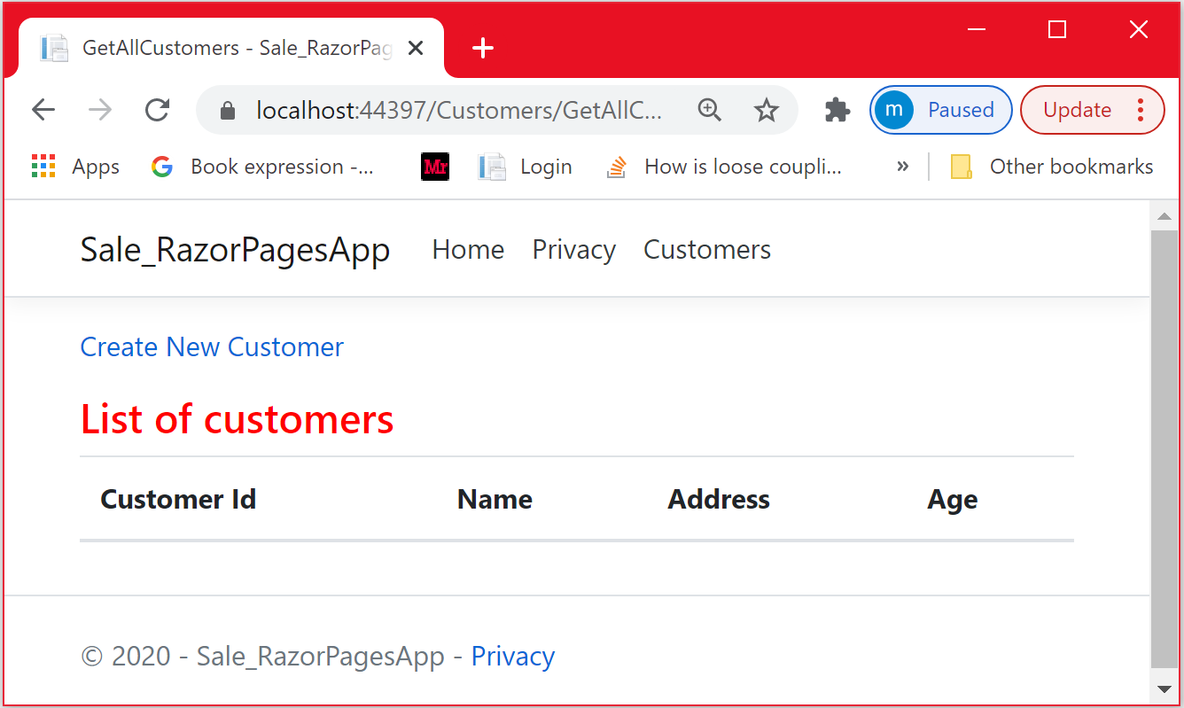

Let us create a new customer with no data at all. As you can see, the data is not validated.

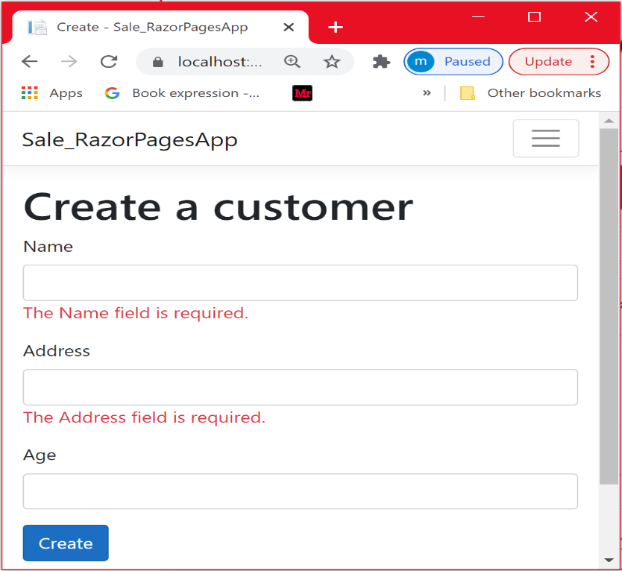

Let us provide only the Name and the address. The age is not required

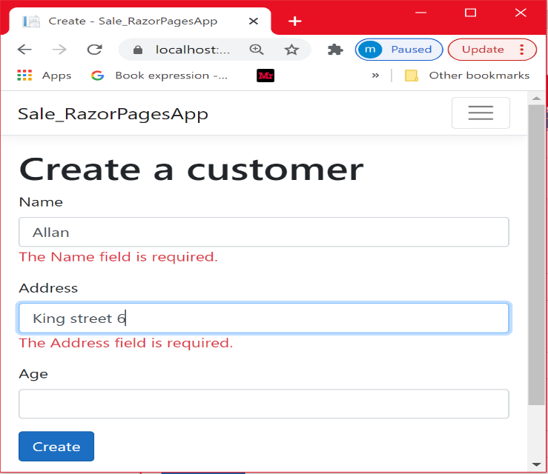

As you can see, the new customer has been created.

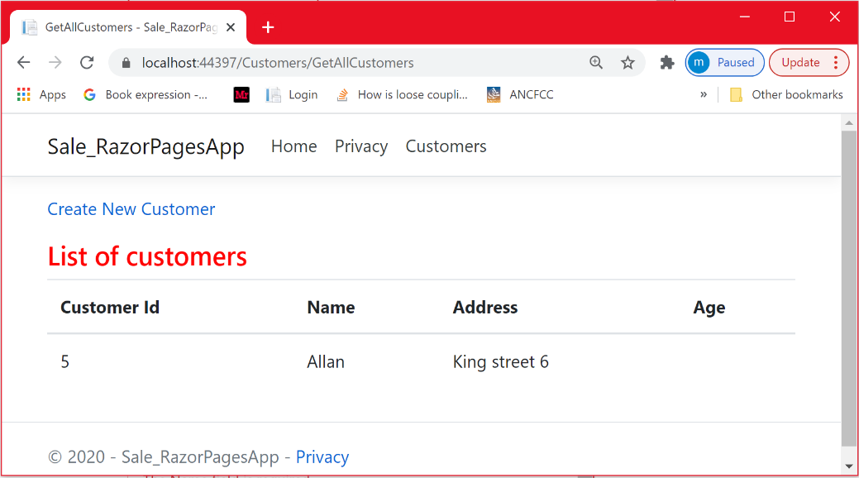

Let us have a look at the database.

To see the new created customer, please click on the **Refresh** button.

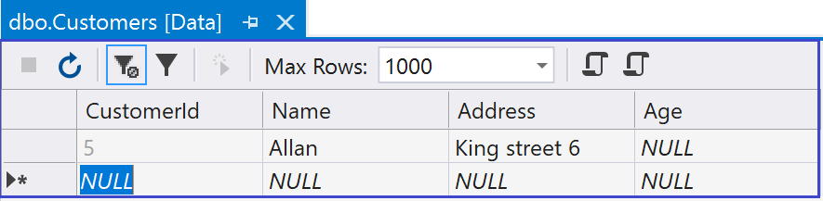

**User story***:* ***As a customer, I will be able to place a Sale***

This user story is not so difficult. It is similar to the process of creating a new customer:

* + - We need first to select a customer.
    - Its Id is then passed to the CreateSale Razor Page and then assigned to the new Sale object that is created
    - Then, the Sale is added to the Sale table the same way we did for adding a customer.

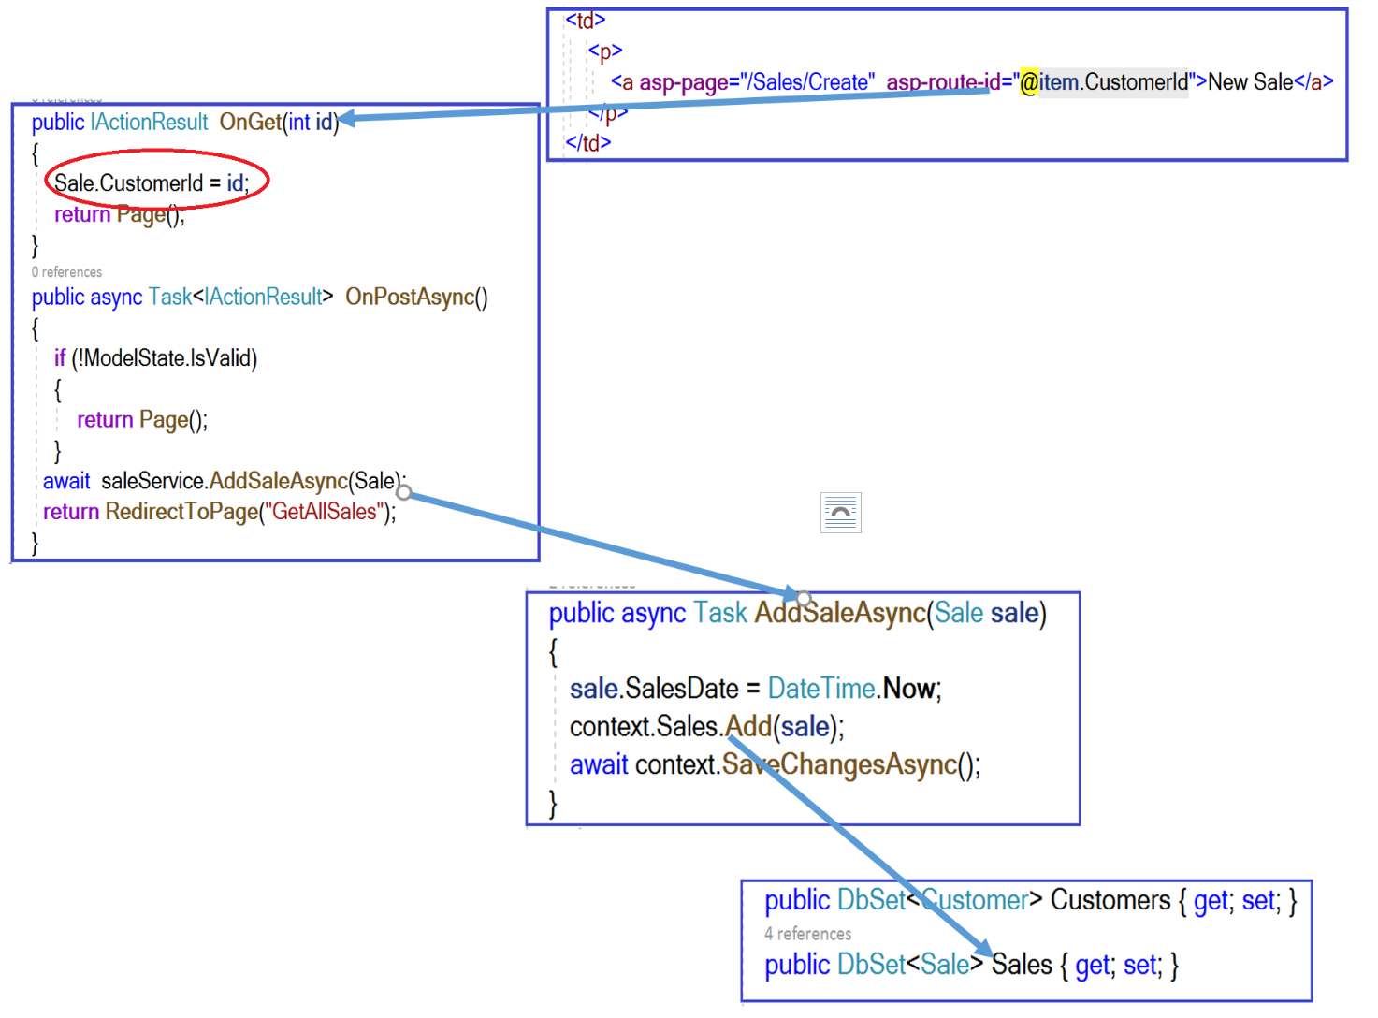

***Sprint Review***

Let us run the application



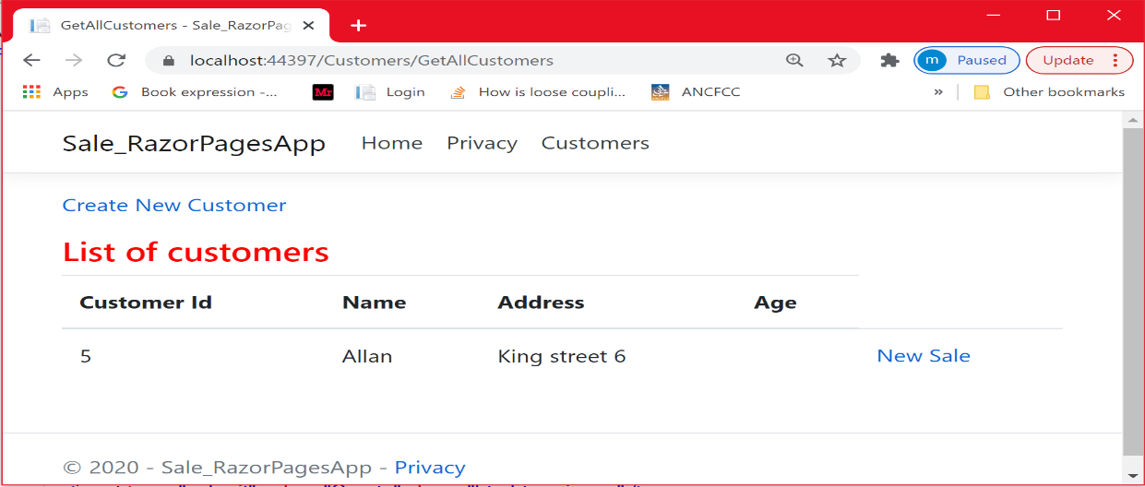

By clicking the **New Sale** link, we pass the id of the selected customer to the CreateSale page. As you can see, the id is passed through the URL (***Reminder***: not recommended for sensitive data)

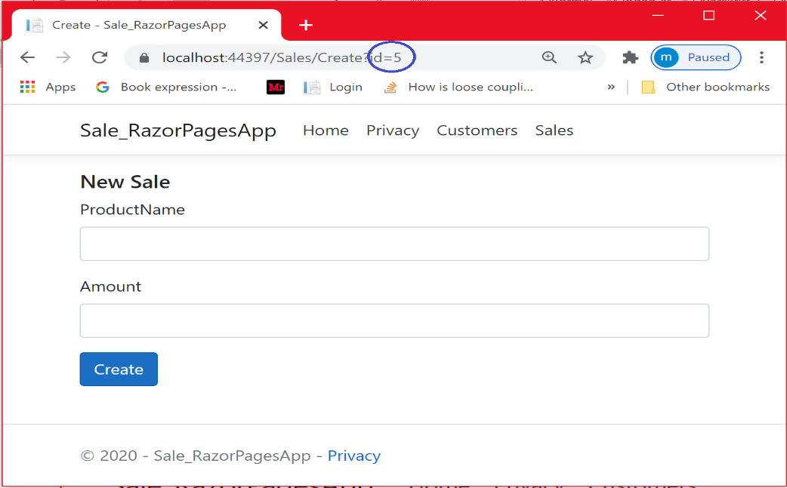

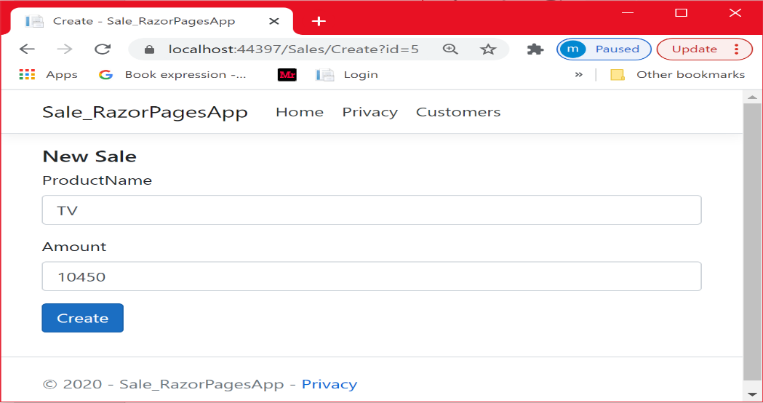

As you can see below, a new Sale is placed by the customer whose id is 5

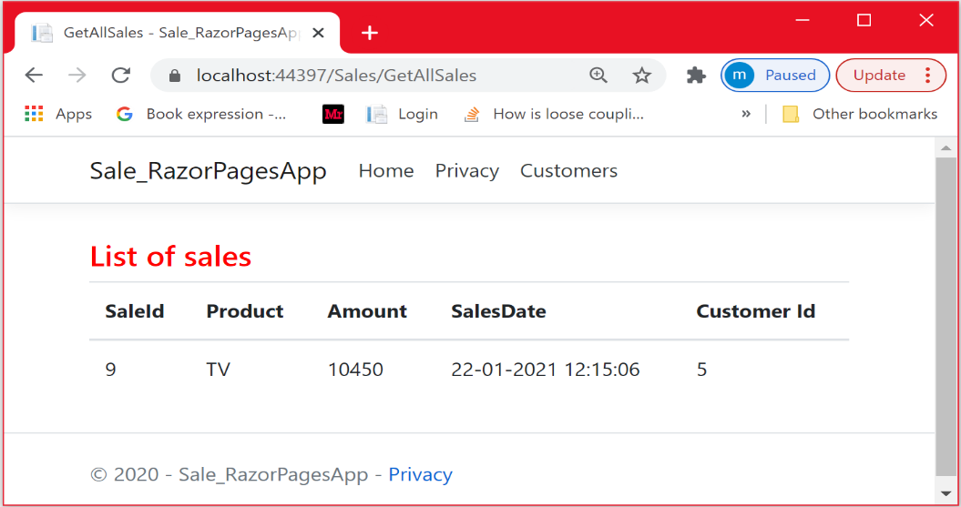

Let us place 2 other sales for the same customer. This is shown below.

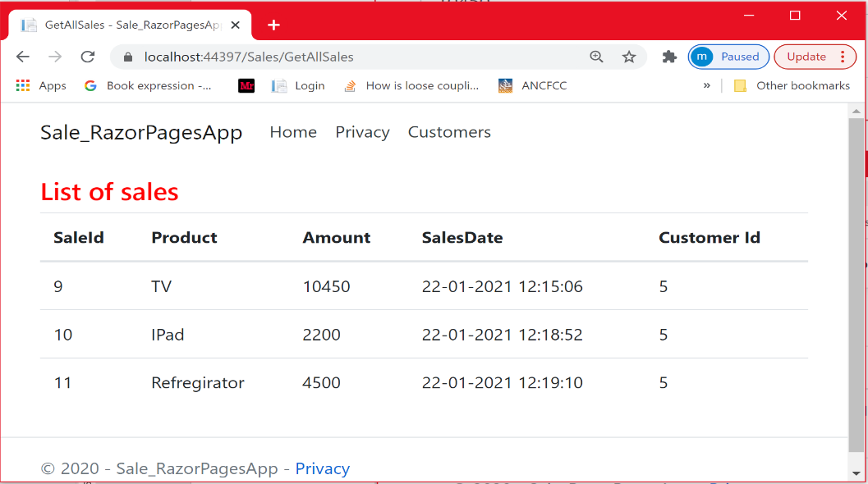

Let explore the database. As you can see, there are 3 sales assigned to the customer having the id=5.

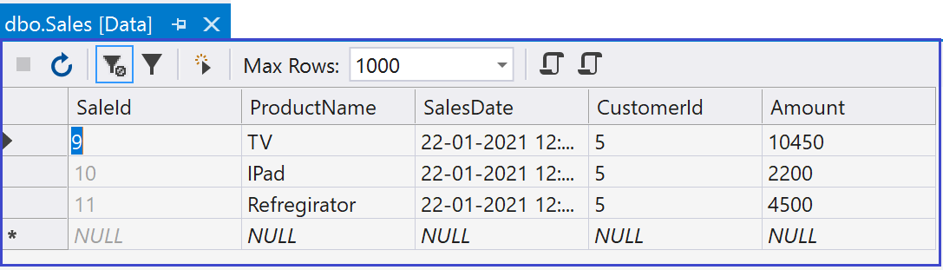

**User story***:*

* + - ***Be able to filter sales based on the amount .***
    - ***Be able to filter customers based on the name (this user story is similar to the previous one)***
    - ***Be able to view all sales***

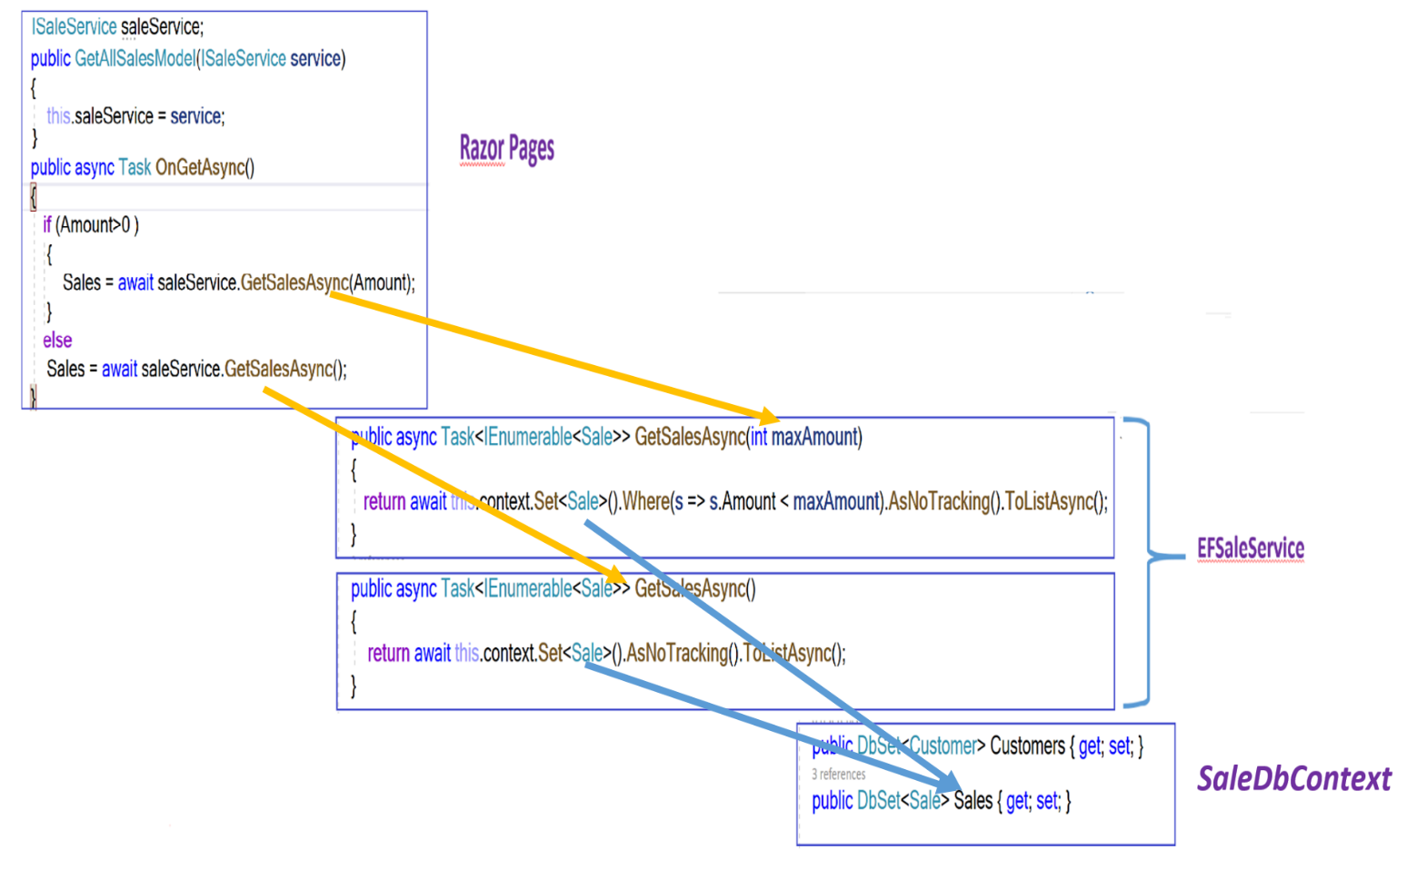

The code that deserves some attention is the one at the EFSaleService level. In the **GetSalesAsync(int maxAmount)** method, we used the generic method **Set< >** that returns a **Dbset< >** object. We then apply the **Where** clause on the set to apply a filter in the form of a Boolean expression. The filter causes the query to return only those elements for which the sale´s amount is less than maxAmount.

Another important code is the use of the **AsNoTracking()** method. By default, queries that return entity types are **tracking**. Which means you can make changes to those entity instances and have those changes persisted by **SaveChanges()/SaveChangesAsync().** This is relevant when you want to make changes to your entity instances. However, if you want just to retrieve data (read-only scenario) without tracking , no tracking queries are useful. They are quicker to execute because there's no need to set up the change tracking information.

***Sprint Review***

I created two other customers, having 1 Sale each.

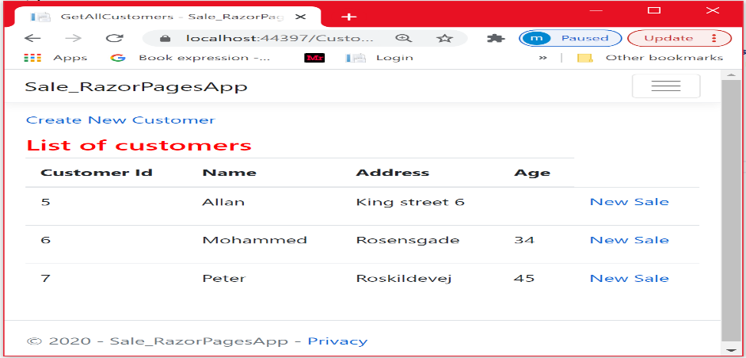

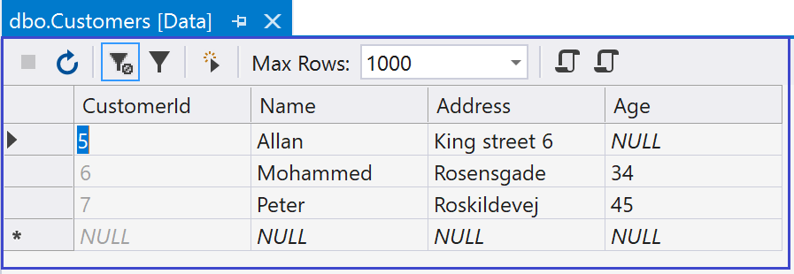

The customers Mohammed and Peter placed one sale each.

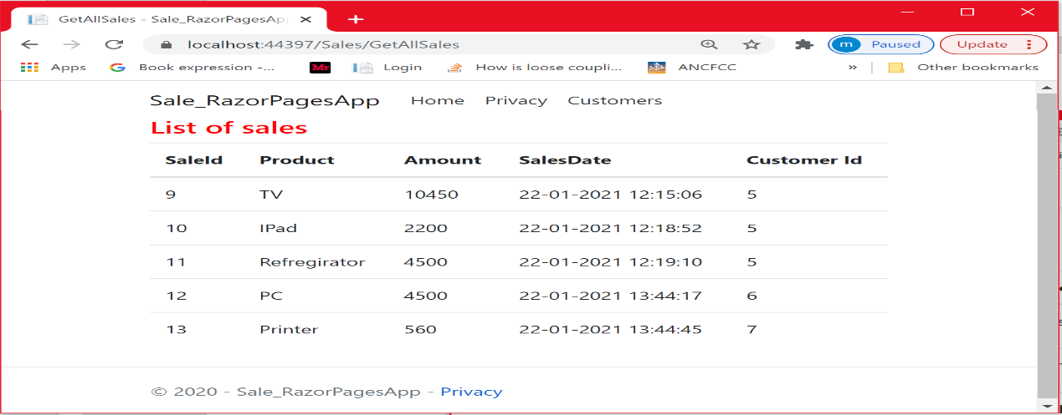

Let us filter customers based on the name

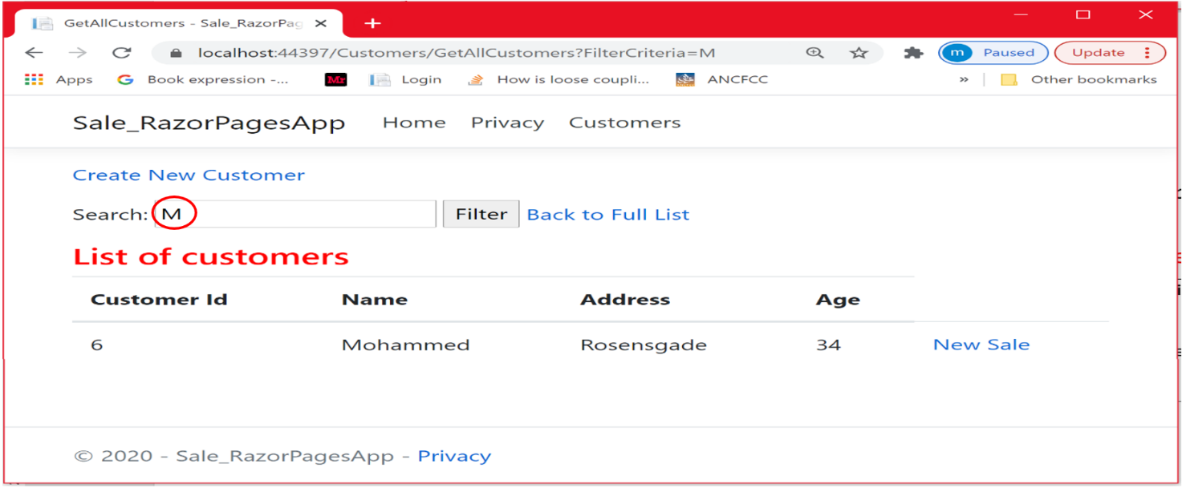

Let us filter sales based on the max amount

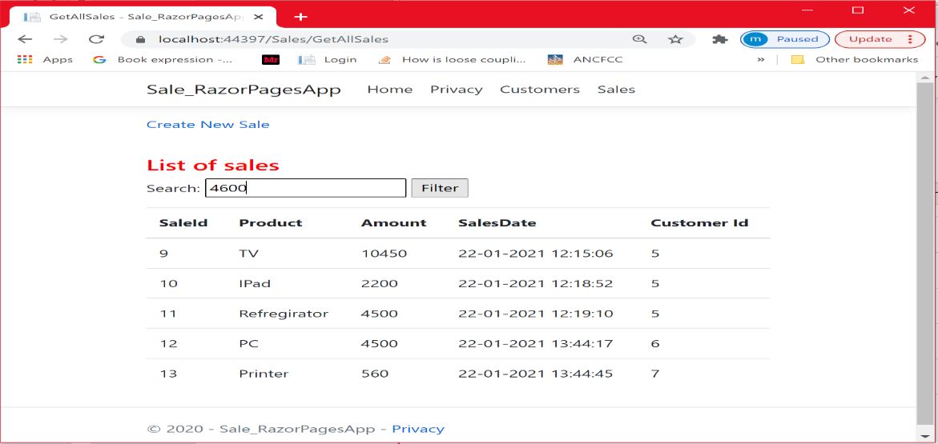

As you can see, the sale with amount 10450 is not shown

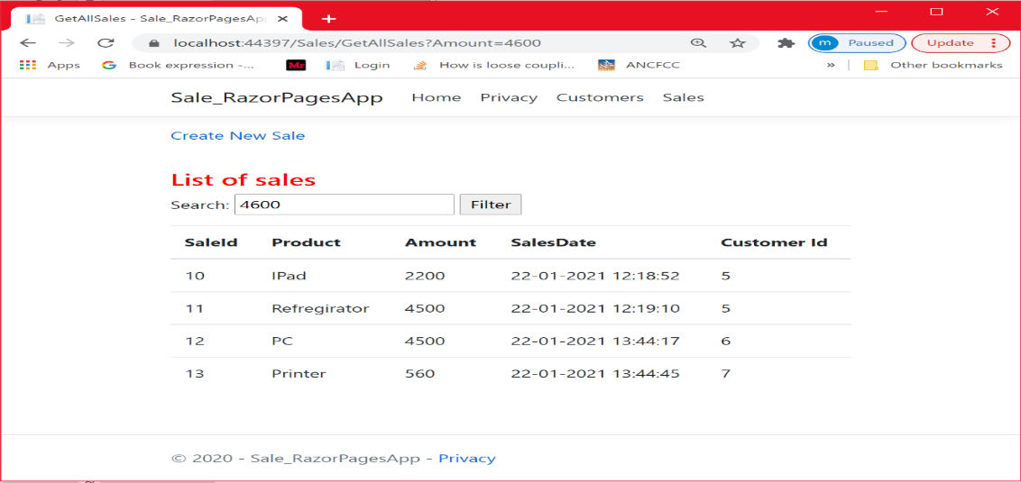

**User story***:* ***As a customer, I will be able to view all my sales***

This user story is interesting because we will see how the navigation property Sales in the Customer class is useful for retrieving all the sales made by a specific customer from the database in a single query. We cannot use the ***GetAllSales*** page to display the sales for a specific customer as we did previously. We need to create a new Razor Page ( i.e. Customer_Sales).

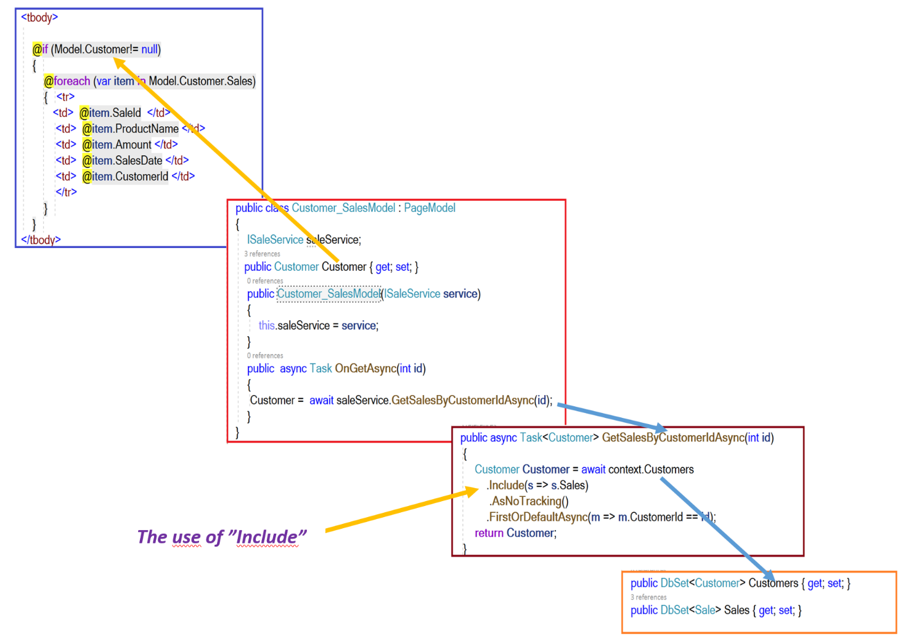

As you can see, we used the **Include** extension method to include all sales belonging to the first or default customers found in the Customers set. We could use the Include statement because the customer model contains Sales as a navigation property(explained earlier).

**Sprint Review**

Let us run the application.

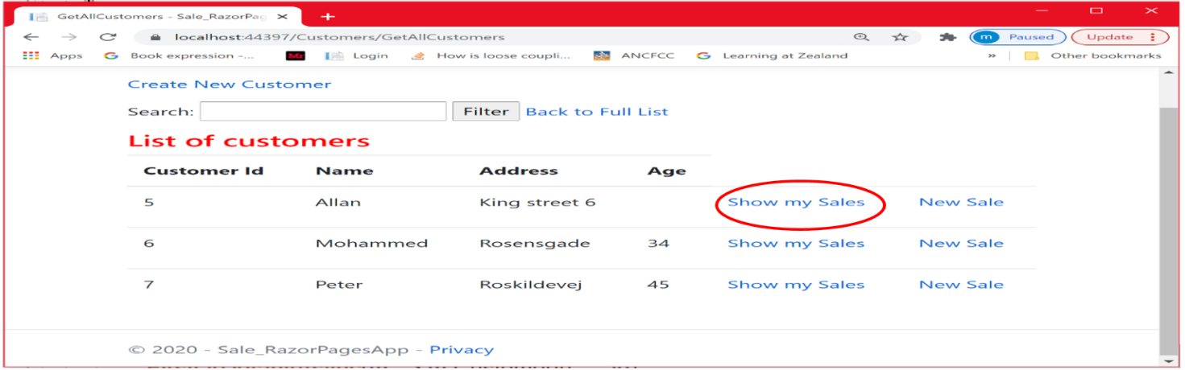

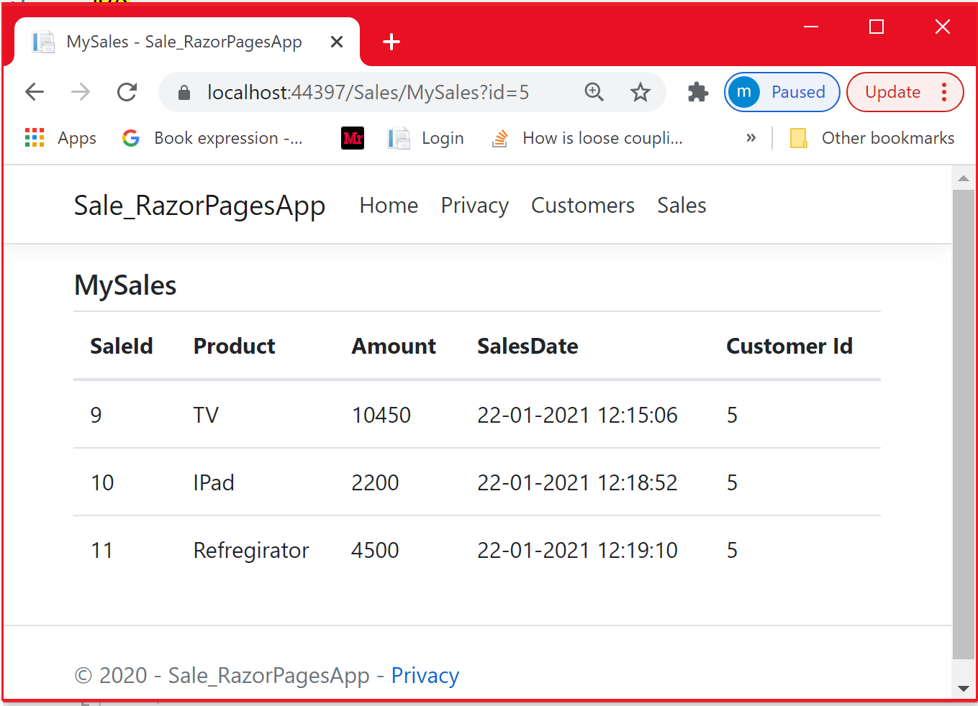

***Conclusion and Reflection***

In this chapter, we implemented the 5 user stories mentioned above. The application is perfectly functioning. However, there are some issues with the previous code. These issues are related to maintainability and code reusability, which are good features for any application. Looking at the code in both **EFCustomerService** and **EFSaleService** classes, there are a lot of similarities . So the question that you may ask yourself is :

* + - Is it possible to replace the EFCustomerService and EFSaleService classes by a Generic class ?

The answer to this question is somehow **YES** at some extend.

* + - Why are we interested in making our code generic?

In the previous chapter, the application only involved 2 classes : Customer and Sale. It was relatively easy to maintain the application. However, you are probably going to build applications where you are dealing with numerous entities (types). Writing and maintaining similar code in each service is going to be a nightmare because changing the code in one class may involve performing the change in all classes. We can minimize this issue by making our code more generic. This is what we are trying to do in the next chapter.

**Chapter 4 : Entity Framework- Code First using Generics**

### **Introduction**

Code reuse is very important when developing applications. It comes with many benefits: maintainability, reusability ….etc. As mentioned at the end of the previous chapter, a real application involves numerous entities (Customer, Employee, Sale, Product, …etc). Managing the same code across many entities is a nightmare. In this chapter, we are going to make our code more reusable and easy to maintain by making similar code more generic.

Let us investigate the code in both the ***EFCustomerService*** and the ***EFSaleService***  classes.

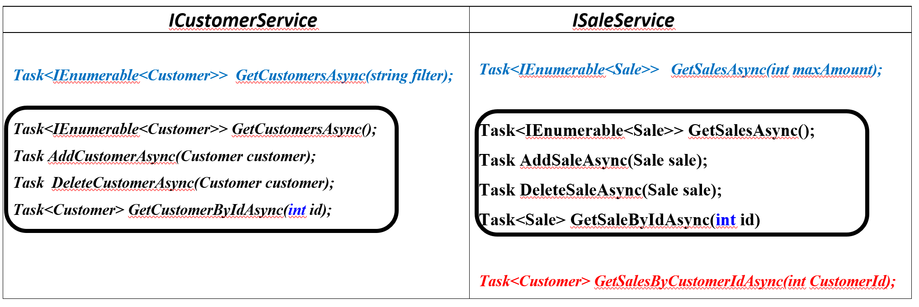

Looking at the code implemented in the application in the previous chapter, it is very similar in 4 methods (in black on *the* *table above*). The only difference is the type (Customer or Sale). If we look at the filtering (*see the table above*), the difference between these two methods (in blue) is the way we perform the filtering. In GetCustomersAsync(filter), the filtering is based on the name of the customer whereas the filtering is based on the maximum amount of the sale in the GetSalesAsync(maxAmount) method. So we may find a way to make the code generic.

Finally, the GetSalesByCustomerIdAsync () method (in red in the table above ) is specific to the EFSaleservice.

**Solution**: The solution is illustrated in the following class diagram. In this design class diagram, we have only represented the data access layer services.

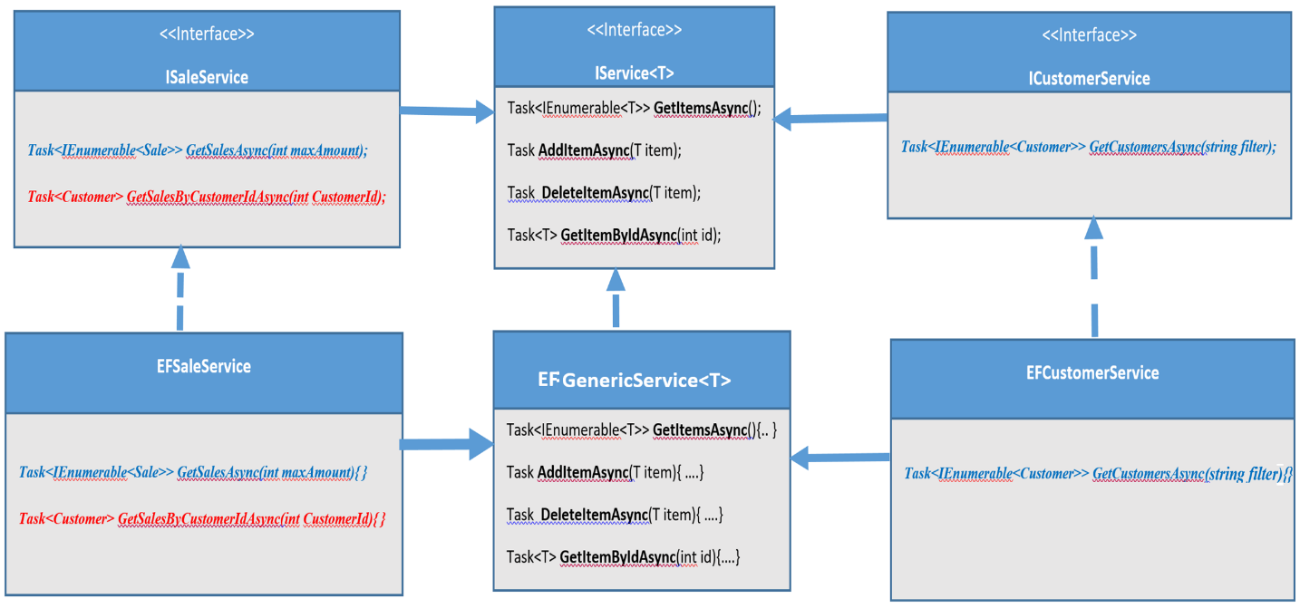

Let us explore our design. I create a generic **interface (IService<T>)** that defines the operations similar for both **EFCustomerService** and ***EFSaleService***. Once the Generic interface is in place, we need a Generic class (**EFGenericService<T>**) that implements this Generic interface. As a non generic class can inherit from a generic class, the ***EFSaleService*** class is going to inherit from the **EFGenericService<T>** with T being the Sale type **and** the **EF*CustomerService*** class is going to inherit from the **EFGenericService<T>** with T being the Customer type. If what I said is not clear yet to you or it does not make sense yet, look at the illustration below. It will give you an overall insight into how the code is implemented.

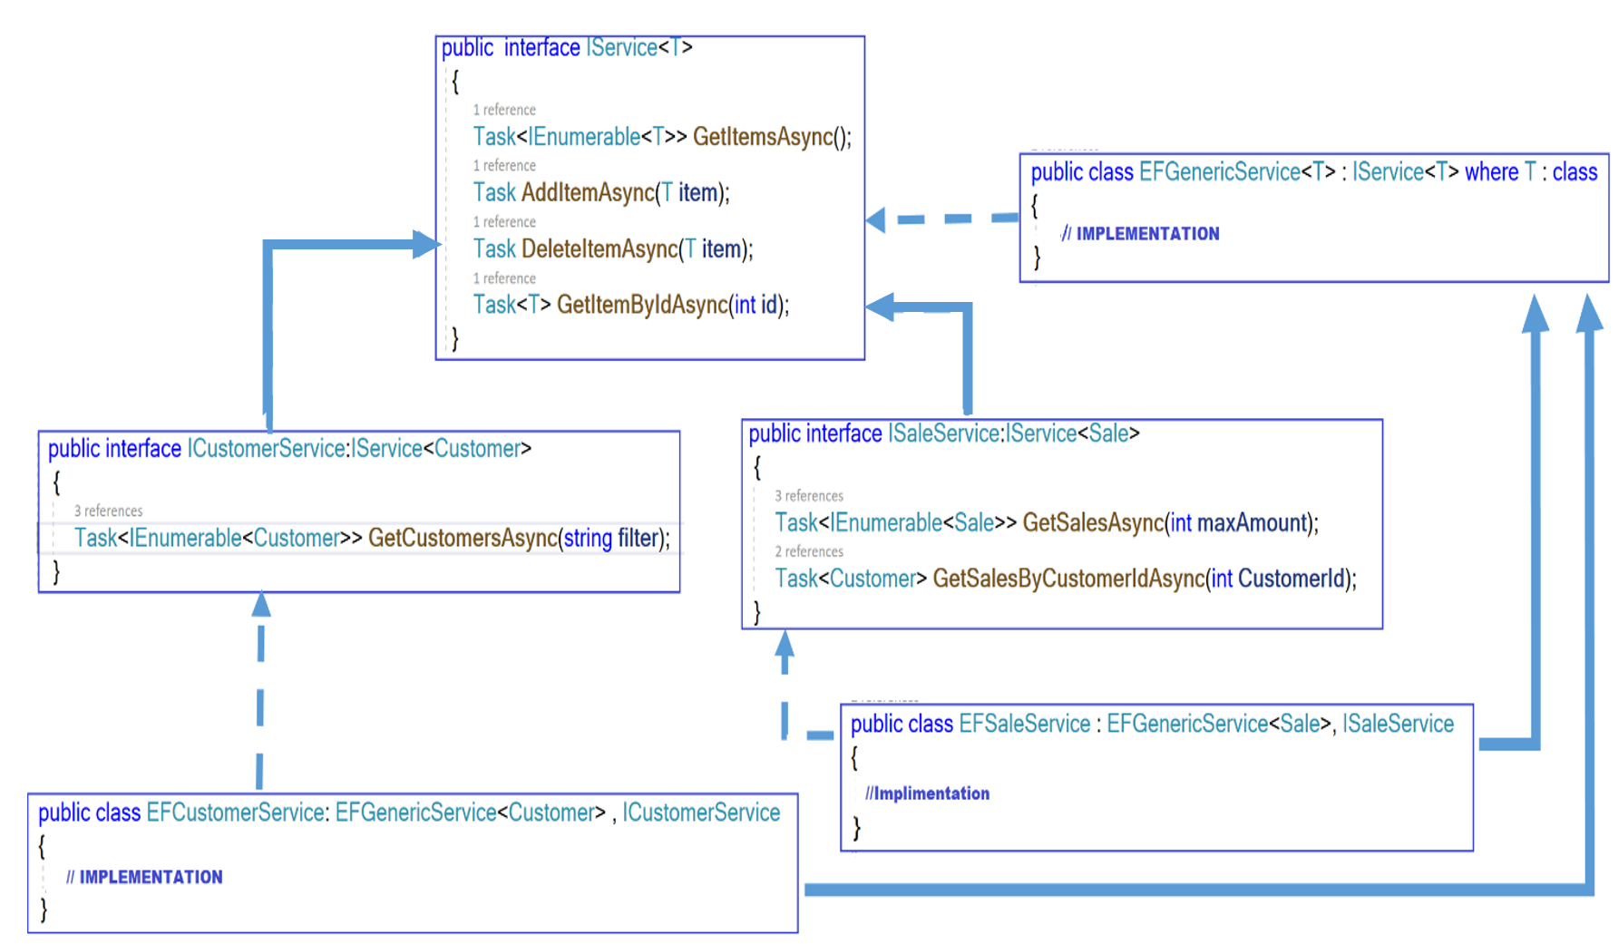

The interfaces **ICustomerService** and **ISaleService** are going to be injected into the Customers Razor Pages and the Sales Razor Pages respectively using Dependency injection. The context class ( SaleDbContect) is injected into the base generic class **EFGenericService**, so it can be accessed by the two derived classes **EFSaleservice** and **EFCustomerService.**

The figure below illustrates an overall design where we conceptualize the relationship between the Razor Pages App, the data access layer services (shown above) and the database.

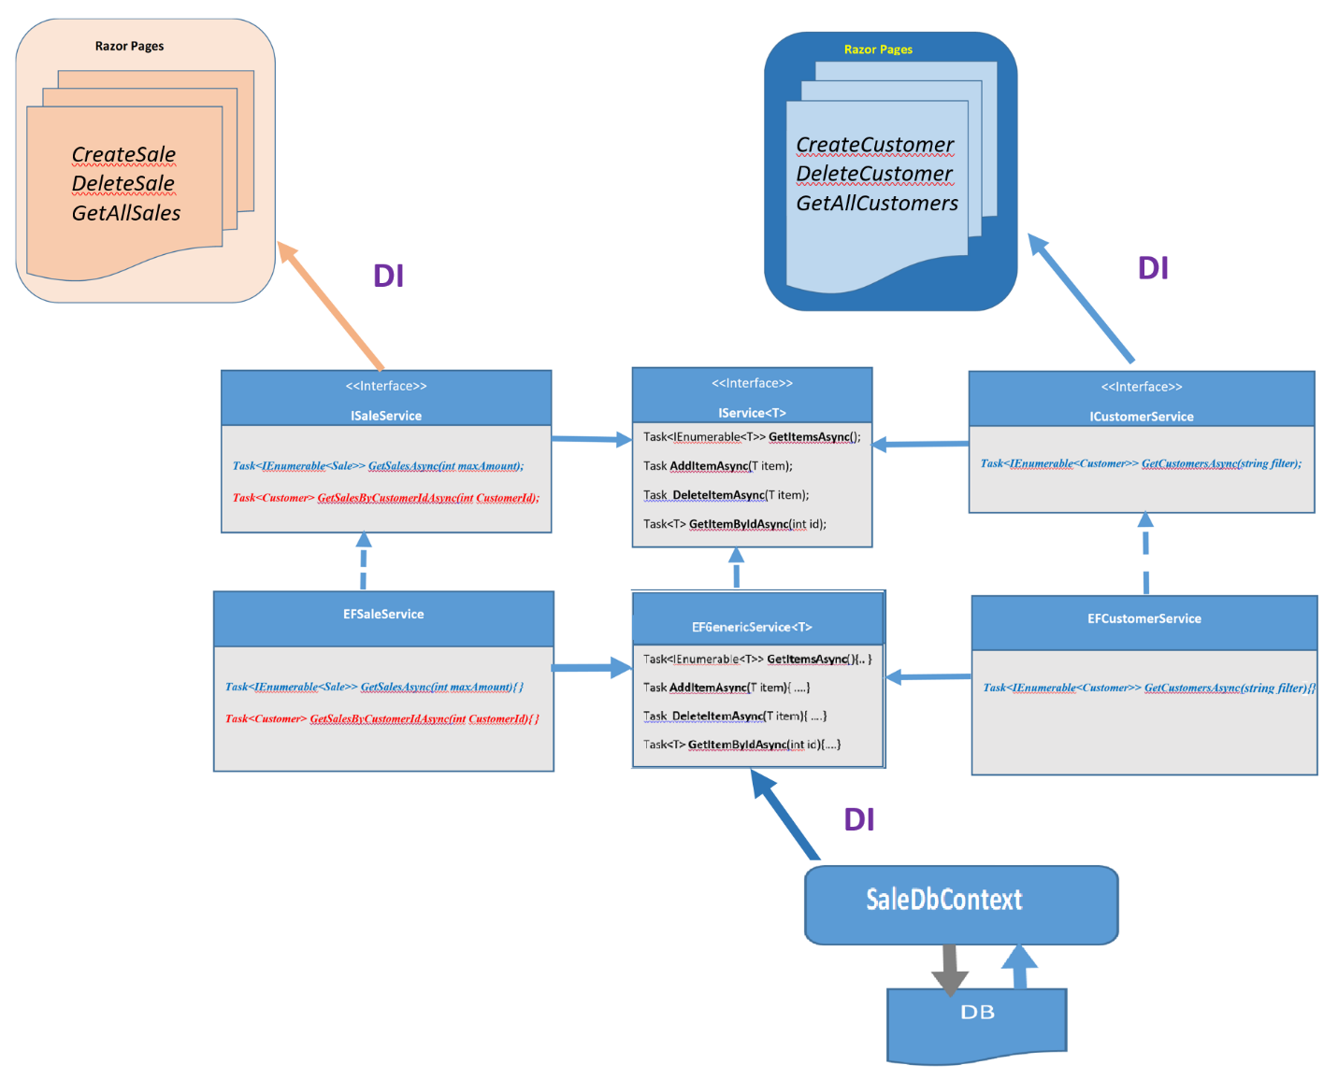

I hope I did not overburden you with many illustrations. The reason why I use illustrations is that I am really convinced that many of you will benefit from these illustrations to understand the implementation. I hope it is the case for many of you if not all of you.

But before digging into the implementation, let us look at the question we asked ourselves at the beginning of this chapter:

* + Is it possible to make the code of **GetCustomersAsync(filter)** and **GetSalesAsync(maxAmount)** generic when one is filtering based on the name of the customer and the other is filtering sales based on the amount of the sale ? The answer is **YES** at some extend.
  + ***H***ow is it possible when the way of filtering is different?

Indeed, it is possible if we abstract the way we filter. We do that by passing the filtering method as a parameter using one very powerful feature in .NET , which is **Delegate**

Let us investigate the implementation of these two methods. The code is shown below.

|  |  |
| --- | --- |
| public async Task<IEnumerable<Customer>>  **GetCustomersAsync**(string name)  {    return await  context.Set<Customer>().Where(**c => .Name.StartsWith(name)**)  .AsNoTracking().ToListAsync();  } | public async Task<IEnumerable<Sale>>  **GetSalesAsync**(int maxAmount)  {  return await  context.Set<Sale>().Where(**s=> s.Amount < maxAmount)**  .AsNoTracking().ToListAsync();  } |

***How can we abstract the way we filter?*** We can achieve that using delegates. As you can see below, we create the filtering operation as a delegate (***a predicate***) that takes a Customer/Sale as an input parameter and returns a Boolean.

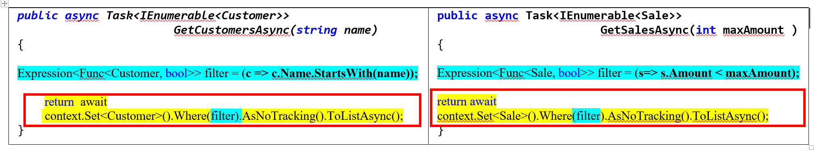

Now, I hope that making the code somehow generic is obvious because the code in red is the same. This code can be a method (let us call this method ***CheckExpression*** ) that takes our predicate **filter** as a parameter , then checks the expression ( to true or false) and return the entities that satisfy the condition.

After such refactoring, the **GetCustomersAsync**, **GetSalesAsync** methods look like the followings:

|  |  |
| --- | --- |
| public async Task<IEnumerable<Customer>>  **GetCustomersAsync**(string name)  {  Expression<Func<Customer, bool>> filter = (c => c.Name.StartsWith(name));  Return **CheckExpression**(filter)  } | public async Task<IEnumerable<Sale>> **GetSalesAsync**(int maxPrice )  {  Expression<Func<Sale, bool>> filter = (s=>s.Amount < maxAmount);  **CheckExpression**(filter);  } |

Where the **CheckExpression** method is generic and defined as follows:

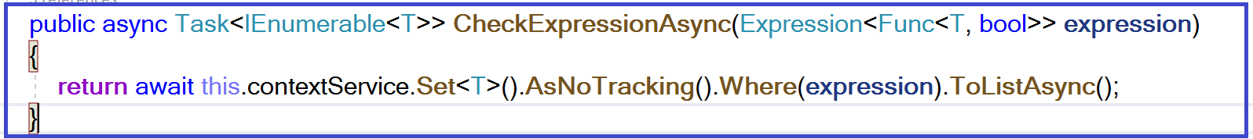

The interfaces in the final design are shown in the figure below.

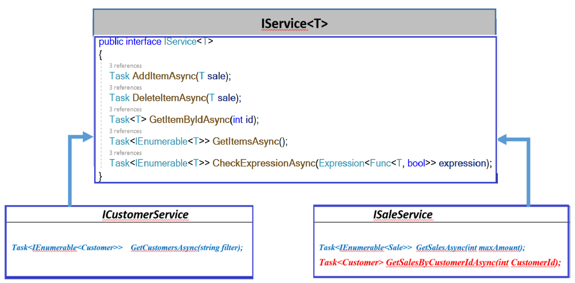

Now it is time to show some implementations of the different services. The service level is the only part affected by the new implementation. The other parts (Razor Pages & the context class) are identical to the code from the previous chapter.

**User story**: I will be able to create a sale

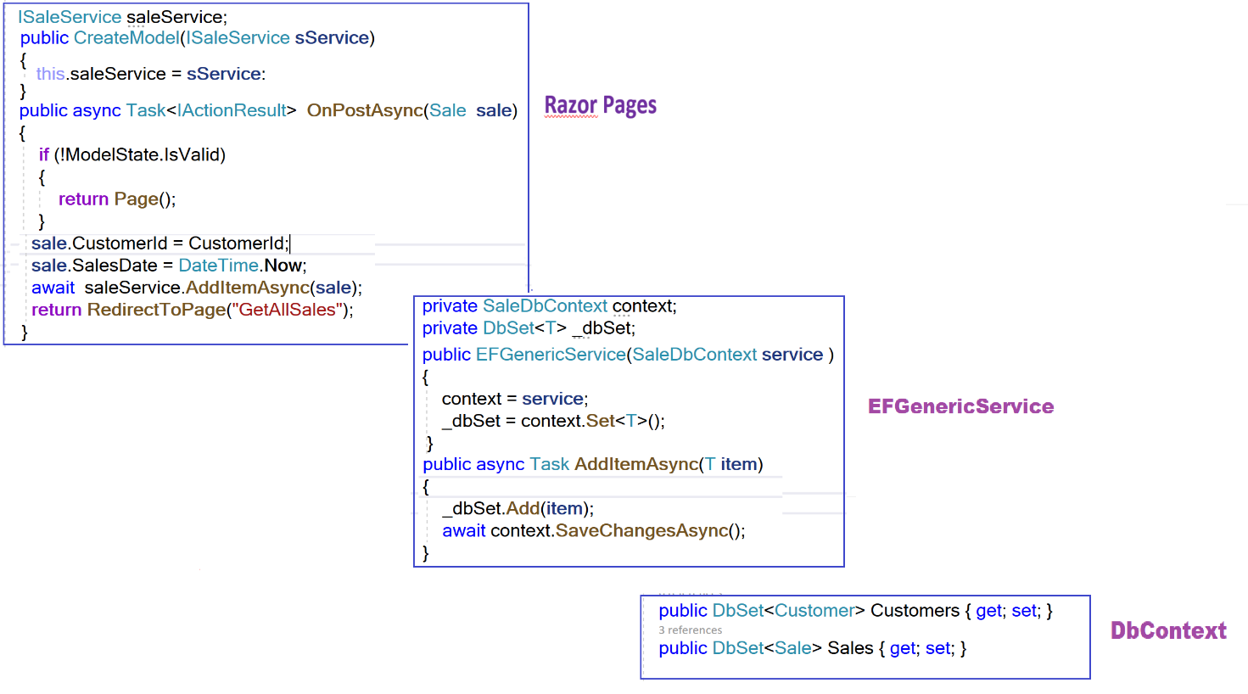

The only code that is not covered yet is the use of the **Add()** method of the **DBSet<>** class. This method adds the given entity to the context underlying the set. By calling the SaveChangesAsync() method, the entity is then inserted into the database.

**User story:** I will be able to create a customer. This user is similar to the previous one.

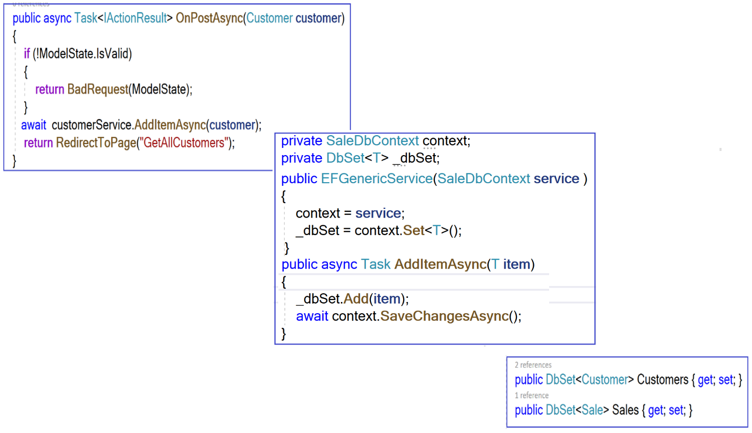

**User story:** I will be able to display a customer´s sales

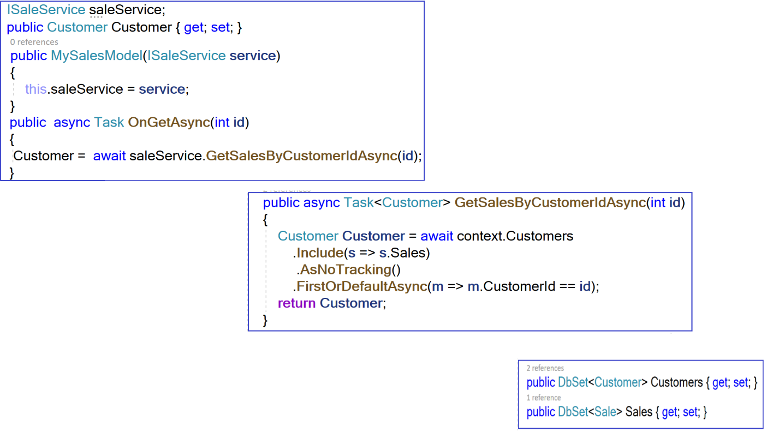

**User story:** I will be able to filter customer based on the name

**User story**: I will be able to filter sales based on the maximum amount

The code of these two user stories are similar.

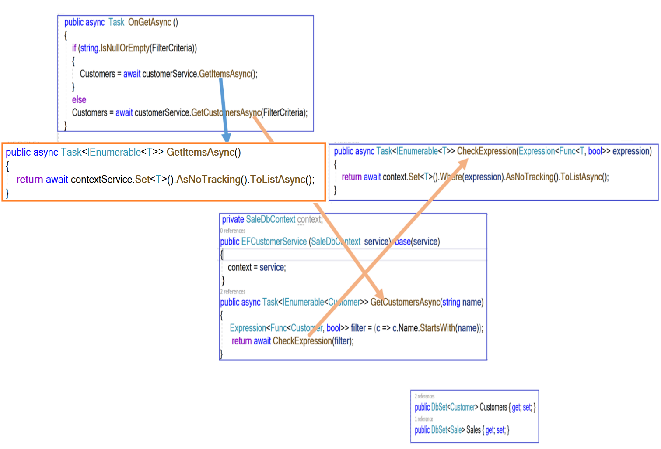

Looking at the code snippet shown above, you are probably familiar with it. The only code that may be new to you is the use of the delegate ***Expression<Func<Customer, bool***>> to represent a lambda expression in the form of what we call an expression tree.

**Sprint Review**

Let us run the application.

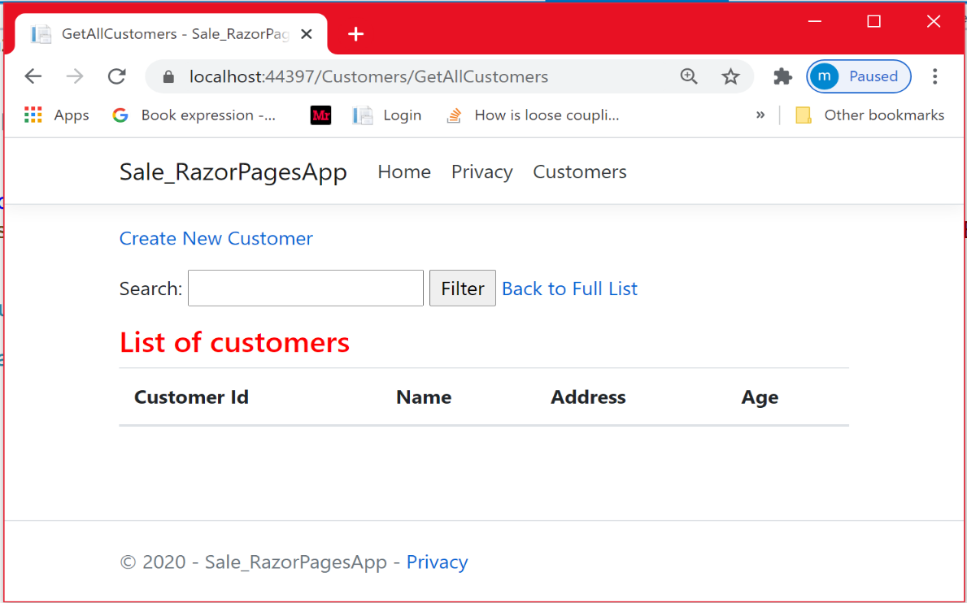

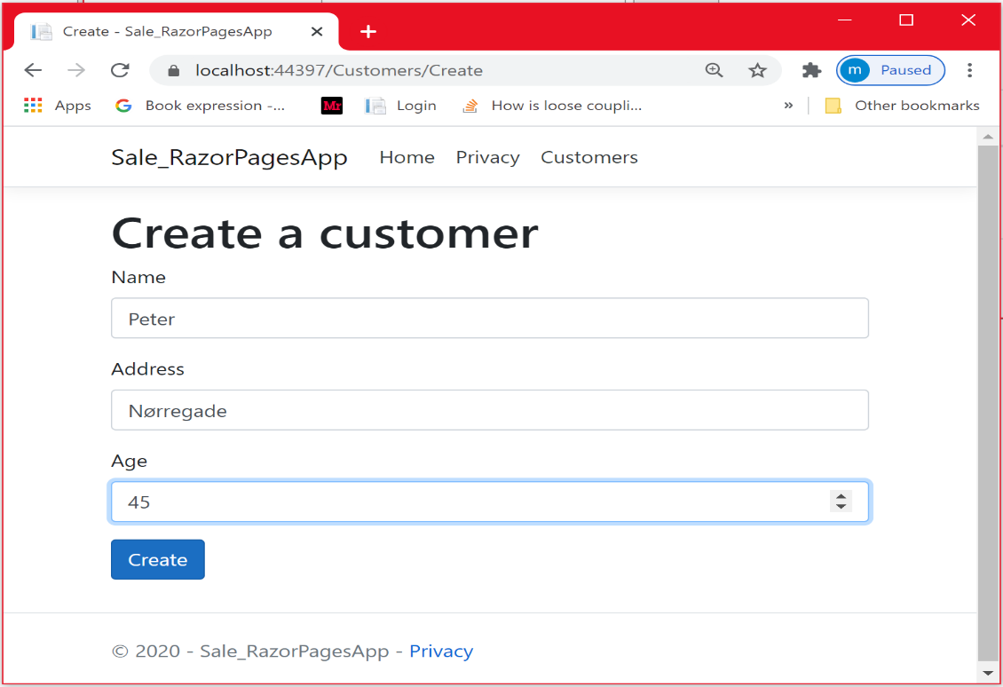

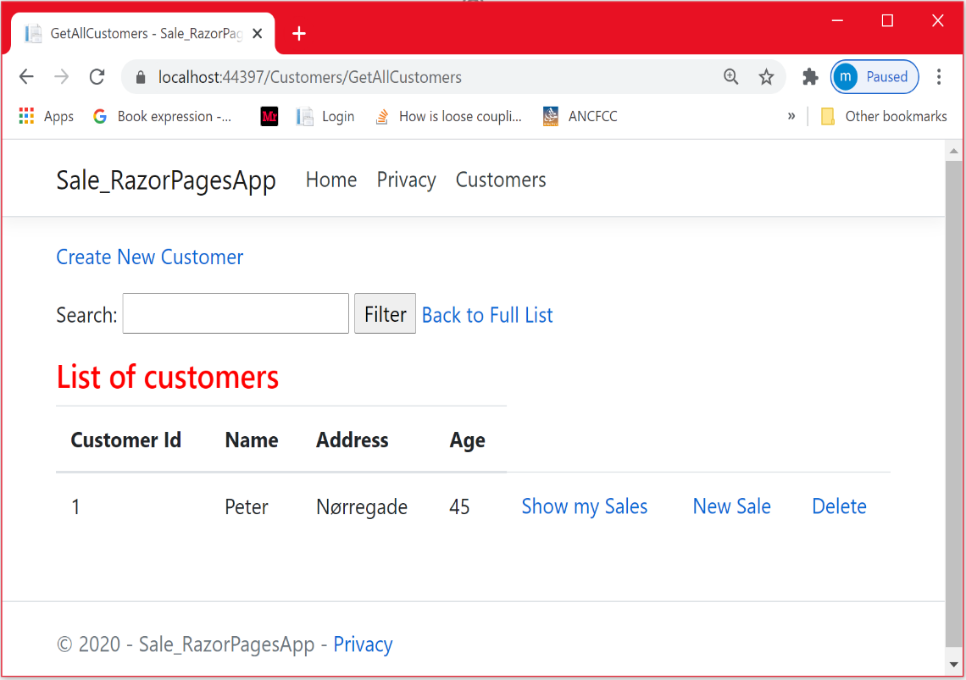

**User story**: I will be able to create a sale

This customer is going to place 3 sales.

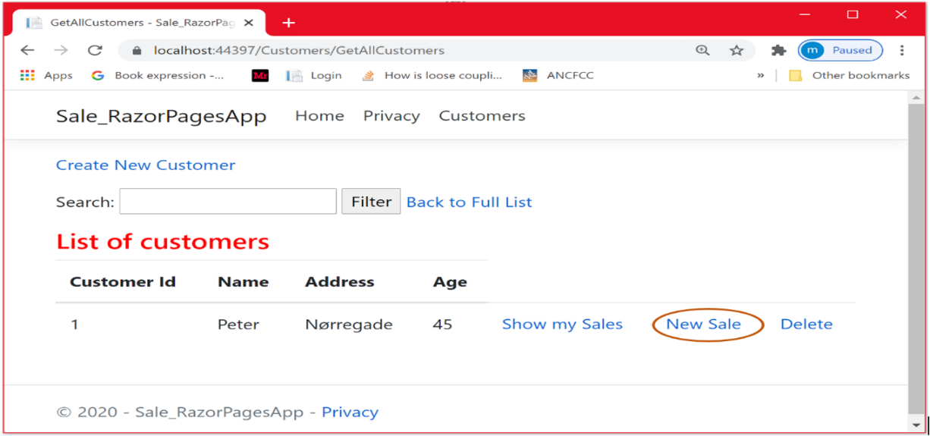

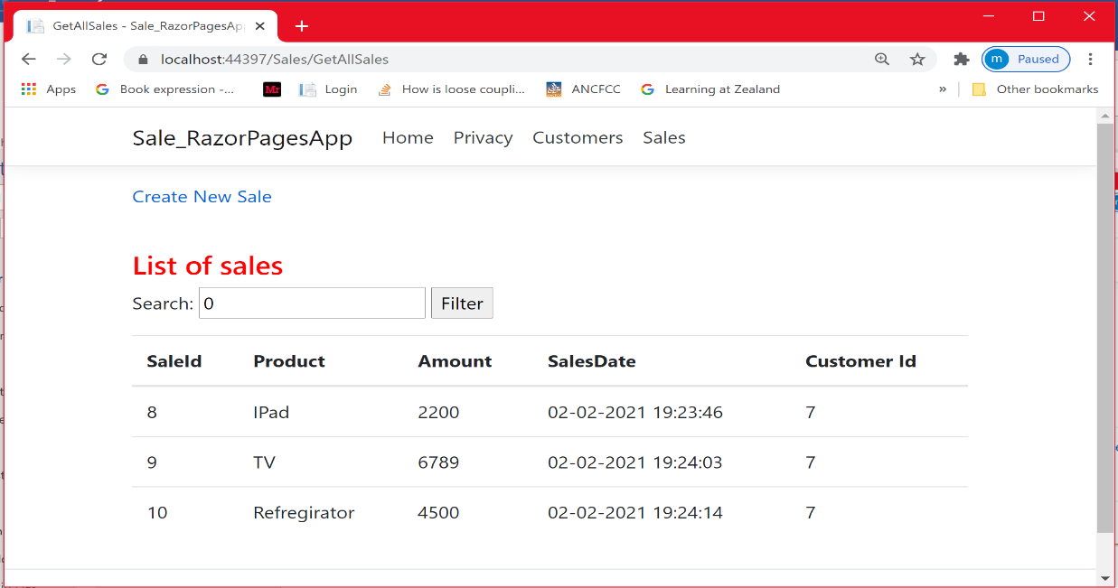

Let us have a look at the database.

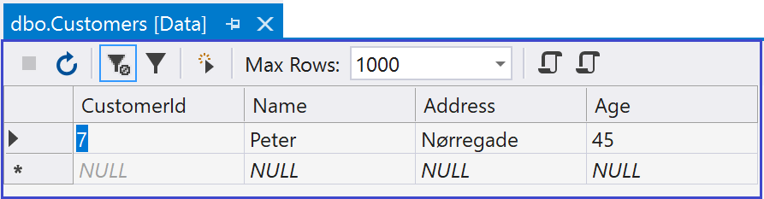

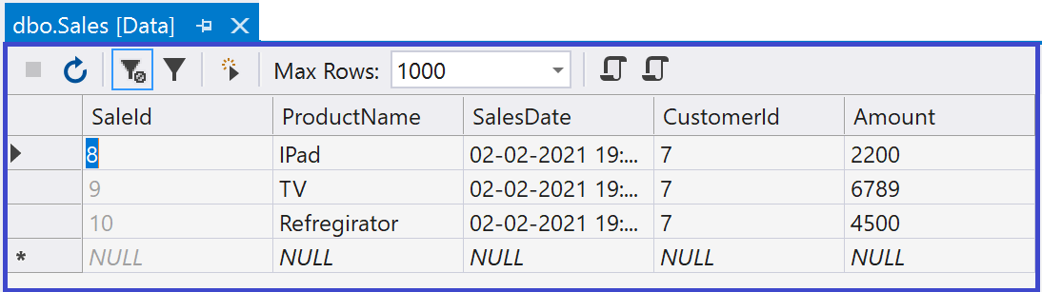

**User story** : I will be able to view my Sales

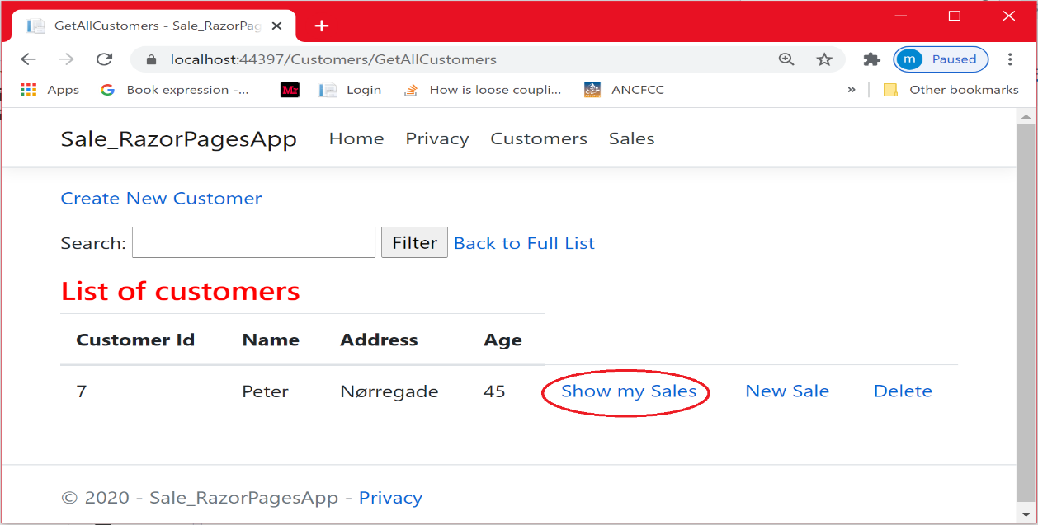

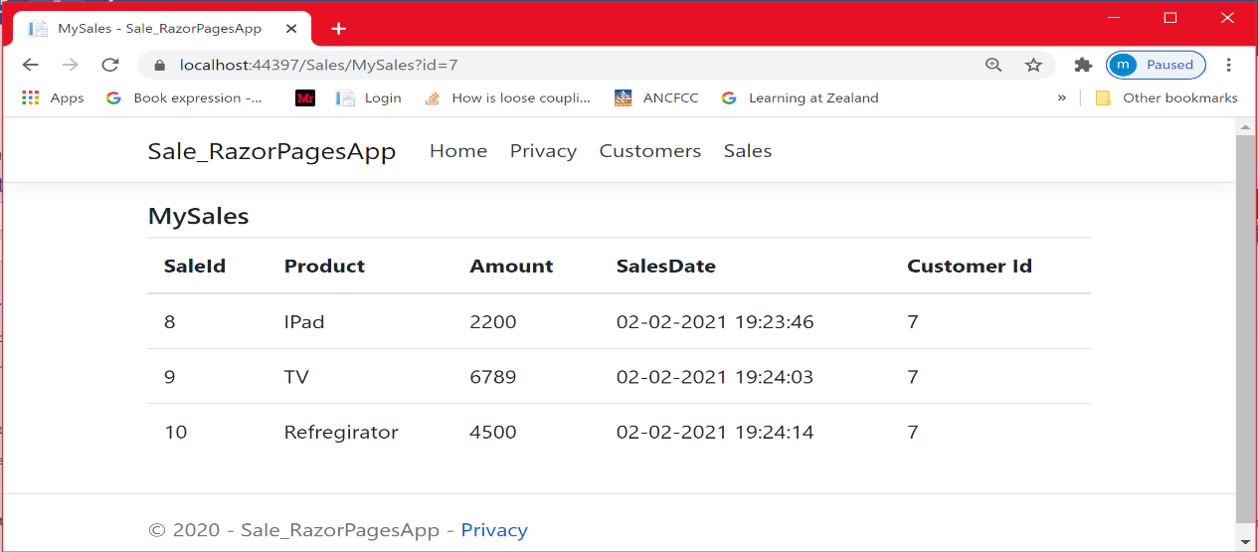

**User story**: I will be able to filter sales based on the amount

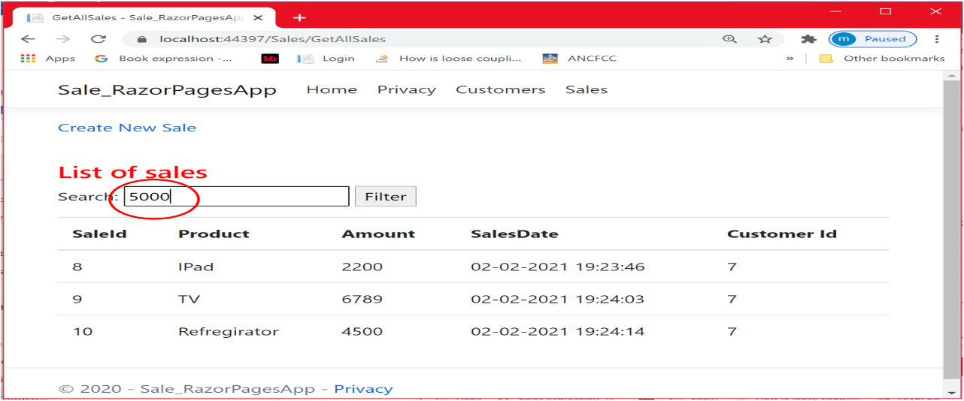

As you can see, the TV product with an amount= 6789 is not shown because it is filtered out.

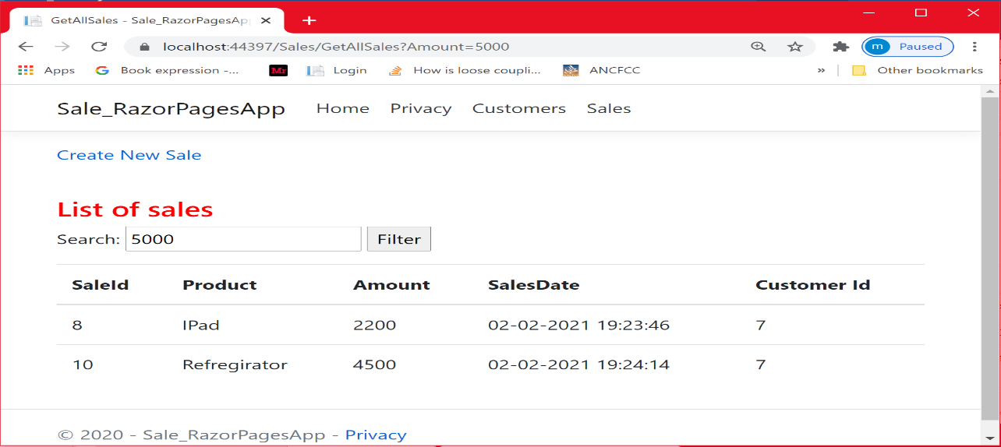

As you can see, only the sale with an amount less than 3000 is shown

**User story**: I will be able to delete a customer. I expect that the customer´s sales will also be removed (Remember the rule: ON DELETE CASCADE ).

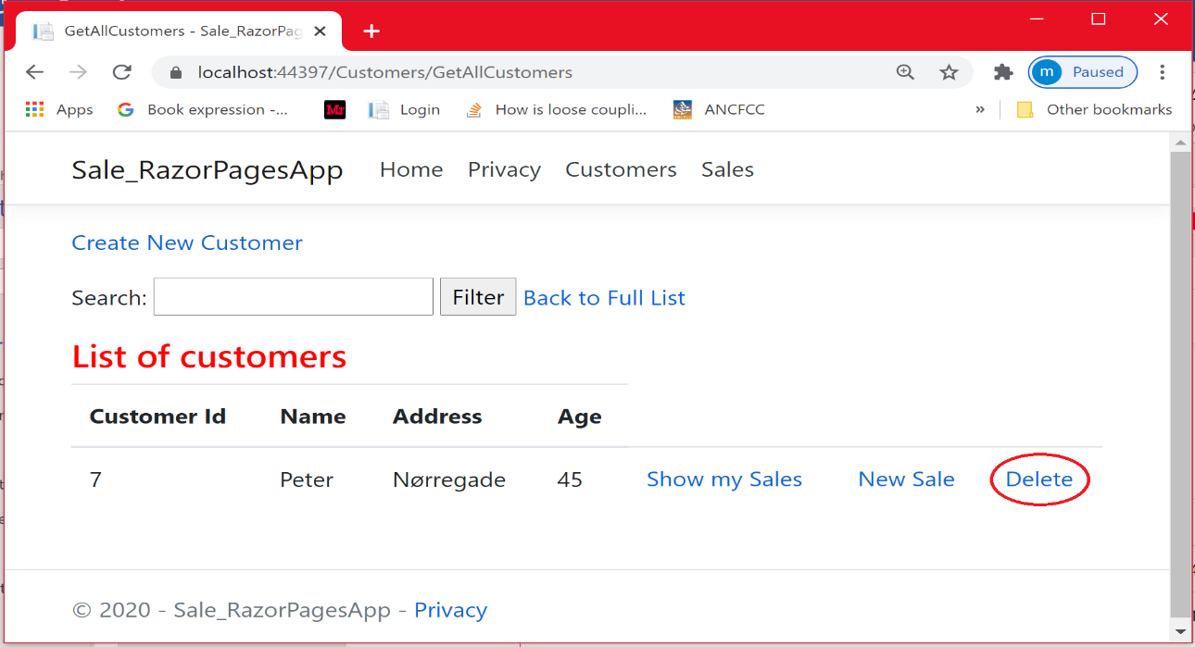

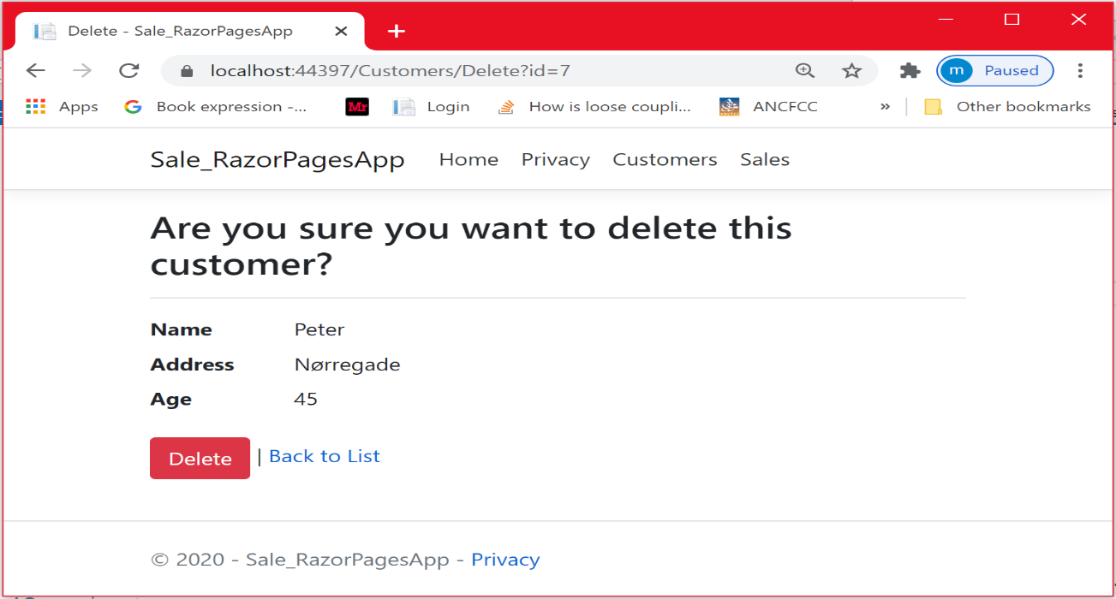

As you can see, the customer disappeared.

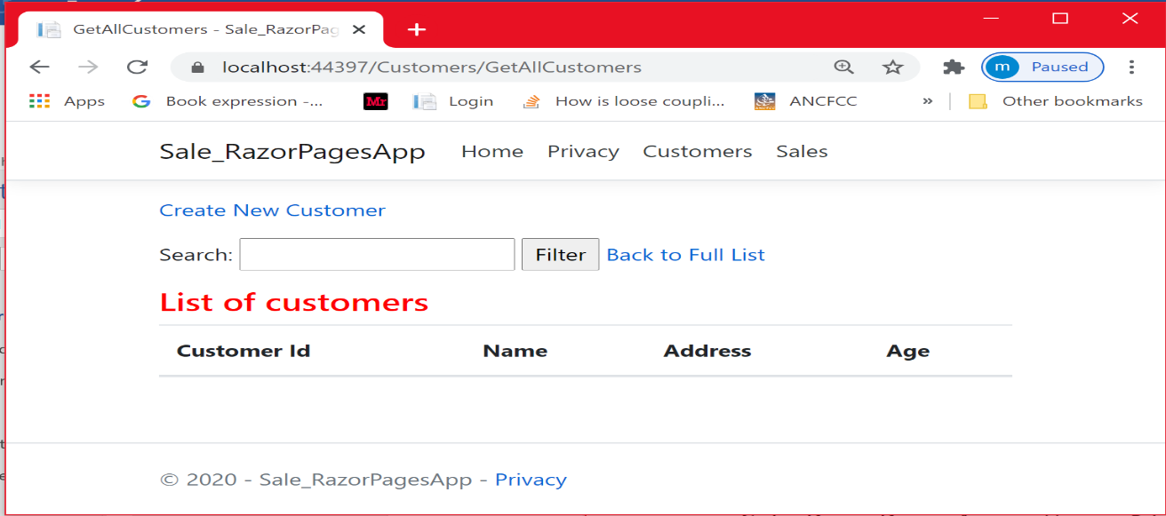

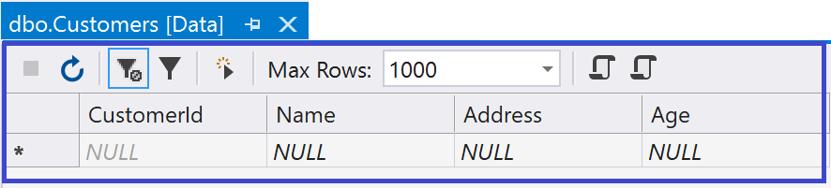

What about the customer´s sales?

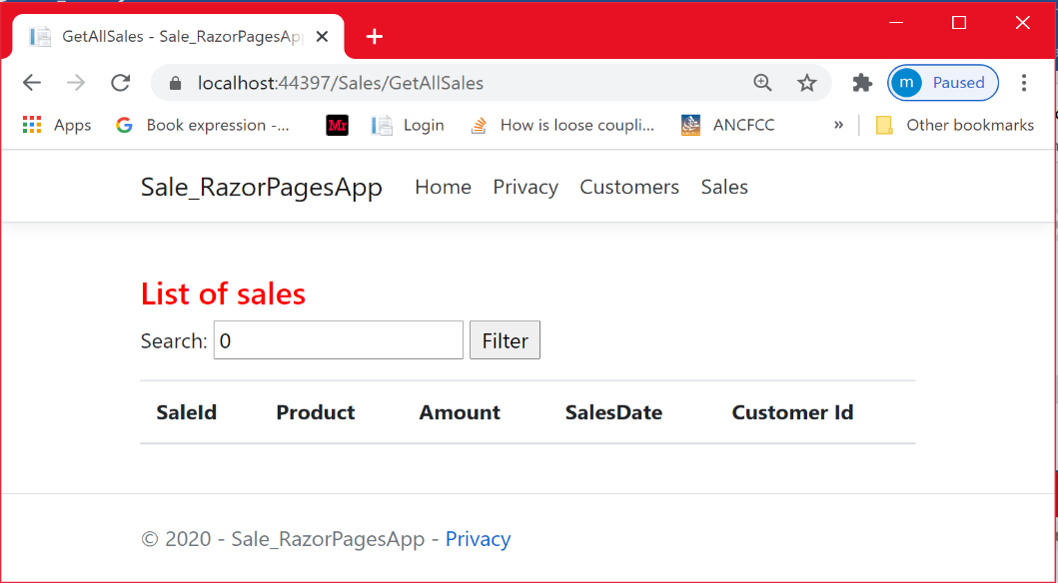

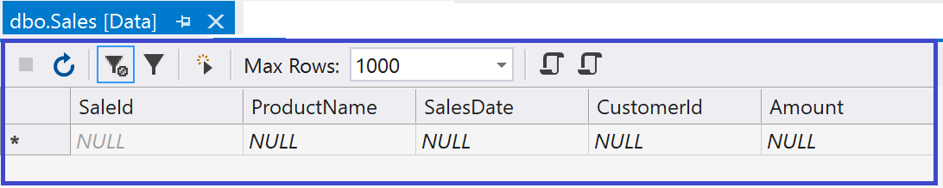

**Conslusion**

In this chapter, you learned how to make code more generic to enhance code reusability and maintainability. You also learned how you can pass a method as a parameter using Delegate.

**Chapter 5**

**Web Application with ASP.NET Core Razor Pages Using ADO.NET**

**Introduction**

Along this tutorial, we have seen many ways to implement the data access layer to store and retrieve data from an SQL database. In this chapter, you will learn another technology for implementing the data access layer. We are going to use **ADO.NET**. We will implement the Sale Management System we have been working with in the previous chapter.

The design is illustrated in the figure below.

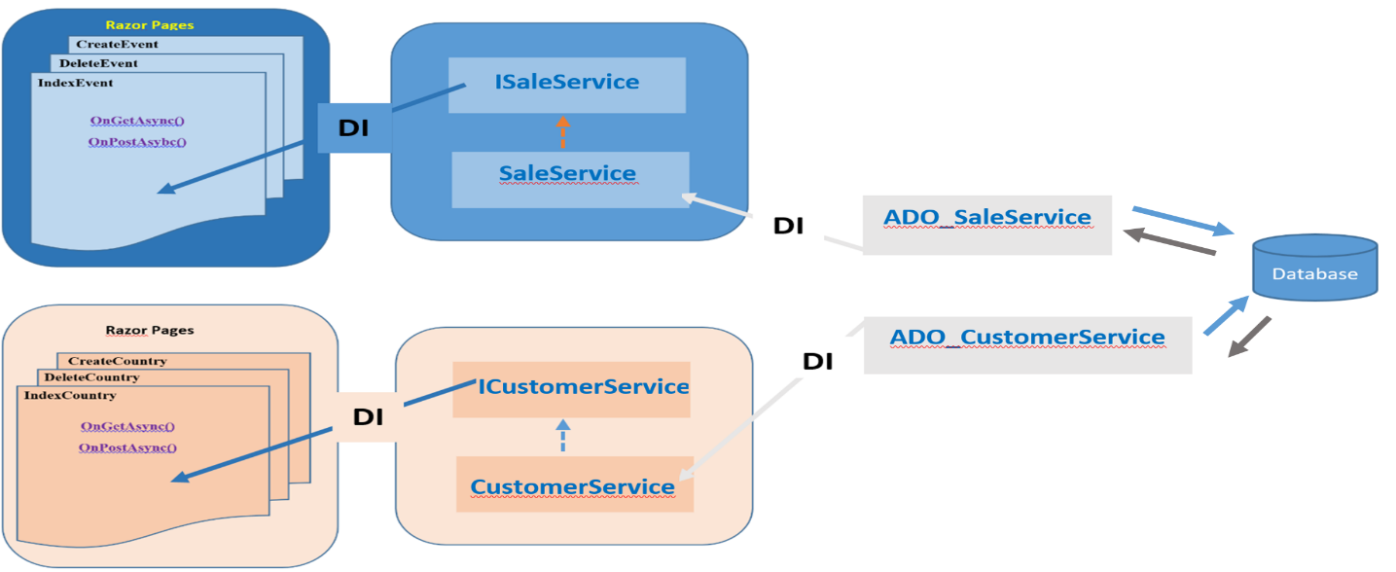

As you can see, we still have the same interfaces injected to the Razor Pages , so again, it is very easy to remove a data access layer service (i.e. using Entity framework) and plug-in another one (i.e. using ADO.Net) without changing the code at the Razor Pages level. This way, we achieved loose coupling by abstracting the implementation of the different services.

|  |  |
| --- | --- |
|  |  |

**What is ADO.NET ?**

In this tutorial Part II, you will learn how to work with ADO.NET to communicate with SQL Server database. We are adopting the so called ***Connected environment*** approach. That means that the application will remain connected with the database throughout the whole operation. You typically interact with the database using Connection, command, and data reader objects. ADO.NET supports many data providers for the different databases. In this tutorial, we are going to use **System.Data.SqlClient**, a data provider for Sql Server (including SQL Server Express and LocalDb). This namespace will provide all the classes for connecting to the database, executing commands and retrieving data from the database. In this chapter, all what you need from this data provider are mainly the following classes: **SQLConnection**, **SQLCommand**, and **SqlDataReader**. You can also benefit from other SQL classes (please consult the literature). What are these main classes helping with?

* + **SqlConnection** : establishes the connection to the database
  + **SqlCommand** : execute the command against the established connection
  + **SqlDataReader** : reads data one by one from the database in a forward only manner( forward-only)

**Implementation**

Now that you have an overview of how ADO.Net works, you have the necessary tools to be able to start the implementation.

## **Creating the database**

First, you need to create a database. In chapter 2, I showed you how to create the database and the tables using the Table Designer and the T-SQL windows. In this section, I will show you how to do the same by executing a script. You have probably learned how to create an Sql script.

* Select your local server Right-click on it choose NewQuery

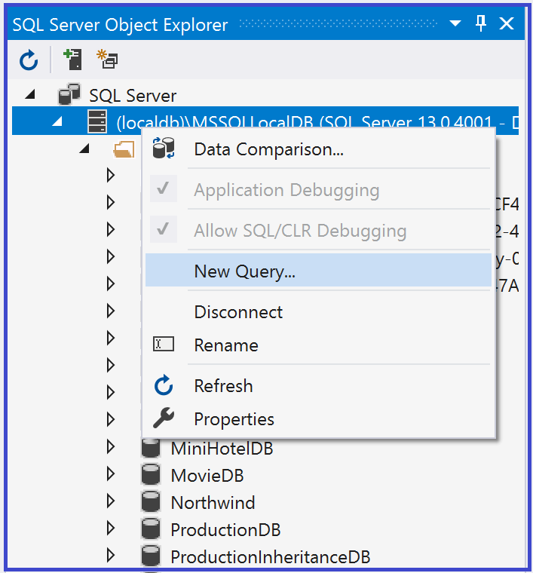

* In the Sql Query window, type the following script.

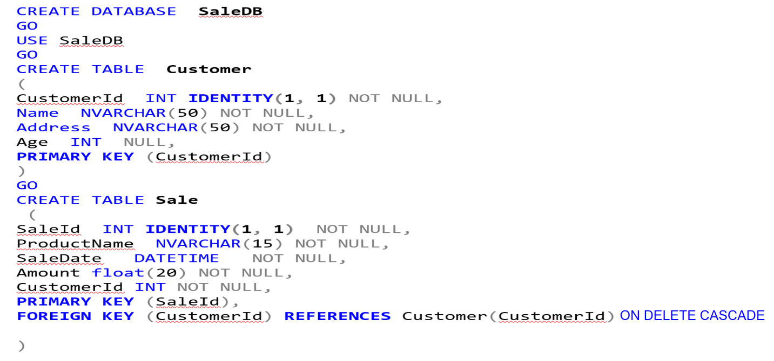

Pay attention to the rule (**ON DELETE CASCADE**) we imposed to the foreign key. Whenever we delete the parent (Customer), all its children(Sales) are automatically removed.

* Once, you finish typing the whole script, click on the small green triangle. The query will be executed.

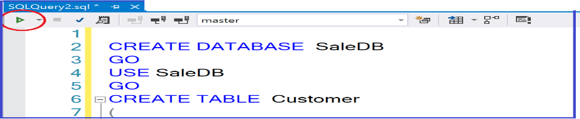

* If everything is OK, you will get a “successful” message and the database is created as shown below.

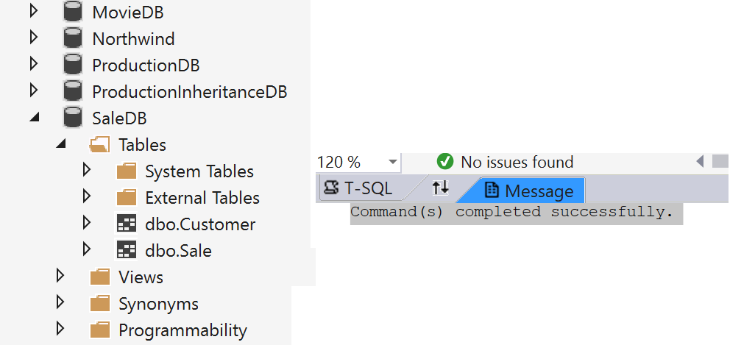

## **Adding Database Connection String**

We did work with the connection string in the previous chapters without mentioning what it is. Let us describe a little bit what is a database connection string. A **Database Connection String** stores the parameters that are required to connect the application to the database. It contains the name of the driver, Server name and Database name. It also contains security information such as user name and password needed for database connection. A good place to place the connection string is the ***appsettings.json*** file, a file that resides on the root of the project. The figure below shows an example of setting the connection string for my SaleDB database.

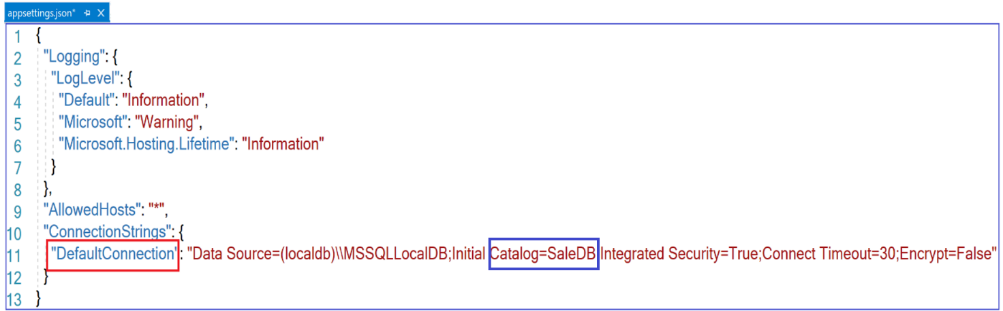

Some words about the connection string

* Notice the name “**DefaultConnection*”*** given to the connection string. This name is going to be used for configuration purpose.
* **(localdb)*****\\SSQLLocalDB*** : we specify the name of the local SQL Server instance the application will be connected to.
* ***Catalog=SaleDB*** . It specifies the name of the database created in the local SQL Server
* ***Integrated Security= True.*** It specifies that the Windows credentials of the current user are used to authenticate against the SQL Server.
* ***Connect Time= 30***. It specifies the timeout to create the connection. That means within 30second, the Sql server should establish the connection, otherwise current connection request will be cancelled
* ***Encrypt=false***. It means that no encryption is used

## **Working with SqlConnection, SqlCommand and SqlDataReader objects**

The process of using of ADO.Net to connect to a database is very simple and more logical:

Once the database is created and the ***connection string*** is defined, you need to create an ***SqlConnection*** object by specifying the ConnectionString as a parameter. Then you define the **query** (what you intent to do with the database). Once the connection is opened, you need to send an Sql command to the database. To create an ***SqlCommand*** object, you need to specify the SqlConnection object that you want to use and you need also to specify your query. When we send an SqlCommand to the database, we expect a reply from the database. We should be able to read the response from the database. For that, we need to create and use an ***SqlDataReader*** object.

In terms of code, this looks somehow like this

SqlConnection connection= new SqlConnection(connection string)

SqlConnection.Open()

String query=” Select * from Customer”

SqlCommand command= new SqlCommand(query, connection)

SqlDataReader dataReader = command.ExecuteReader())

while (dataReader.Read())

{

Customer customer = new Customer()

*// read the first column from the row we are reading*

customer.CustomerId = **Convert.ToInt32**(dataReader["**CustomerId”])**

**NB** *: You can also specify the column based on the index ( 0 for the first column and so on…..):*

customer.CustomerId = **Convert.ToInt32**(dataReader[0**])**

*// read the second column from the row we are reading*

customer.Name = **Convert.ToString**(dataReader["**Name**"]);

*// read the third column from the row we are reading*

customer.Address = **Convert.ToString**(dataReader["**Adress**"]);

*// read the fourth column from the row we are reading*

customer.Age = **Convert.ToInt32** (dataReader["**Age**"]);

}

Notice the use of the ExecuteReader() method on the SqlCommand object. This call returns

the data provider’s SqlDataReader object, which provides forward-only, read-only access for the result of the query. ***What does “forward-only, read-only access” means*** ? It means that we iterate through each row in the result set one row at a time by moving forward through the result set. We don't wait for the entire result set to load before we start iterating through it. For this type of access, it makes sense to keep the connection to the data source open until we've finished iterating through the data. This is what I called the ***Connecting Environment*** approach mentioned at the beginning of the chapter.

## **Dependency Injection & IConfiguration**

Since we need to access the connection string info from the appsettings.json file, we need to inject (using Dependency injection) the **IConfiguration** type in the services that use the connection string, as show below.

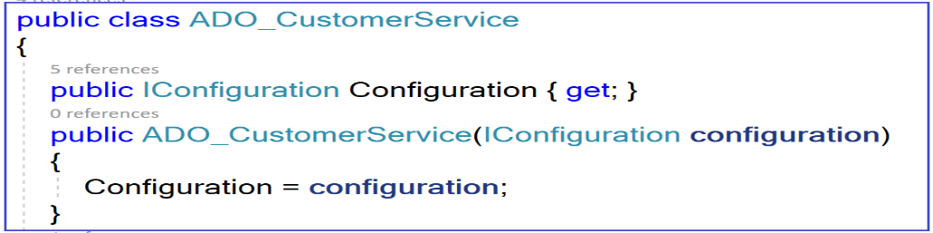

## **Asynchronous or synchronous**

We could debate about whether to implement the data access layer in an asynchronous way or not. Indeed sometimes, we cannot experience any improvement in the performance when using the asynchronous approach. The worst is that sometimes asynchrony will do harm more than good to your application. I had implemented both the asynchronous and the synchronous approaches for the example of this chapter. I would say that I could not see any significant difference in the performance. Anyway, I am going to show the asynchronous implementation.

## **User story:** *View all Customers* **&** *Filter customers based on the name*

You may have no customers yet in your database. Anyway, I started with this user story because it is very simple and no need for other classes than the ones we have just covered.

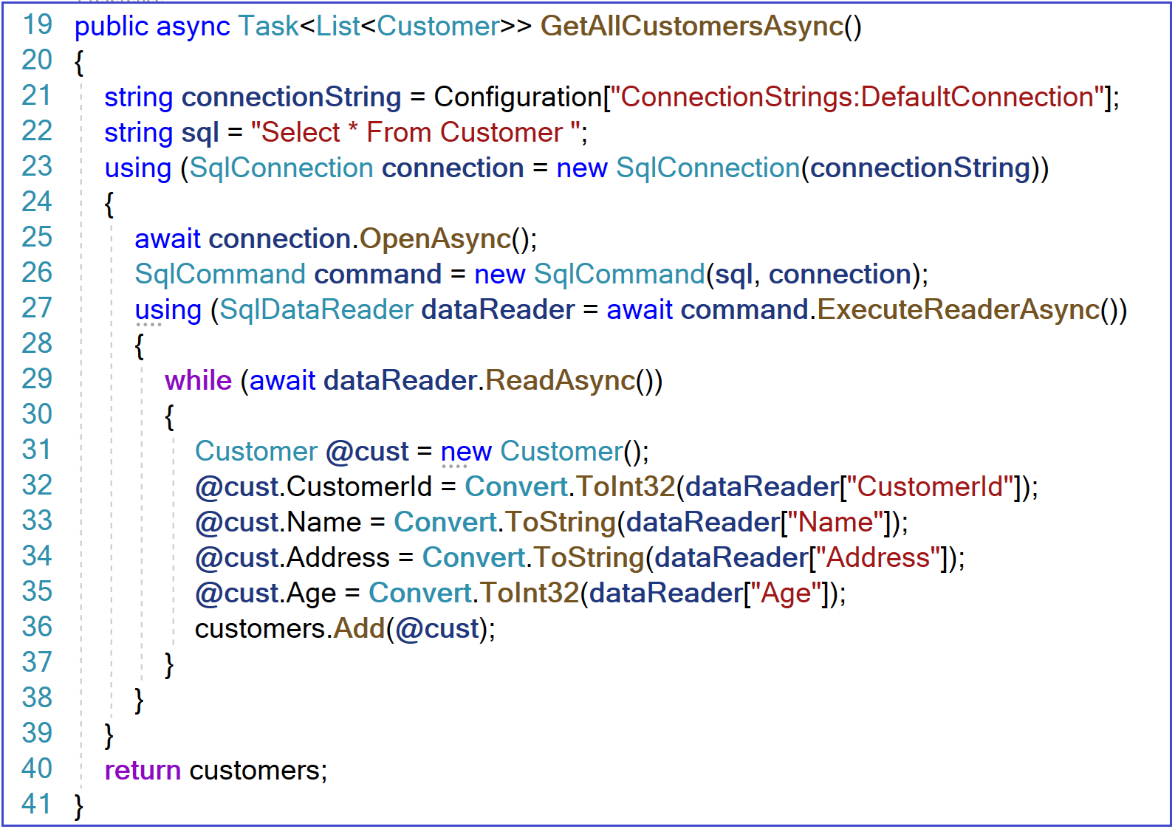

**Line 21:** I am fetching the DefaultConnection that was setup inside the appsettings.json file.

**Line 22:** I define the SQL statement (the query) in a string variable. This statement will select all the rows in the customer table.

**Line 23**: I create an ***SqlConnection*** object (part of System.Data.SqlClient) by passing the connection string as a parameter to the constructor. Notice the use of **using** keyword. This will make sure that resources are released after usage. In this case, the connection object will automatically be released after finishing reading the data.

**Line 25:** Since we adopted the connected environment approach, I have to open the connection before execution any command. Notice the call to the OpenAsync method and how we await such call.

**Line 26:** I create the SqlCommand object by passing the Sql statement (query) and the connection string .

**Line 27:** The SqlCommand class has a method ExecuteNonQueryAsync to execute an SQL statement in an asynchronous way. In this line, I am creating an SqlReader object by calling the ExecuteNonQueryAsync method.

**Line 29-38**: While asynchronously reading one row at a time (using the ***ReadAsync*** method) by moving forward through the result set, we create the customer object that correspond to the row. The object is then added to a list. Notice the use of the **Convert** class to convert the value of the specified object returned by the DataReader into the right type.

Let us look at the other class that applies filtering based on the name 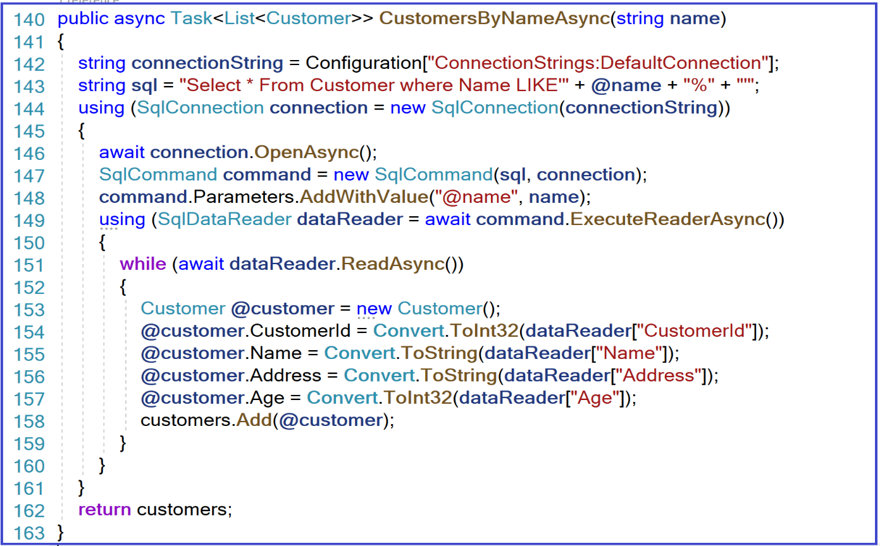

The code is practically the same. Notice the use of the **LIKE** operator for searching for any pettern that starts with the “name” parameter.

## **User story:** *I will be able to create a new Customer*

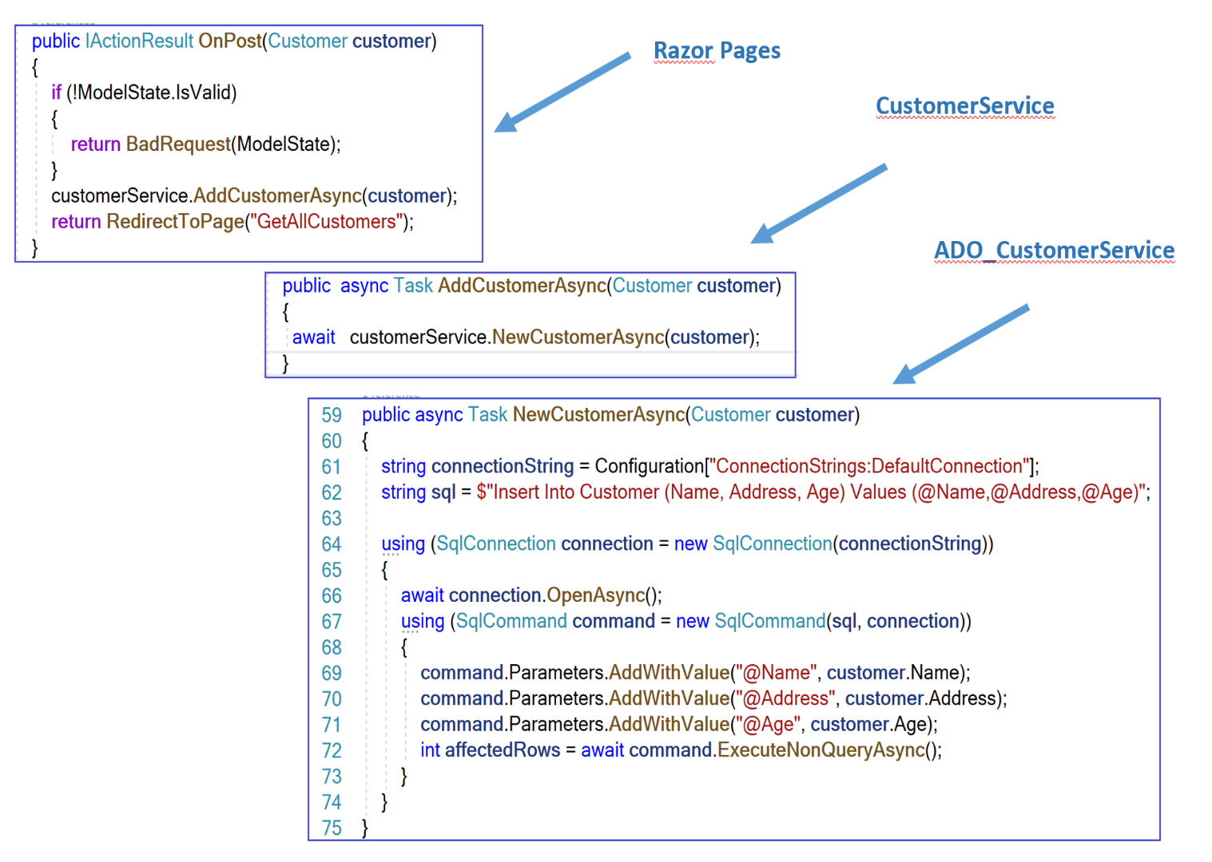

**Razor Pages**

As you can see from the code snippet, the process for creating a new customer is the same. It is based on the same 3 objects: SqlConnection, SqlCommand and SqlDataReader , with minor difference that we will look at. This time, we are using the **ExecuteNonQueryAsync()** method (an asynchronous version of the ExecuteNonQuery method) on the SqlCommand object. You generally use the ExecuteNonQueryAsync() method to change the data in a database (e.g., insert, update, delete, or create table). It does not return any row. For UPDATE, INSERT, and DELETE statements, the return value is the number of rows affected by the command. For all other types of statements, the return value is -1.

Another important issue that we addressed in this code is what is called: **Sql** **injection attack**. It is not our subject. However let us explain in brief what it is. Injection attack can be performed by attackers by sending untrusted data through a form input , for example. For example, an attacker could enter SQL database script into a form that expects a plain text. Then, this would result in that script code being executed in the database. We may think of properly validating the form inputs but validation is just a first line of defense and we cannot completely rely on validating the form input for our application’s security. Another way to prevent injection attacks is to use ***Parameterized queries*** as shown below.

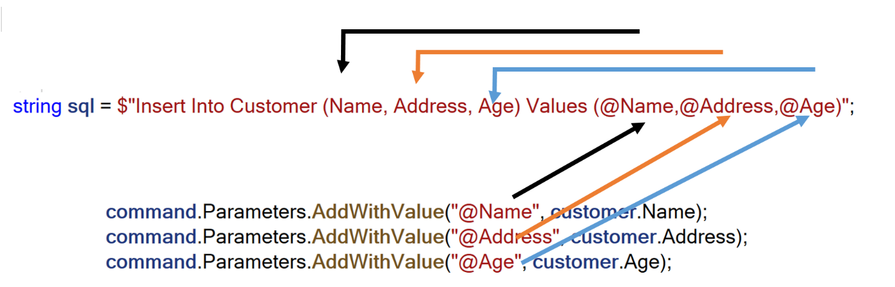

As you can see, our query contains some parameters (i.e. @Name). This parameter is assigned a value later on using the ***Parameters*** property of the SqlCommand class. This way, we can avoid injection attack vulnerability.

## **User story:** *Delete a Customer*

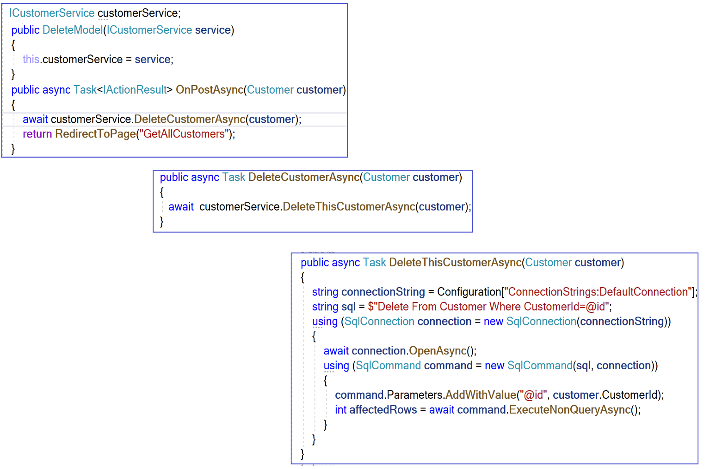

No need to explain the code. Most of it was covered previously.

## **User story:** *View a customer´s Sale*

The implementation of this user story is very important. We do not need to create a new Razor Page to display the sales for a specific customer. We are using the same page for displaying all the sales .

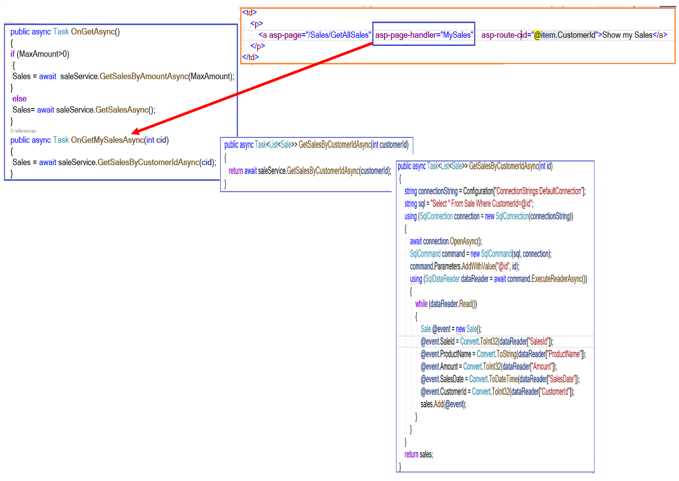

## **User story:** *Filter Sales based on the amount*

In this case, I am going to show only the code at the ***ADO_SaleService*** class.

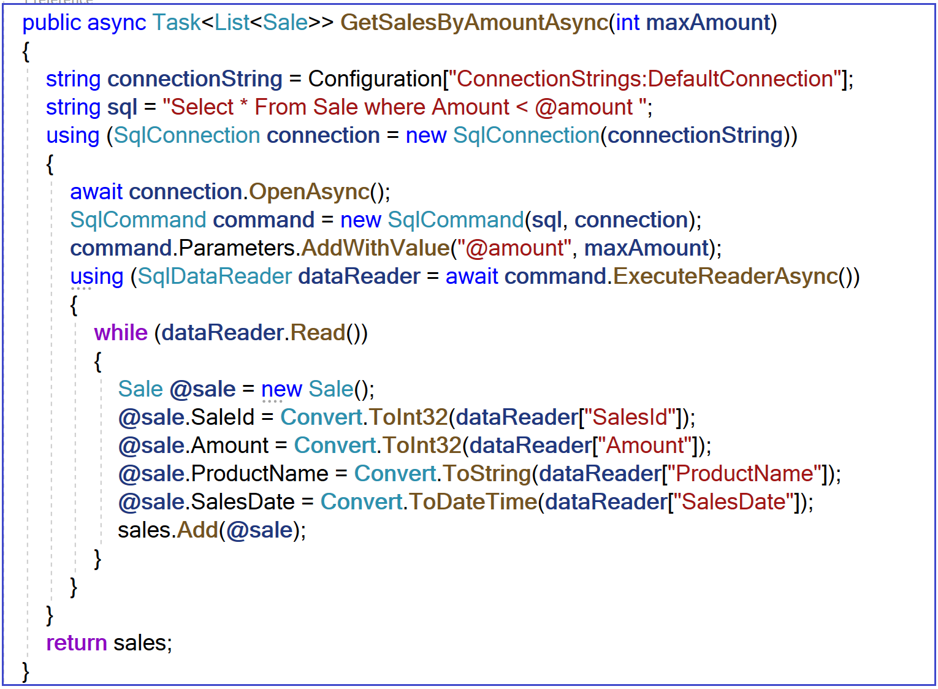

**Sprint Review**

Let us run the application

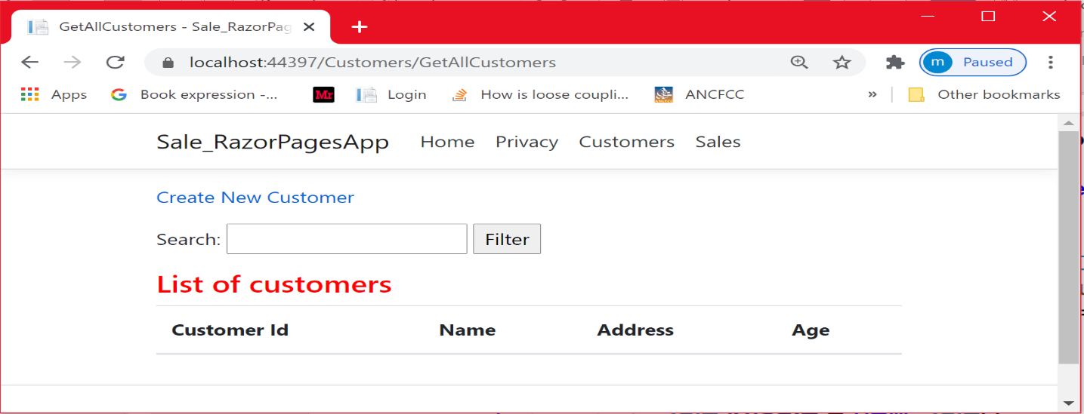

Let us create a new customer

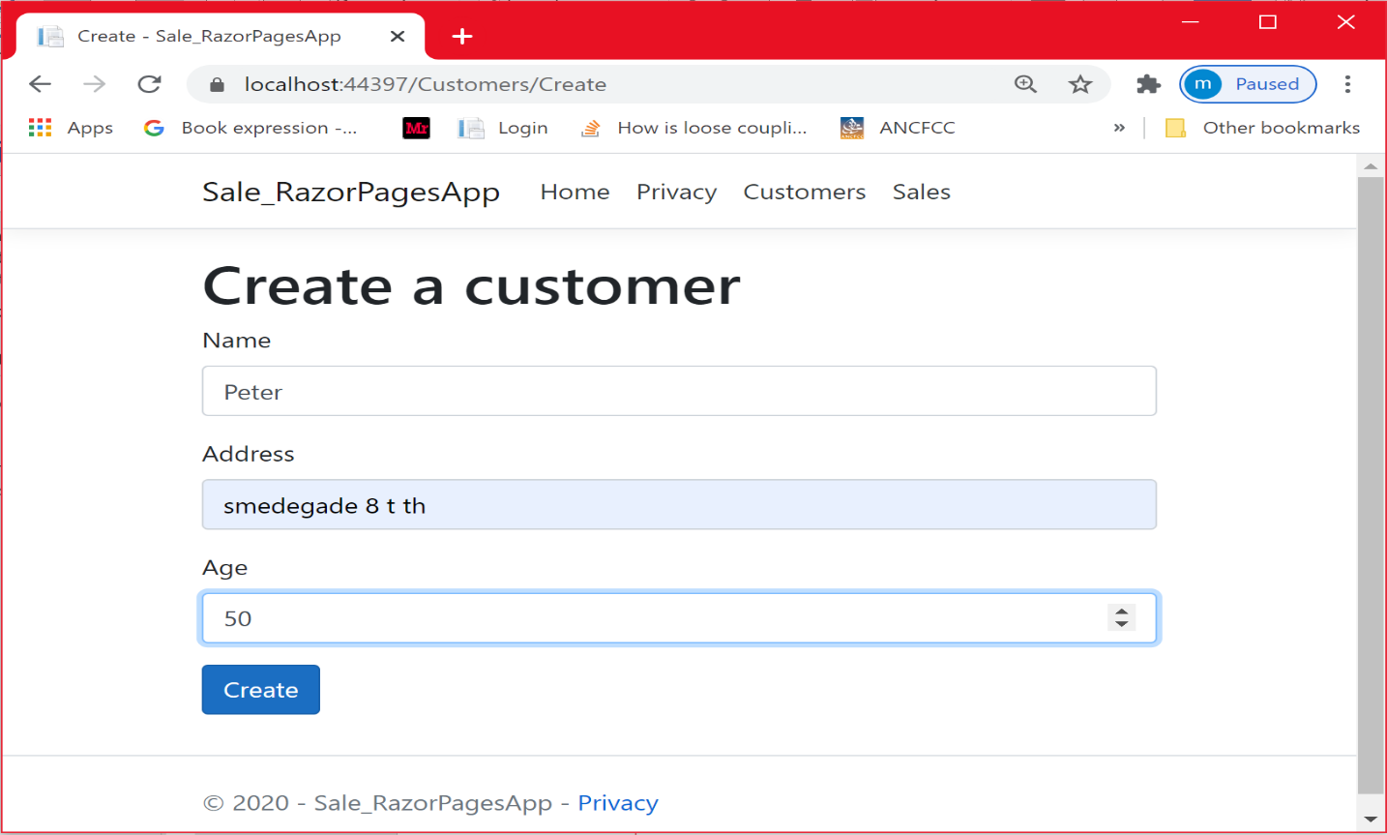

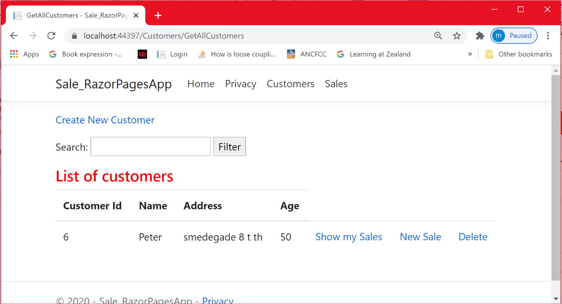

Let us have a look at the database.

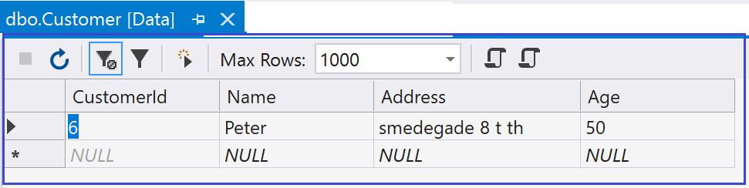

Let us create 2 other customers: Mohammed and Poul

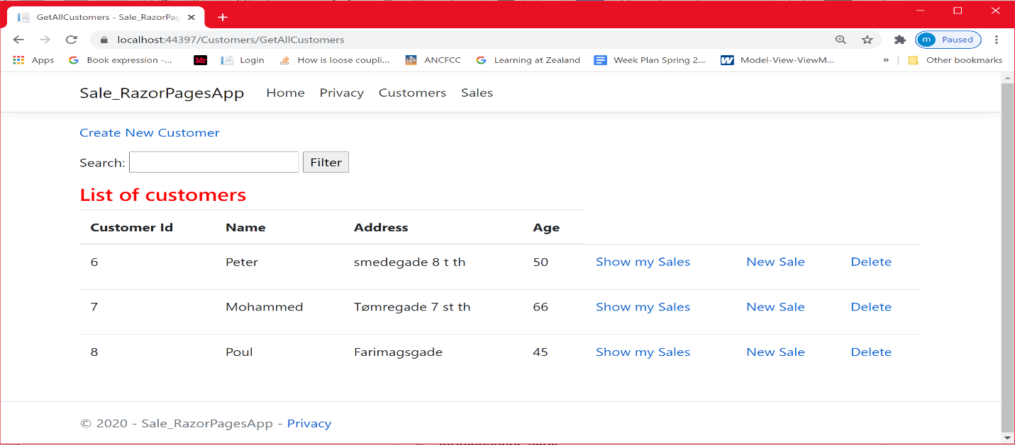

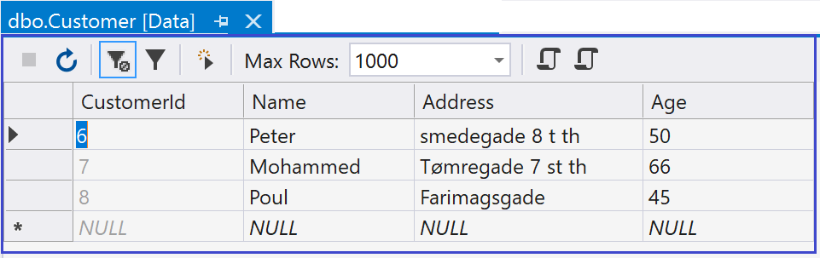

Let us filter the customer based on their name

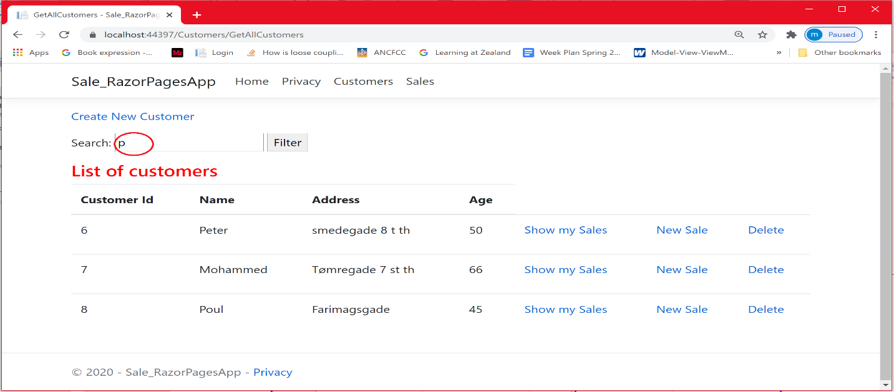

As expected, the Customer Mohammed is not shown

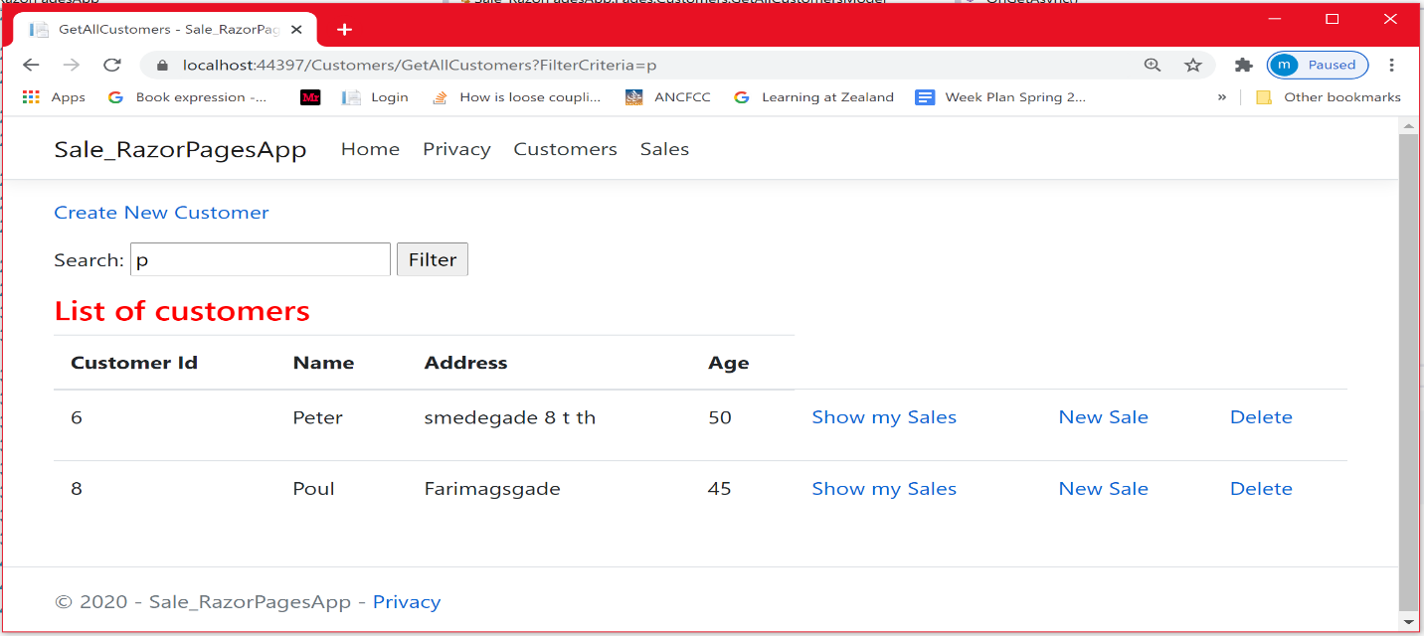

Let us add a new Sale to Peter

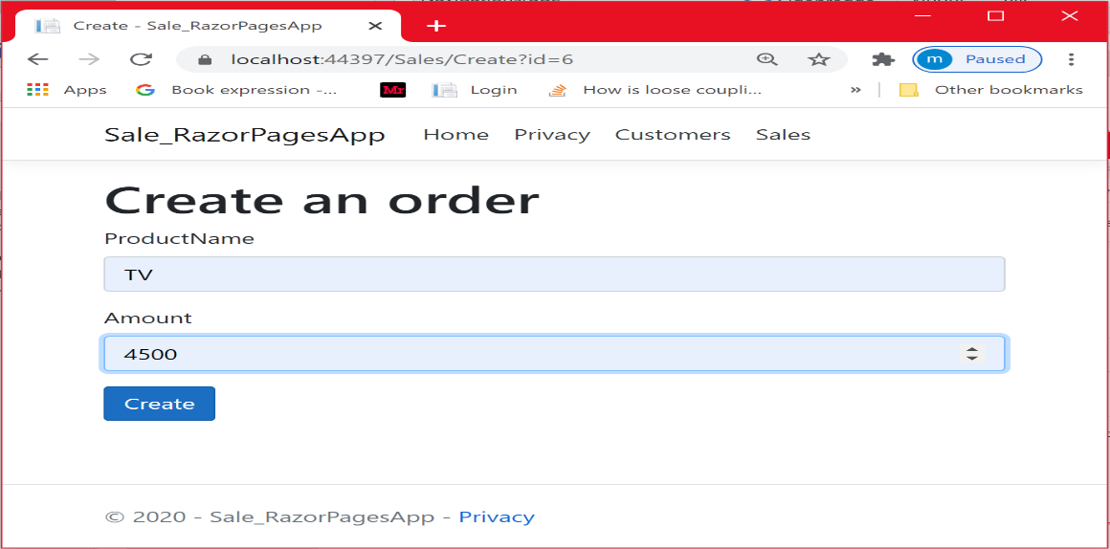

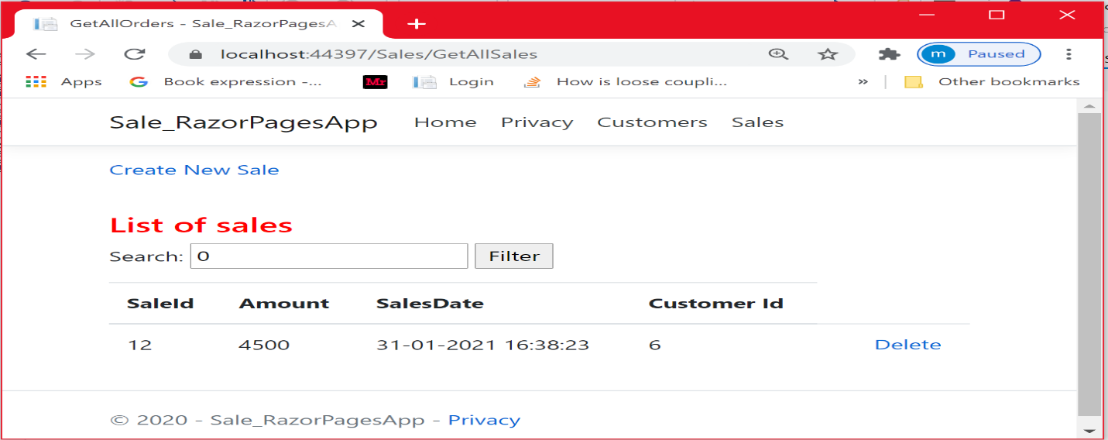

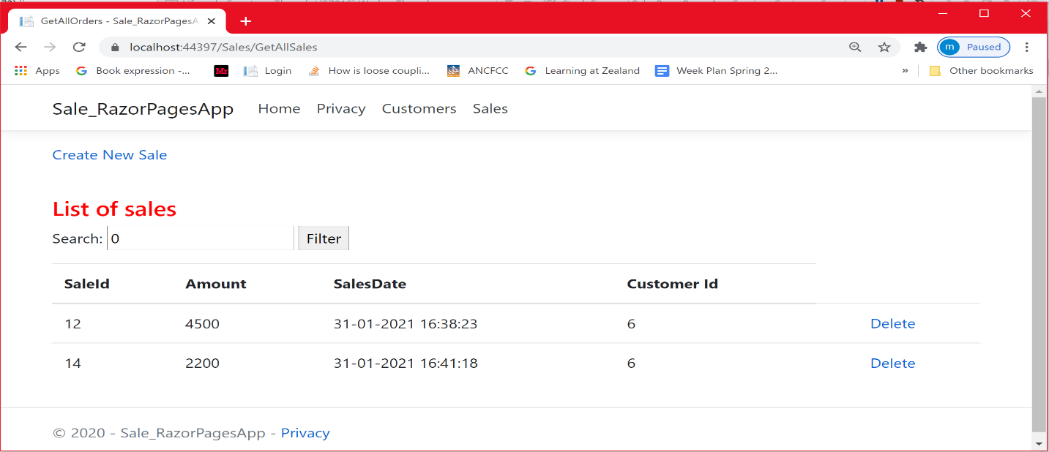

Let Mohammed place a sale. Poul is not going to place any sale.

The figure below shows all the sales.

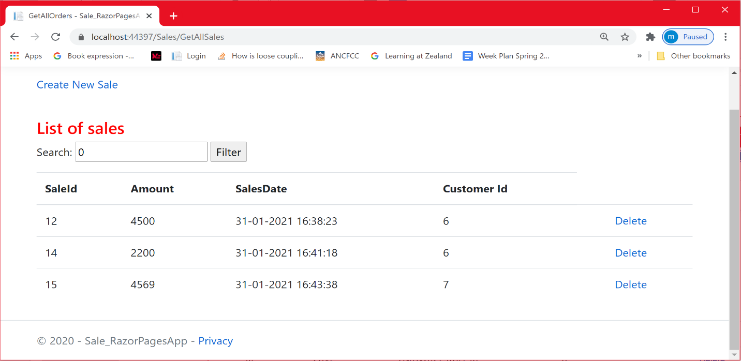

Let us filter the sales on the maximum amount.

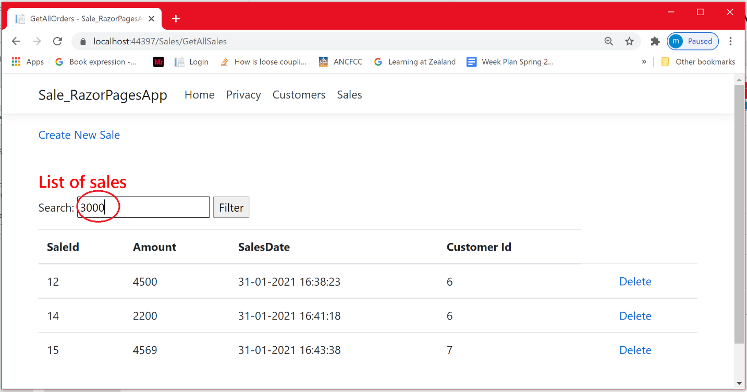

As expected, only the sale that is shown is the one involving the IPad.

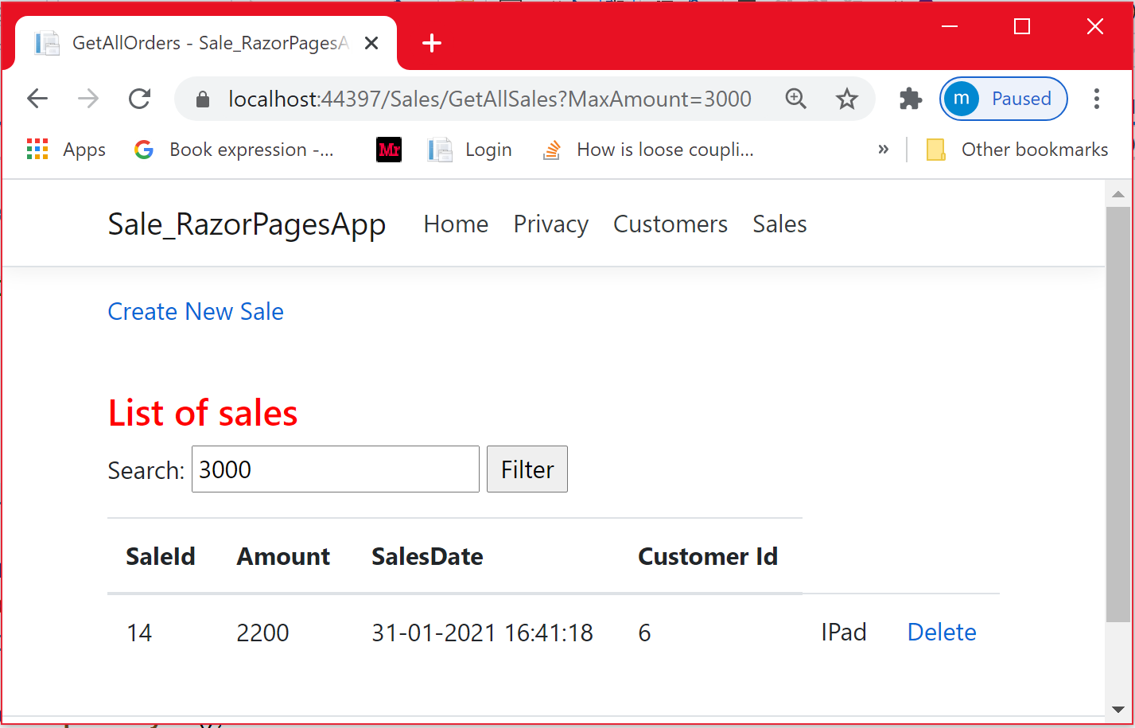

**User story**: be able to delete a customer having some sales

Let us delete Peter who has 2 sales

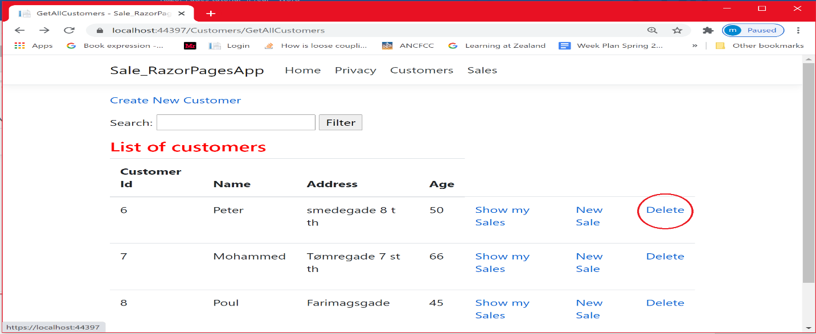

As you can see, peter is removed

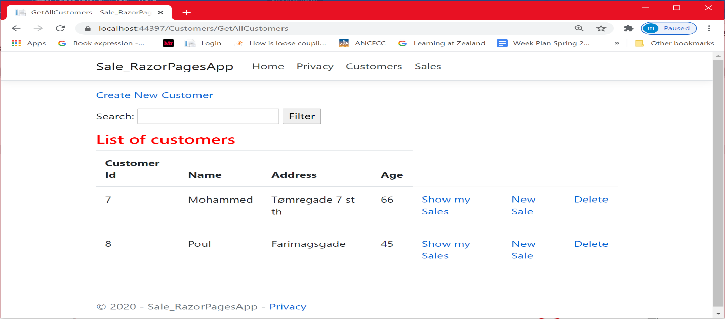

Let us check whether Peter´s sales are removed as well. As you can see, all peter´s sales are removed. This is due to the rule ON DELETE CASCADE imposed on the foreign key.

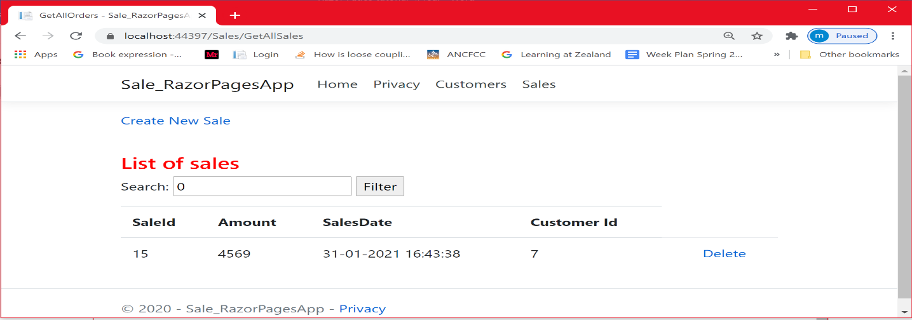

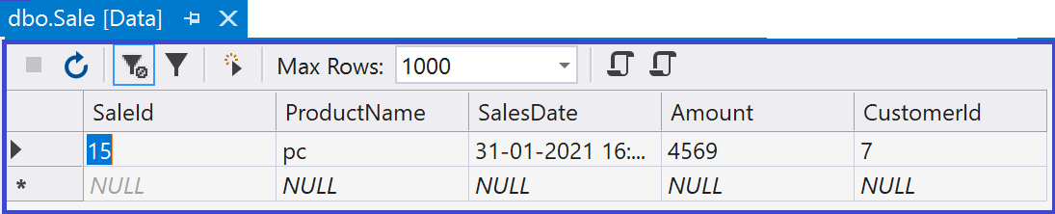

**Conclusion**

In this chapter, you did learn a new data access technology ADO.Net. You have seen how easy the technology was. Uisnf it relies on almost the 3 objects SqlConnection , SqlCommand and DataReader , which are part of the System.Data.SqlClient library. With ADO.Net, you could avoid Sql injection attack by using Parameterized queries.